

VistA Imaging DICOM Gateway

Installation Guide

May 2013 – Revision 18

MAG*3.0*34, MAG*3.0*116, and MAG*3.0*118

Department of Veterans Affairs

Product Development

Health Provider Systems

**DICOM Gateway Installation Guide  
VistA Imaging 3.0 MAG*3.0*34, MAG*3.0*116, MAG*3.0*118**May 2013

**Property of the US Government**

This is a controlled document. No changes to this document may be made without the express written consent of the VistA Imaging Product Development group.

While every effort has been made to assure the accuracy of the information provided, this document may include technical inaccuracies and/or typographical errors. Changes are periodically made to the information herein and incorporated into new editions of this document.

Product names mentioned in this document may be trademarks or registered trademarks of their respective companies, and are hereby acknowledged.

VistA Imaging Product Development  
Department of Veterans Affairs  
Internet: <http://www.va.gov/imaging>  
VA intranet: <http://vaww.va.gov/imaging>

**Caution: Federal law restricts this device to use by or on the order of either a licensed practitioner or persons lawfully engaged in the manufacture or distribution of the product.**

# Preface.............

This guide is written to assist in the installation of the VistA Imaging DICOM Gateway. The recommended background of those installing this software includes knowledge of Windows and network component installation.

This guide also provides configuration specifications needed by the commercial DICOM vendors to properly interface their equipment to VistA.

| **Revision History** | |
| --- | --- |
| 14 May 2013  12 Dec 2012 | Incorporate MAG*3.0*123 Change pages, Roy R. Seabolt  Change pages for MAG*3.0*034, MAG*3.0*116, and MAG*3.0*118, Roy R. Seabolt |
| 1 Sept 2011 | Applied change pages for: MAG*3.0*49 (sections 4.1, 4.3.27, 4.3.28, 4.4.15, 4.4.16, 5.1, 5.1.1-5.1.7, 5.3, 5.4, B.4.5, B.4.8).  MAG*3.0*99 (sections 3.4, 3.5, 3.8, 4, B.4.2, B.4.3, B.4.3.1, B.4.3.2, B.4.3.2.1, B.4.3.2.1.1, B.4.3.3, B.4.3.4, B.4.6). L. Scorza, L. Jenkins. (Rev 16) |
| 1 Dec 2010 | Applied change pages for: MAG*3.0*53 (sections 1.2, 2.8.1, 3.5, 3.6.2, 4.3, 4.4, 4.5, Appendix B, B.2.1, B.4, B.4.1, B.4.2, B.4.3, B.4.4, B.4.5, B.4.6, Appendix F, Appendix I).  MAG*3.0*66 (sections 3.1, 3.2, 3.4, 3.5, 3.6, 3.7, 3.8, 3.8.1, B.4.4, Appendix E, Appendix F, Appendix J).  General corrections (removed duplicate spaces in the beginning of sentences). L. Scorza, L. Jenkins. (Rev 15) |
| 20 Oct 2009 | Applied change pages for Patch 54. General corrections in section B.4.4, added revision number, fixed typos and document conventions throughout document, updated organizational name to OED. A. McFarren, S. Littles. (Rev 14) |
| 15 Aug 2007 | Updated section 4.3 for Patch 69. S. Davis. (Rev 13) |
| 20 Mar 2007 | Updates for Patch 69. Updated content in sections 1.2, 2.1, 2.4, 2.7, 2.8.1-2, 3.2, 3.4-11, 4.3.1, 4.3.12-13, 4.3.20, 4.3.26-27, 4.5, 4.5.7-9, 5.2.1-3, A.1-4, B.3.4, and B.4. Additional cosmetic updates reflecting shift to Caché made throughout manual. Remove obsolete section B.3.7. E. DeMoel, A. McFarren, S. Davis. (Rev 12) |
| 20 Jul 2006 | Patch 50 changes: Added Appendix H. S. Davis, A. McFarren, R. Coney. (Rev 11) |
| 30 Jun 2006 | Patch 51 changes: Updated sections B.4.2.2.1, B.4.4, G.1. A. McFarren, R. Coney. (Rev 10) |
| 12 Dec 2005 | Patch 57 changes: Updated obsolete information in sections 3.2, 3.5.2, 3.5.3, 4.5, and A.4. Verified removal of sensitive data and references to NT. A. McFarren, C. Huesman. (Rev 9) |
| 23 Nov 2004 | Updated Section 4.7 to reflect default partition size of 500 (Rev 8) |
| 20 Apr 2004 | Removed “draft” wording |
| 6 Mar 2004 | Patch 11 - Incorporated revisions from developer feedback. (Rev 7) |
| 14 Jan 2004 | Patch 11 - Incorporated revisions from developer feedback. (Rev 6) |
| 22 Dec 2003 | Formatting updates (Rev 5) |
| 3 Nov 2003 | Patch 10 – updated footer dates (Rev 4) |
| 31 Oct 2002 | Changes for Patch 10 – replaced references to Clinical Specialties with Healthcare Providers (Rev 3) |
| 30 Aug 2002 | Added information about interface to Healthcare Provider (Rev 2) |
| 21 Sep 2000 | Incorporated final review comments from Dr. Ruth Dayhoff (Rev 1) – P. Kuzmak |
| 20 Sep 2000 | Incorporated final review comments from Dr. Ruth Dayhoff – Pete |
| 8 Sep 2000 | Update names of accounts and groups to latest convention. P. Kuzmak |
| 9 Mar 2000 | Original version checked in – E. deMoel. |
| 30 Aug 2000 | Added reviewer comments from Amy Padgett – P. Kuzmak |
| 16 Aug 2000 | Editing revisions – P. Kuzmak |
| 1 Aug 2000 | Many editing revisions – P. Kuzmak, E. deMoel. |

**Copyrights**

The following terms are copyrighted or are trademarks.

ADAC ADAC Laboratories, Milpitas, CA

AGFA Agfa Division of Miles Laboratory, Inc., Ridgefield Park, NJ

ACR-NEMA National Electrical Manufacturers Association, Rosslyn, VA

Auscon Auscon Corporation, Mountain View, CA

BRIT Brit Systems, Dallas, TX

Caché InterSystems, Corp., Cambridge, MA

Cemax-Icon Cemax-Icon, a Kodak Company, Fremont, CA

CT/i General Electric Medical Systems, Milwaukee, WI

DICOM National Electrical Manufacturers Association, Rosslyn, VA

EasyVision Philips Medical Systems, Shelton, CT

eMed eMed Technologies Corporation, Lexington, MA

EndoWorks Olympus America, Inc., Melville, NY

GEMS General Electric Medical Systems, Milwaukee, WI

ImageShare DeJarnette Research Systems, Towson, MD

Lumisys 75 Lumisys, Inc., Sunnyvale, CA

MediShare DeJarnette Research Systems, Towson, MD

MSM InterSystems, Corp., Cambridge, MA

OEC C-Arm OEC Medical Systems, Inc., Salt Lake City, UT

PACS Broker Mitra Imaging Inc., Waterloo, Ontario Canada

Siemens Siemens, Iselin, NJ

VistA U.S. Department of Veterans Affairs

Windows XP Microsoft Corporation, Redmond, WA

**Note**: All patient and provider names, as well as all IP addresses used in example scripts are fictional.

# Table of Contents

Preface............. iii

Table of Contents v

Chapter 1 Introduction 1

1.1 Overview 1

1.2 Typical configuration 1

1.3 Networking Topology Options 2

1.4 Commercial DICOM devices connected to Main Network Backbone 2

1.5 Commercial DICOM Devices on Separate Physical Networks 2

1.6 Documentation Conventions 3

Chapter 2 Pre-Initialization Instructions 5

2.1 Hardware and Software Requirements 5

2.2 VA Security Policy 6

2.3 Sequence of activities 6

2.4 Master Files and Software Required to Run the DICOM Gateway 7

2.5 System Configuration and Global Placement 7

2.6 Resources (unique or unusual) Required for Software Product 8

2.7 Sizing Considerations 8

2.8 Recommendations for Software Installation and Testing 8

2.8.1 For an “initial” installation 8

2.8.2 For an “upgrade” installation 8

2.8.3 Software to be installed in the main VistA System 9

Chapter 3 Installing the VistA Imaging DICOM Gateway 10

3.1 Prerequisites for Getting Started 10

3.2 Setting Up the Operating Environment 10

3.3 Map a Network Drive for Dictionary Files 11

3.4 Installing the Software 11

~~3.5~~~~Modifying or Repairing an Existing Installation~~ 23

~~3.6~~~~Running the Java Installer~~ 25

3.6 Installing the MAG*3.0*123 DICOM Gateway (new) 28

~~3.7~~~~Laurel Bridge DICOM Server Runtime License Setup~~ 32

~~3.7.1~~~~How the License Works~~ 32

~~3.7.2~~~~Installing the License~~ 33

3.8 Further Set-Up 33

3.8.1 Configuring the Caché System 34

3.8.2 Configuration of the VistA Imaging DICOM Gateway Application 35

3.9 Creating a Caché License 35

3.10 Security Issues 37

3.10.1 Application-Related Passwords 38

3.10.2 Access to Networked Disk Drives 39

3.10.2.1 Credentials for Caché 5.0 39

3.10.2.2 More Privileges 42

~~3.11~~~~Starting Application Routines~~ 45

3.12 Installation Error Messages 45

3.13 End of First Phase of Installation 47

Chapter 4 Site-Specific Set-Up 49

4.1 Site-Specific Parameters 49

4.2 Local Modifications 49

4.3 Configure the Legacy DICOM Gateway and Load the DICOM Dictionaries 49

4.3.1 Name of System 50

4.3.2 Location of DICOM Gateway 51

4.3.3 DICOM Data Directories 51

4.3.4 Percentage of Free Disk Space 51

4.3.5 DICOM Dictionary Directory 51

4.3.6 Communication Channels 51

4.3.7 DICOM Image Gateway 52

4.3.8 DICOM Text Gateway 52

4.3.9 DICOM Routing Processor 52

4.3.10 Auto-Routing Active 52

4.3.11 Radiology 53

4.3.12 Consults 53

4.3.13 Send Text to commercial PACS 53

4.3.14 Receive EXAM COMPLETE Message from commercial PACS 53

4.3.15 Kind of PACS 53

4.3.16 Modality Worklist Provider 54

4.3.17 Send CPT Modifiers 54

4.3.18 Dashes in SSN sent to PACS 54

4.3.19 TCP/IP Address for VistA 54

4.3.20 TCP/IP Port for MUMPS-to-MUMPS Broker 54

4.3.21 Mail Group 55

4.3.22 Display Patient Name 55

4.3.23 Access Code for Modality Worklist 55

4.3.24 Verify Code for Modality Worklist 55

4.3.25 Modality Worklist Port Numbers 56

4.3.26 E-Mail Post Office 56

4.3.27 E-Mail Post Office Port Number 57

~~4.3.28~~~~Enabling the IMPORTER~~ 57

4.3.29 4.3. 29 Specifying the Agency (new) 57

4.4 Loading the DICOM Dictionaries 57

4.4.1 DICOM Data Element Dictionary 58

4.4.2 DICOM Message Template Dictionary 58

4.4.3 DICOM Unique Identifier Dictionary 58

4.4.4 Extended SOP Negotiation Table 58

4.4.5 DICOM PDU Types 59

4.4.6 Imaging Service Dictionary 59

4.4.7 DICOM HL7 Segment and Field Dictionary 59

4.4.8 Instruments 59

4.4.9 Modalities 59

4.4.10 CT Conversion History 60

4.4.11 Modality Worklist 60

4.4.12 Port Numbers for Text Gateway sending messages to PACS 60

4.4.13 User Application Parameters 60

4.4.14 Provider Application Dictionary 60

4.4.15 Application Entity Title Dictionary 61

4.4.16 Data Transfer 61

4.5 Automatically Generating Instrument Shortcut Icons 61

4.6 Adding DICOM Application Entities to the HOSTS file 62

4.7 M Security – Programmer Access Code and Tied Terminal Table 63

4.8 Personal Preferences 64

4.9 Recommended Icons 65

Chapter 5 KIDS Package to Install in the VistA System 67

5.1 VistA -PACS Radiology Interface Setup Instructions 67

5.1.1 Step 1 67

5.1.2 Step 2 67

5.1.3 Step 3 67

5.1.4 Step 4 68

5.1.5 Step 5 68

5.1.6 Step 6 69

5.1.7 Step 7 69

5.2 VistA -PACS ADT Interface Setup Instructions 69

5.2.1 Step 1 70

5.2.2 Step 2 70

5.2.3 Step 3 71

5.3 Change Subscribers 72

5.3.1 Radiology HL7 Protocols and Imaging Subscribers 74

5.4 Entering Facility Names for Sending and Receiving Applications for PACS Messaging 76

5.5 Service Account 78

Appendix A Creating Shortcuts 80

A.1 Shortcuts 80

A.2 Defining a Shortcut 80

A.3 Shortcuts for the VistA Imaging DICOM Gateway 80

A.4 Directory Tree Containing Shortcuts 81

Appendix B Master Files 83

B.1 Overview 83

B.2 Master Files 83

B.2.1 Master File Menu Options 83

B.2.2 General Formatting Issues 84

B.3 Static Master Files 84

B.3.1 Element.DIC 85

B.3.2 HL7.DIC 87

B.3.3 CT_PARAM.DIC 88

B.3.4 SCP_List.DIC 89

B.3.5 Template.DIC 90

B.3.6 UID.DIC 93

B.3.7 Additional Data 94

B.3.7.1 DataMisc.DIC 95

B.3.7.2 DataGECT.DIC 95

B.3.7.3 Data_CR.DIC 96

B.3.7.4 Data_MRI.DIC 97

B.4. Site-Specific Master Files 98

B.4.1 AETITLE.DIC 99

B.4.2 Instrument.DIC 99

~~B.4.2.1 Icons for Instruments~~ 101

B.4.3 Modality.DIC 103

B.4.3.1 Image Processing Overview 103

B.4.3.2 Assigning Field Values for the Modality Dictionary 103

B.4.3.3 Example of a MODALITY.DIC File 117

B.4.3.4 Setting Up the MODALITY.DIC File 117

B.4.4 Portlist.DIC 119

B.4.5 SCU_List.DIC 120

B.4.6 Worklist.DIC 122

B.4.7 Populating the DICOM Healthcare Providers Service File 124

B.4.8 Populating the Related Hospital Location File 125

Appendix C Networking Fundamentals 127

C.1 Overview 127

C.2 IP Addresses and Subnet Masks 127

C.2.1 Example 1 – Original Configuration – Nine-bit Subnet Mask 128

C.2.2 Example 2 – Change to Eight-bit Subnet Mask 129

C.2.3 Example 3 – Keep Nine-Bit Subnet Mask and Add Secondary IP Address to Servers 130

C.2.4 Example 4 – Use Multiple Subnets 130

C.3 Default Gateways 131

C.4 HOSTS File 132

Appendix D Diagnostic Networking Tools 135

D.1 HOSTDIR.BAT 135

D.2 IPCONFIG 135

D.3 PING 136

D.4 TRACERT 136

D.5 NETSTAT 137

D.6 DICOM_Echo 137

D.7 Send_Image 138

Appendix E Port Numbers for VistA Imaging DICOM Gateway Applications 141

Appendix F VistA Imaging DICOM Gateway Application Entity (AE) Titles 143

Appendix G Setting Up the MUMPS-to-MUMPS Broker 145

G.1 Caché on VMS 145

G.2 DSM on VMS 146

G.3 Setting up a UCX service under VMS 146

G.3.1 Setting up a new user 146

G.3.2. Establishing the UCX Listener Service 148

G.4 Caché on Windows 148

Appendix H TCP/IP Settings 151

H.1 Registry Settings 151

H.2 Network Interface Card Settings 152

~~Appendix I Importer Setup~~ 153

~~I.1 Importer Configuration Procedure~~ 153

~~I.2 Enabling the DICOM Importer~~ 153

~~Appendix J Query/Retrieve Setup~~ 155

~~J.1 Prerequisites~~ 155

~~J.2 VistA Connection Setup (jaas.config)~~ 155

~~J.3 SCU_List.dic Setup~~ 156

~~J.3.1 Information Needed for Devices Using the Query/Retrieve Application~~ 156

~~J.3.2 Information Needed for the Query/Retrieve Application~~ 157

~~J.3.3 Adding Query/Retrieve-Related Entries to SCU_List.dic~~ 157

~~J.4 Display and Upload Timestamp/Location Data~~ 159

~~J.5 Message of the Day Setup (Optional)~~ 159

**MAG*3.0*034, MAG*3.0*116, and MAG*3.0*118 Update**

**If you are installing a MAG*3.0*99 gateway, please refer to the MAG*3.0*99 version of this document.**

**If you are setting up a new MAG*3.0*118 gateway server, a combination of two documents will be used. The documents are this guide MAG*3.0*118 DICOM Installation Guide and the MAG*3.0*118 Planning and Installation Instructions. Please be sure to review all referenced documentation prior to beginning the installation.**

|  |  |
| --- | --- |
| **Activity** | **Guide** |
| **Plan Installation** | **MAG*3.0*118 Planning and Installation Instructions** |
| **Configure DICOM Server** | **MAG*3.0*118 Planning and Installation Instructions** |
| **Install Cache Database** | **MAG*3.0*118 DICOM Gateway Installation Guide** |
| **Install KIDS** | **MAG*3.0*118 Planning and Installation Instructions** |
| **Install Legacy DICOM Gateway** | **MAG*3.0*118 Planning and Installation Instructions** |
| **Install HDIG** | **MAG*3.0*118 Planning and Installation Instructions** |
| **Setup Text Gateway** | **MAG*3.0*118 DICOM Gateway Installation Guide** |
| **Setup Routing** | **MAG*3.0*118 DICOM Gateway Installation Guide** |
| **Setup Query/Retrieve** | **MAG*3.0*118 Planning and Installation Instructions** |
| **Setup Importing** | **MAG*3.0*118 Planning and Installation Instructions** |
| **Test and verify system** | **MAG*3.0*118 DICOM Gateway Installation Guide**  **MAG*3.0*118 Planning and Installation Instructions** |

# Introduction

## Overview

**DICOM** is the abbreviation for the **D**igital **I**maging and **C**ommunications in **M**edicine standard. DICOM brings open systems technology to the medical imaging marketplace and enablesVistA to communicate directly with commercial medical imaging equipment.

DICOM is a set of networked client/server applications that are implemented on top of TCP/IP. DICOM is part of the VistA networked application suite, along with CPRS, Kernel Broker, MS Exchange, and Windows file servers. Similar networking techniques are used for installing and maintaining all of these applications.

The VistA Imaging DICOM Gateway is written in MUMPS and Java and runs on Microsoft Windows Server platforms. The interface uses the TCP/IP protocol to communicate with commercial DICOM devices and Windows file servers, and the VistA hospital information system (HIS).

## Typical configuration

The diagram below shows the most common configuration of a system in which the VistA Imaging DICOM Gateway will be deployed.

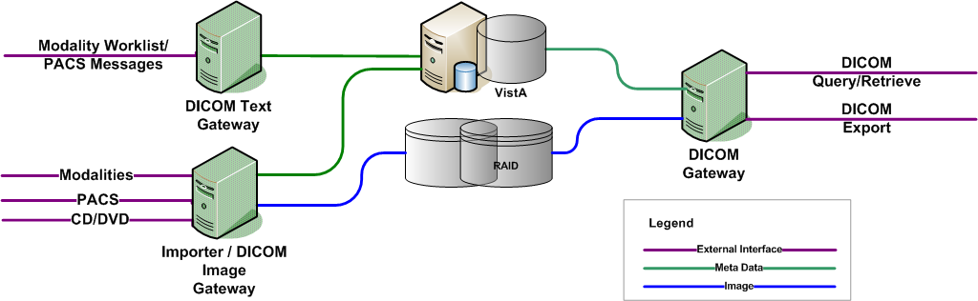

The software described in this document (the DICOM Gateway installation executable and the Java components) should be installed on all DICOM Gateways. Depending on the purpose of the gateway, several different configuration options can be used: Text Gateway, an Image Gateway, a Routing Processor, or any combination thereof. In addition, you can configure an Image Gateway to be an Importer. You can also enable the Query/Retrieve application on a gateway.

**Note**: You need a Laurel Bridge license to use the Importer and the Query/Retrieve functionality. You can use the same license if the Importer and Query/Retrieve are on the same computer.

In the diagram above, each computer has a dedicated function. It is possible to assign any combination of functions to any of these computers.

In theory, one computer could perform all tasks. In practice, however, it is much more efficient to assign specific tasks to specific computers. The typical configuration is one text gateway and one or more image gateways.

~~Load balancing modalities on DICOM Image Gateways is part art and part science. No more than one multi-image device (such as a CT or MRI) should be placed on a gateway since every image must go through the telnet session for processing images on the gateway. In addition to this, no more than six other single-image modalities like CR or US should be placed on the same DICOM Gateway.~~

## Networking Topology Options

The VistA Imaging Project needs Ethernet capabilities for testing equipment configurations that are being placed in the medical centers.

VistA DICOM Gateways may use either one or two networking interfaces, depending on whether the commercial DICOM devices are connected directly to the main network backbone or are located on separate physical networks.

## Commercial DICOM devices connected to Main Network Backbone

Some sites may choose to have all devices (workstations, main hospital computer, DICOM imaging producing equipment, etc.) connected to a single high-speed switched network backbone. In this case, the VistA Imaging DICOM Gateway will have a single network connection to the backbone (see Figure 1.4).

**Single High-Speed Switched Network**



**Figure 1.4**

## Commercial DICOM Devices on Separate Physical Networks

Other sites may choose to have a separate dedicated network for the commercial DICOM devices. In this case, the VistA Imaging DICOM Gateway should have two network interfaces: one to connect the main hospital network backbone; and the other to connect to the dedicated network for the commercial DICOM devices (see Figure 1.5).

**Separate Dedicated DICOM Network**



**Figure 1.5**

## Documentation Conventions

The following conventions are used in this manual.

| **Convention** | **Description** |
| --- | --- |
| **Bold type** | User keyboard entry. |
| **<Enter>** | Return key or Enter key. |
| **<Control+x>** | A keystroke that involves pressing the control-key, keeping it depressed, and then pressing another key. |
| <**SHIFT**> | Shift key. |
| <**ESC**> | Escape key. |
| <**Num Lock**> | Top left key on the numeric keypad (above the 7), may also be labeled Numeric Lock; this makes any keypad key activate the number shown on its surface; it is the equivalent of a SHIFT LOCK for alphabetic keys. |

# Pre-Initialization Instructions

## Hardware and Software Requirements

A site may have one or more PCs running the VistA Imaging DICOM Gateway software.

It is assumed that a network will be present with sufficient capacity to transport image files in a reasonable amount of time. See Appendix C for details about network set-up, which needs to be completed *before* any VistA Imaging DICOM Gateway computer can be installed.

The hardware requirements for each processor are the same.

* The PC should have enough memory (RAM) to run the operating system and 4 or more megabytes of VRAM. A 17-inch (or larger) color monitor should be used, configured to 1280 x 1024, true color. This configuration is identical to the one used for a “Clinical Workstation” (Higher resolution, 1600 x 1200, or dual monitors is even better, since it provides more screen space on the workstation and allows more windows to be visible at once).
* The DICOM Gateway software is approved to run on Windows 2003 servers based on VA Policies and Procedures, CLIN 3 support and VI NPO development office.
* Any disks that are permanently mounted on the system must be formatted using the NTFS format (the FAT format is no longer permitted at the VA).
* Caché Version 5.0.20 or newer.
* Symantec PC-Anywhere, Version 12.5 or newer.
* VA-Mandated, up-to-date, virus protection software.
* The installer needs local administrator privileges on any machine for the duration of the installation procedure.

It will usually take less than one hour to complete the entire installation process for one PC. Configuration and interfacing with DICOM devices will take additional time.

**Caution**: When performing an installation as an upgrade to an older installation of the VistA Imaging DICOM Gateway, review Appendix B.4 for details about master files that may need to be upgraded manually.

Instructions are provided in Appendix C for setting up the network between the various DICOM related processors and the VistA system.

Instructions for adding a “modality” are described in the VistA Imaging DICOM Gateway User Manual.

Instructions are provided in Appendix A for creating icons to start components of the Gateway software.

## VA Security Policy

VA Security Policy requires that on many computers, specific software be installed to ensure that the machines are running the most up-to-date virus protection software.

While it is acknowledged that any computer that is connected to the network must have adequate virus protection, software must not be installed on a medical device that causes it to reboot while it might be processing essential data.

As a result, it cannot be permitted that the VA’s SMS and EPO software be installed on any VistA DICOM Gateway.

Each site must appoint a person to be responsible for applying Microsoft updates to the DICOM Gateways when Microsoft makes mandatory patches (also known as “Critical Updates and Service Packs”) available. The easiest way to make this work is to enable the Automatic Updates feature in the Windows Control Panel, and to set this option to “Download the updates automatically and notify me when they are ready to be installed.”

The responsible person should check at least once per week as to whether any “critical updates” are available, and make certain that they are installed while the medical software is not active.

The virus protection software should be configured such that it automatically downloads and applies new updates for the virus definition files on a daily basis.

## Sequence of activities

See MAG*3.0*118 Planning and Installation Instructions

~~The correct sequence of activities for most patches is as follows:~~

1. ~~Perform KIDS install for any Kernel components (e.g., MUMPS-to-MUMPS Broker).~~
2. ~~Stop all C-Store processes; leave image processing running.~~
3. ~~Perform KIDS install for Imaging patch on VistA.~~
4. ~~Perform any updates to user accounts on VistA.~~
5. ~~Stop all gateway processes.~~
6. ~~Load Imaging patch on gateways.~~
7. ~~Configure gateways.~~
8. ~~Connect to VistA (using MUMPS-to-MUMPS Broker).~~
9. ~~Test user accounts.~~
10. ~~Start regular gateway processing.~~

## Master Files and Software Required to Run the DICOM Gateway

Software for the VistA Imaging DICOM Gateway is distributed as a single executable file. This file performs an installation using the tool-set from InstallShield. This file may be downloaded from the Imaging FTP server.

When the installation process is completed, all software for the VistA Imaging DICOM Gateway will be installed, and the documentation will be copied onto the end user’s computer.

When a patch contains components that reside on a DICOM Gateway as well as components that reside inside the VistA Hospital Information System, the distribution will include a VA-Kernel KIDS file, as well as an InstallShield set-up executable.

**Note:** It is recommended that users copy the install file to a local hard drive on the machine before starting.

## System Configuration and Global Placement

Some global variables are local to the DICOM Gateway, while others are maintained on the VistA system. The global variables that reside on the VistA system are:

|  |  |  |
| --- | --- | --- |
| **Name** | **Initial Size [MB]** | **Growth** |
| ^MAGD | 0.1 | Does not grow beyond 0.5 MB |
| ^MAGDAUDT | 0 | 1 MB per 250,000 studies |
| ^MAGDHL7 | 0[1] | Should be purged when size exceeds 5 MB |
| ^MAGDOUTP | 0 | Does not grow beyond 0.5 MB |

**^MAGD** is for the legacy “DICOM Correct” application, the MAG*3.0*53 Importer and error handling procedures. It contains information about every image file that fails a patient and study lookup on the main system. When manual corrections are made, the entries are deleted from ^MAGD, so it does not continually grow.

**^MAGDAUDT** counts the number of different types of messages per day, as well as the number of images acquired from each instrument.

**^MAGDHL7** contains all of the HL7 messages passed from the HIS/RIS to the DICOM Gateway. The data in it can be periodically deleted, so that it will plateau to some maximum size and then be trimmed back.

**^MAGDOUTP** contains the requests for DICOM Image transmission from VistA to a remote Application Entity. Since the requests are deleted after being satisfied, the global remains very small.

**Note**: The global variables ^MAGDHL7 and ^MAGDWLST will be created as the system is being used, ^MAGDHL7 on the main VistA System, and ^MAGDWLST on the VistA DICOM Text Gateway System.

## Resources (unique or unusual) Required for Software Product

The VistA Imaging DICOM Gateway will require a high-speed network capability. Storage of acquired images will require a multi-gigabyte storage capability (typically a juke-box).

## Sizing Considerations

A typical installation uses about 300MB of disk space for the Caché system and the various supporting files. As images are acquired, disk space will be used temporarily, until the images have been processed by the DICOM Gateway application, and moved to their permanent storage. When a site acquires a new modality and images cannot be processed until parameters are set up properly to support that modality, the temporary image storage may grow to several gigabytes.

## Recommendations for Software Installation and Testing

The installation procedure described in the following chapters involves the following steps.

### For an “initial” installation

To install the VistA Imaging DICOM Gateway on a new PC, perform the following steps:

1. Create a number of files and directories on the target system.
2. Create a number of icons on the target system.
3. Create Caché environment.
4. Establish master files containing site-specific information (lists of modalities, instruments, port numbers, and so forth).
5. Load master file information into Caché database.
6. ~~Create icons for the various instruments.~~
7. Establish Caché logon security.

Steps 1 through 6 above are described in Chapter 3; steps 7 through 9 are described in Chapter 4. Most of these steps can be executed in an automated fashion using the scripts from Chapter 3.

### For an “upgrade” installation

Reference the MAG*3.0*118 Planning and Installation Instructions.

~~Perform the following steps to upgrade an old version of the VistA Imaging DICOM Gateway to the current revision:~~

1. ~~Upgrade application software to current version.~~
2. ~~Modify master files containing site-specific information to reflect all parameters that are required by the current version of the software.~~
3. ~~Load master file information into Caché.~~
4. ~~Create icons for any new instruments in the upgraded setup.~~

**~~Note~~**~~: Step 1 is described in Chapter 1; steps 2 through 4 are described in Chapter 4.~~

### Software to be installed in the main VistA System

In addition to software to be installed on the PCs, there is also software to be installed in the main VistA system. This installation procedure is described in Chapter 1.

# 

# Installing the VistA Imaging DICOM Gateway

This chapter provides instructions for installing the MAG*3.0*99 DICOM Gateway, which is a prerequisite to install the MAG*3.0*123 DICOM Gateway.

If you are installing the MAG*3.0*123 DICOM Gateway or upgrading to the MAG*3.0*123 DICOM Gateway at a US Department of Veterans Affairs (VA) site, please install the MAG*3.0*99 DICOM using the instructions in this chapter. Then, install the MAG*3.0*123 DICOM Gateway using the instructions in *Section 3.6 Installing the MAG*3.0*123 DICOM Gateway*.

If you are installing the MAG*3.0*123 DICOM Gateway or upgrading to the MAG*3.0*123 DICOM Gateway at an Indian Health Services (IHS) site, please use the instructions for installing the MAG*3.0*123 at IHS sites in the *MAG*3.0*123 Patch Description*.

## Prerequisites for Getting Started

1. Windows operating system is installed on the target computer.
2. Suitable up-to-date virus protection software has been installed.
3. See MAG*3.0*118 Planning and Installation Instructions
4. ~~The VistA Imaging KIDS package must be installed. See the~~ *~~VistA Imaging Installation Guide~~* ~~for details.~~
5. ~~The DICOM Gateway installation *.exe file has been downloaded from the Imaging FTP server and is placed on the C:\ drive of the target computer.~~
6. ~~Local administrator rights to the target computer (not domain admin user rights).~~
7. ~~If either the image directory or the master files directory will reside on network drives, these drives should be mapped consistently on the target computer (with the same drive letters).~~

## Setting Up the Operating Environment

The following steps will generally make the use of the system easier.

1. Complete the installation of Microsoft Windows and Internet Explorer.
2. Apply the latest approved Service Packs for Microsoft Windows operating system and Internet Explorer.
3. The system should be a member of the VISN domain, **VHAxx**, where **xx** represents the two numbers that identify the site VISN.
4. When VistA Imaging is first installed, a user is created in the master domain (the VISN’s domain) named VHAvv\VHAxxxIA, where xxx are the three letters that identify the site and vv is the identification of the VISN (usually two digits). If this user is not yet set up, see the VistA Imaging Install Guide for details on creating this user.
5. On the VistA workstations, add the global group **VHAvv\VHAxxxIA** to the local **Administrators** group.
6. Configure the Network Interface Cards (NICs) for usage through TCP/IP. **Do not** use Microsoft’s DHCP to assign any addresses. For each system, hard-code a specific IP address and a default gateway address.
7. Make sure that the WINS/DNS information is defined according to the VA’s national mandates. Contact your local LAN Administrator with any questions about the settings.
8. If a local Domain Name Server (DNS) system is being used, make sure this local DNS is the first DNS server in the list.
9. From this point forward, login as **VHAvv\VHAxxxIA** to perform the rest of the installation.

**Note:** Any changes to the desktop are made only for the current account. If specific changes to the desktop are also needed for user accounts, first complete the installation. Then log in into the desired user accounts and make the desired changes in those accounts.

1. Install either **Dameware** or **PCAnywhere** and set up the selected remote control application to use TCP/IP for its communication.
2. Follow the instructions published on <http://vaww.cis.va.gov/Pages/default.aspx> to set up **Dameware** and/or **PCAnywhere** according to the latest VA policies.
3. If any new disk-drives are installed, they must be formatted using the NTFS format.

## Map a Network Drive for Dictionary Files

When only a single computer is to be installed at a site and this computer will perform all DICOM Gateway tasks, this step may be skipped. However, in a networked configuration with multiple DICOM Gateways, it is usually beneficial to use a shared drive to store the dictionary files and master files, so that all processors on the network can share the same resources. This will also make future maintenance a lot easier. In the examples throughout this manual, the assumption is made that the “dictionary drive” is mapped as drive “**F:**”.

## Installing the Software

**Before you install the DICOM Gateway:**

* Check to ensure the logon user has a \Documents and Settings\[Administrator]\Local Settings\Temp folder.
* ~~Review the Patch Description for patch-specific instructions, particularly if you are updating the DICOM Gateway software.~~
* Review the MAG*3.0*118 Planning and Installation Instructions along with all reference documentation. The planning information must be completed and submitted for approved prior to starting the installation.

**If you are updating the DICOM Gateway, perform these steps before you start the installation:**

1. Back up your master (.dic) files.

**Note**: The installation will not overwrite site-configurable master files.

1. Log into the computer on which the DICOM Gateway is installed as a local administrator.
2. Run option 4-2-1.

4 - System Maintenance

2 – Gateway Configuration and DICOM Master Files

1 – Display Gateway Configuration Parameters

1. Review the general setup of the DICOM Gateway (number of text data directories, mapped drives for components such as dictionary files, and so on.) and record the location of these directories here:

* The local directory for images queued for processing  
  IMAGE INPUT PATH =…………………………………………………………………….
* The local directory for images that have been processed   
  IMAGE OUTPUT PATH =………………………………………………………………….
* The directory for data dictionaries  
  DICT PATH =……………………………………............................................……………..

1. If the dictionary files are on a network drive, make sure that the network drive is mapped to the computer on which you run the installation and that the location matches the location that you recorded in step 4 previously
2. If you are updating the DICOM Gateway, ensure that Caché is running by checking the Windows taskbar and ensuring that the Caché cube is blue. (Version information on the DICOM Gateway can only be updated if Caché is running.)
3. If you are updating the DICOM Gateway and if you have not already done so, for each active menu process/telnet window on the Gateway:

* Stop the process (use CTRL+C if needed). (Clicking only closes the window; it does not stop the process.)
* Navigate to the main DICOM Gateway menu and enter 5 (Quit).

1. ~~Copy the MAG3_0P99_DICOM_SetUp.exe file to the C: drive on the DICOM Gateway that you are upgrading.~~

**To install the DICOM Gateway:**

Reference the MAG*3.0*118 Planning and Installation Instructions

~~The DICOM Gateway installation *.exe file should be on the C:\drive of the target computer (which includes its desktop).~~

1. ~~If you have not already done so, log in as local administrator (not domain admin user).~~

1. ~~Double-click MAG3_0P99_DICOM_SetUp.exe to start the InstallShield wizard, and wait until the installation procedure is extracted. This may take a few minutes.~~

**~~Important~~**~~: While the InstallShield wizard extracts the installation procedure, the Preparing to Install window, illustrated in the following image displays. Do not press any buttons while this window is displayed. The progress bar will advance at an irregular rate and may pause for extended periods.~~

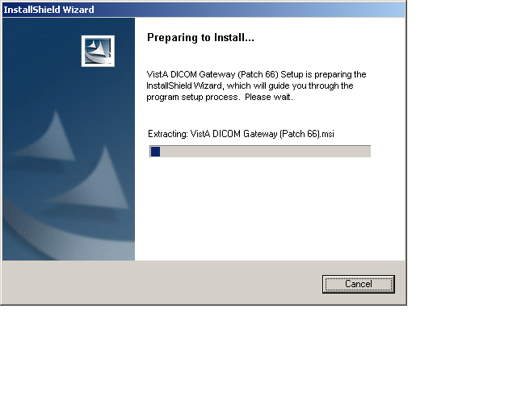

1. ~~When the Welcome dialog box displays, click~~ **~~Next~~**~~. (If you are updating from another patch, the Welcome dialog box displays after the Text Data Directories dialog box).~~

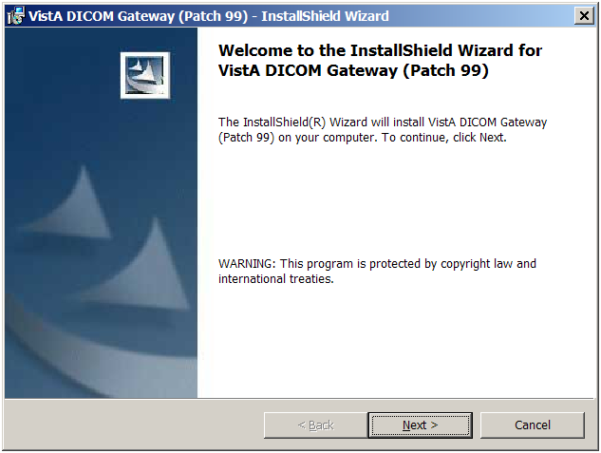

1. ~~In the License Agreement dialog box displays, review the terms of the license agreement, click~~ **~~I accept the terms of this license agreement~~**~~, and then click~~ **~~Next~~**~~.~~

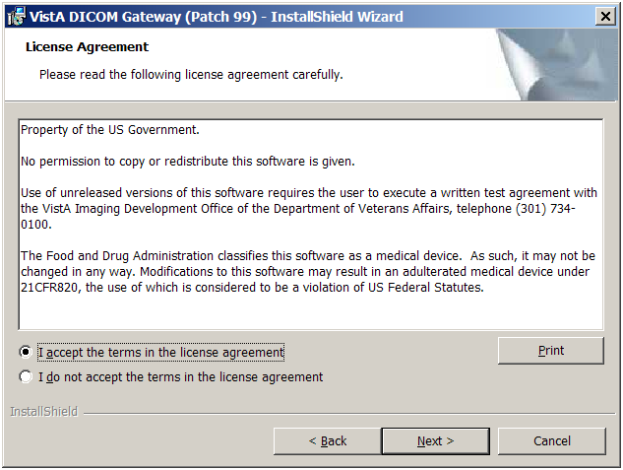

~~If you are installing the DICOM Gateway for the first time, the Text Data Directories dialog box displays after the License Agreement dialog box. If you are updating the DICOM Gateway software, the Text Data Directories dialog box displays before the Welcome dialog box.~~

1. ~~When the Text Data Directories dialog box displays, verify that the correct number of Text Data Directories is indicated. Then click~~ **~~Next~~**~~.~~

~~On systems that are already functioning as Text Gateways, the proper number of data directories will be detected automatically. For most other systems, you can use the default number –~~ **~~2 (Two)~~**~~.~~

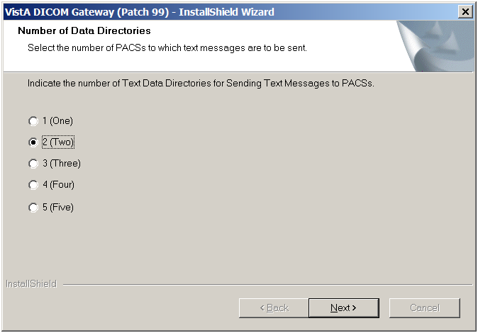

1. ~~When InstallShield prompts you to specify the destination folder (the folder in which the DICOM Gateway is installed), make sure that the installation program is pointing to the~~ **~~C:\~~** ~~drive (local system drive). The installation will likely fail if you choose an alternate path.~~

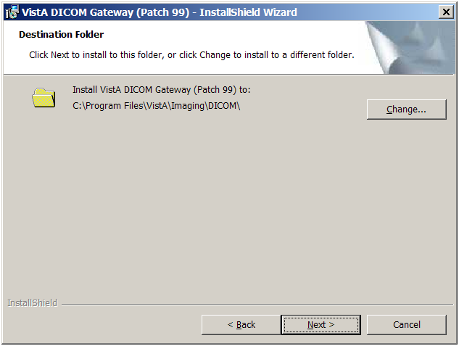

1. ~~In the Setup Type dialog box, if you are upgrading the DICOM Gateway, choose~~ **~~Custom~~**~~. If you are installing a new DICOM Gateway, choose either~~ **~~Custom~~** ~~or~~ **~~Complete~~** ~~setup, depending on your needs. Then, click~~ **~~Next~~**~~.~~
2. ~~The~~ **~~Custom~~** ~~setup allows you to change the default location of the folders for the images (Image_Data) and the dictionary files (DICOM_Dictionaries). This is convenient if you want the images to be stored on a different drive (not the default, which is C). You must use the~~ **~~Custom~~** ~~option if you want the dictionary files to be installed on a network drive. If you choose~~ **~~Custom~~**~~, continue with step~~8~~.~~
3. ~~If you choose the~~ **~~Complete~~** ~~setup, you will not be able to change the default location (C:\DICOM\) for the folders for the images and the dictionary files. If you choose~~ **~~Complete~~**~~, continue with step 11.~~

**~~Important~~**~~: If you are upgrading from another patch and your dictionary files reside on another drive (not in the default location C:\DICOM\), you must use the~~ **~~Custom~~** ~~setup and configure the dictionary files and the image processing directory to be installed in the location you recorded when you ran 4-2-1 before you started the installation. If you use the~~ **~~Complete~~** ~~setup, your dictionary files will be installed in the default location and the DICOM Gateway may not operate as expected.~~

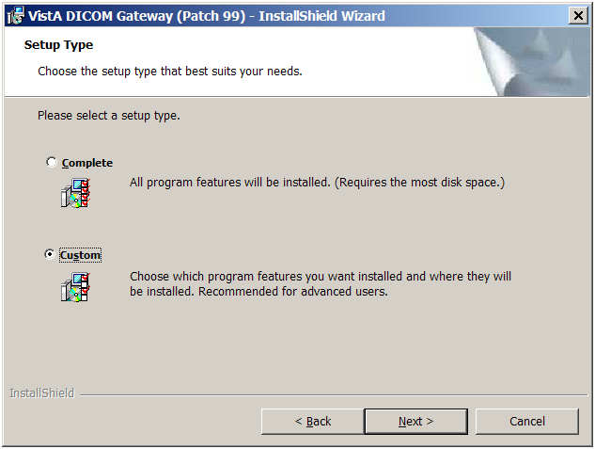

~~If you selected the Custom setup type, the Custom Setup dialog box displays.~~

1. ~~In the Custom Setup dialog box, click each item (not the icon, but the actual item name) in the list and verify that the~~ **~~Install To~~** ~~area shows the correct folder for the installation. You must do this for both Image_Data (the image directory), and DICOM_Dictionaries (the master file directory). If you need to change the location of these directories, click~~ **~~Change~~** ~~and then use the dialog box that displays to select the appropriate location.~~

~~In a typical installation, DICOM_Dictionaries is installed in the \DICOM\Dict directory on a network drive and Image_Data is installed on the C: drive. The installation process does not overwrite site-configurable master files.~~

~~For site configurable master files, like AE_Title.dic, the installation first copies the matching sample file (AE_Title.Sample in this example) to the master files directory. If the master file does not already exist, the installation renames the sample file and makes it a master file. In the example, it will rename AE_Title.Sample to AE_Title.dic. If the master file exists, the installation keeps the sample file in the master files directory for reference.~~

~~Site-configurable master files include: AE_Title, Instrument, Modality, Portlist, Route, SCU_List, and Worklist.~~

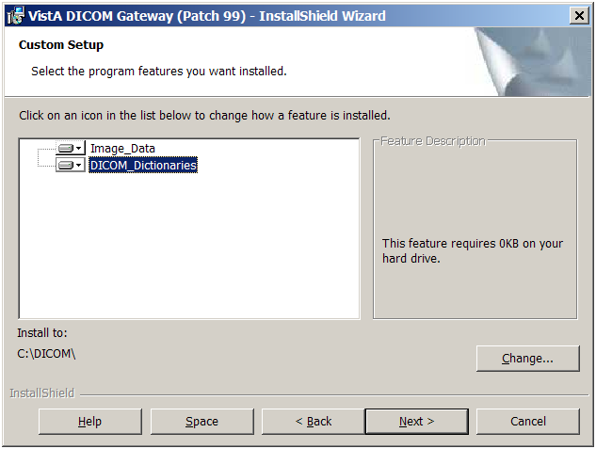

1. ~~Click the names of all components to verify that they are set to be installed onto the correct disk drive.~~

**~~Important~~**~~: The values of the image processing directory and the data dictionary directory must match the values you recorded before you started the installation.~~

**~~Note~~**~~: For the location of Image Data and DICOM Dictionaries, you must use the format: [drive-letter]: \DICOM\, where [drive-letter is the letter of the drive on which the directory resides. For example, F:\DICOM\.~~

1. ~~After verifying that all components are set to be installed in their appropriate destinations, click~~ **~~Next~~** ~~in the Custom Setup dialog box.~~
2. ~~If you want to change any of the installation settings or if you are not sure about the value of a parameter, click~~ **~~Back~~** ~~to go back to the window where that setting may be modified. Otherwise, click~~ **~~Install~~** ~~to begin the installation process.~~

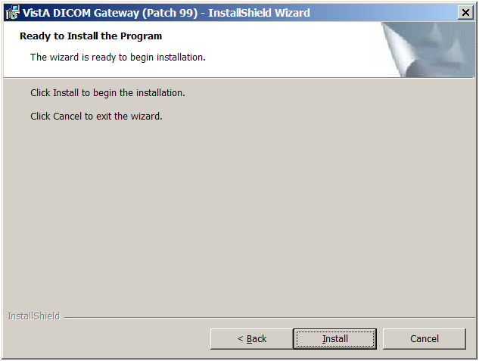

~~While the installation is proceeding, the status of the installer will be displayed in a progress window. Do not click any buttons while this window is visible (the only button available is~~ **~~Cancel~~**~~, and clicking it will discontinue the installation).~~

~~As the installer works its way through the various installation steps, the progress-bar will fill up. The total duration of the installation may vary from about a minute (newer, faster computer) to about 10 minutes (older, slower computer).~~

1. ~~If this is the first installation of the DICOM Gateway software, the installation will proceed without any further questions. If a database from a previous instance of the DICOM Gateway software is still present, the following window will appear.~~

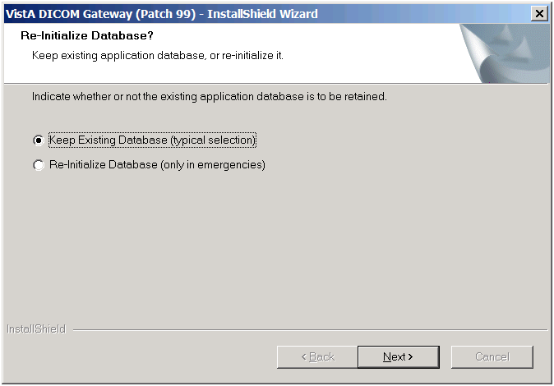

1. ~~Choose the setting you want to use. The options are:~~

* **~~Keep Existing Database (typical selection.~~**~~We strongly recommend you use this setting. Typically, you would keep the existing database, so that any existing data will remain after the installation is complete.~~
* **~~Re-Initialize Database (only in emergencies)~~**~~However, if incorrect information has been entered in the database and it is no longer clear whether the database contains information that allows the DICOM Gateway to run properly, you may opt to discard the existing database and start with a fresh one.~~

1. ~~Click~~ **~~Next~~** ~~to continue.~~

~~As the installation proceeds, several message boxes, will pop up and disappear, such as:~~

~~, , , , or~~

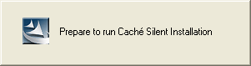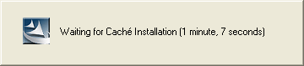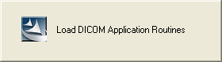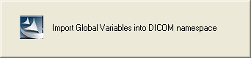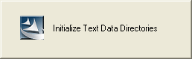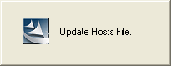

~~These boxes indicate the progress of the installation, and you do not need to do anything while these message boxes are visible.~~

~~When the installation is complete, the last window displays.~~

1. ~~Click~~ **~~Finish~~** ~~to complete the installation of the new DICOM Gateway software.~~

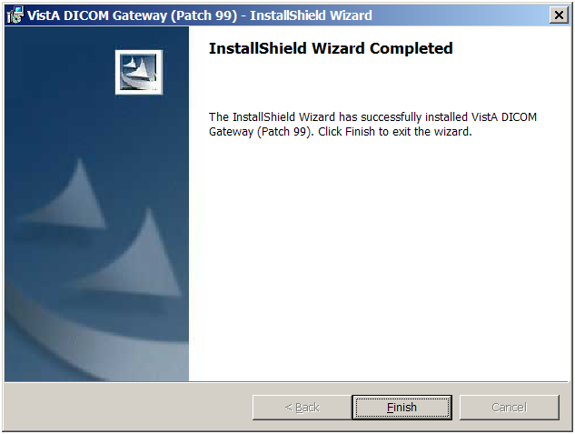

~~In some cases, there may be additional tasks that you must perform. In this scenario, a message box will be displayed that indicates the remaining installation steps:~~

* ~~Install a valid Caché license  
  While an installation can be performed without a valid license on the computer, the application can be used only after a valid license is installed. The directory for installing a Caché license is~~ **~~\CachéSys\Mgr~~**~~.~~
* ~~Reinitialize all DICOM master files (dictionary files)  
  On an upgrade-installation, the master files are updated automatically. Since this action can be performed only after the connection parameters for the VistA Hospital Information system have been entered, an initial installation cannot perform this step automatically.~~
* ~~If you are installing~~ **~~a new DICOM Gateway~~**~~, run the Java installer.~~

**~~Important~~**~~: If you are upgrading the DICOM Gateway, do NOT run the Java installer (the file~~ **~~JavaInstallEngine.bat~~** ~~that the installation places on the desktop).~~

* ~~Update Gateway configuration parameters.~~

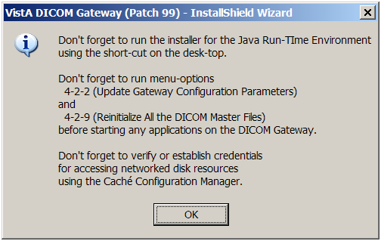

~~When an informational message like this appears, click~~ **~~OK~~**~~, and carry out the actions mentioned in the message.~~

**~~Do the following on the updated Gateway to complete the installation and setup process:~~**

1. ~~Run option 4-1-4 and compare the output to the output in the patch description.~~
2. ~~Run option 4-2-2 and verify that all configuration settings have been retained. Make sure the values match the values you recorded when you ran option 4-2-1 before starting the installation.~~
3. ~~Run option 4-2-9 to reload all .dic (dictionary) files into the local gateway database.~~
4. ~~Run option 4-2-12. This option reports information that other applications need.~~
5. ~~Restore these files, which you backed up before starting the installation, to their original locations:~~
   1. ~~\DICOM\Java\jaas.config~~
   2. ~~\DICOM\Java\application.properties~~
   3. ~~\DICOM\Java\LoggingConfig.xml~~
   4. ~~\DCF_Runtime\cfg\dicom\ext_data_dictionary~~
   5. ~~\DCF_Runtime\cfg\apps\defaults\Listen.~~
6. ~~Start all normal processes on the updated DICOM Gateway~~**~~.~~**

## ~~Modifying or Repairing an Existing Installation~~

~~The steps to modify or repair a DICOM Gateway installation are similar to performing an initial installation. You start the DICOM Gateway installer by double-clicking on the distribution file.~~

**~~Note:~~** ~~For steps describing how to update to a newly released version (patch) of the DICOM Gateway, refer to the appropriate Patch Description.~~

1. ~~Double-click MAG3_0P99_DICOM_SetUp.exe to start the InstallShield wizard.~~
2. ~~Follow the instructions on your screen to page through the InstallShield wizard.~~
3. ~~When the Welcome dialog box displays, click~~ **~~Next~~** ~~to proceed.~~



1. ~~In the Program Maintenance dialog box that displays, select the option that meets your needs.~~ 
   * ~~Typically, you would select~~ **~~Repair~~**~~. This option lets you reinstall the DICOM Gateway software and get correct copies of any component-files that may have been corrupted.~~
   * ~~You can also select~~ **~~Modify~~** ~~to add features that were omitted during a previous installation or to remove features that are no longer needed. If you choose this option and click Next, the Custom Setup dialog box will display.~~
   * ~~When the~~ **~~Remove~~** ~~option is selected, all features of the VistA Imaging DICOM Gateway will be removed (~~**~~un~~**~~-installed).~~

**~~Note~~**~~: If you uninstall the DICOM Gateway, all application-related files will be removed. To remove the Caché system as well, use the~~ **~~Add/Remove Programs~~** ~~function from the Microsoft Windows Control Panel.~~

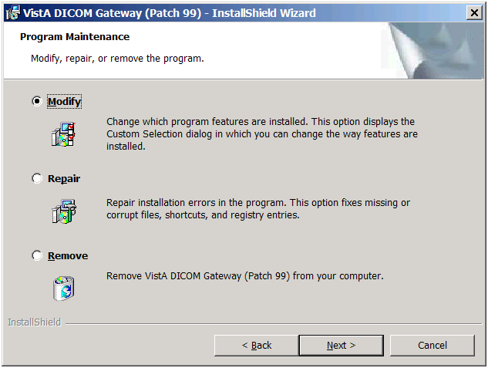

1. ~~After selecting the installation settings you want to modify, follow the instructions on your screen to complete the process.~~

## ~~Running the Java Installer~~

~~You must run the Java installer, which installs the Java components that the Importer and the Query/Retrieve application use. If the Java components are already installed, skip this step.~~

~~To run the Java installer:~~

1. ~~Open the Add or Remove Programs dialog (click~~ **~~Start | Control Panel~~**~~).~~
2. ~~Make sure there are no other versions of the Java Runtime Environment present; if other versions are present, uninstall them.~~
3. ~~On the desktop, double-click the JavaInstallEngines.bat file. This is a batch file that will run through three short installations, which will install the Java components. The file is sometimes paced on the desktop when you install the DICOM Gateway.~~
4. ~~Launch the batch file and follow the prompts on your screen to install Java.~~

~~When you launch the batch file, a command window displays. It does not require any action on your part.~~

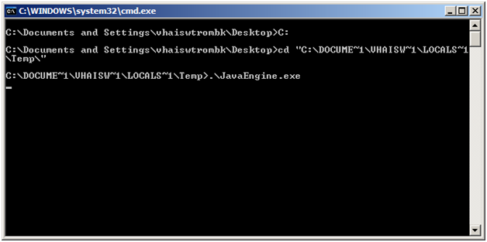

1. ~~When the Java installation wizard displays, follow the prompts on your screen to install the Java Engine. Accept the defaults throughout the installation process.~~
2. ~~Click~~ **~~Accept~~** ~~in the Welcome screen, to start the installation.~~

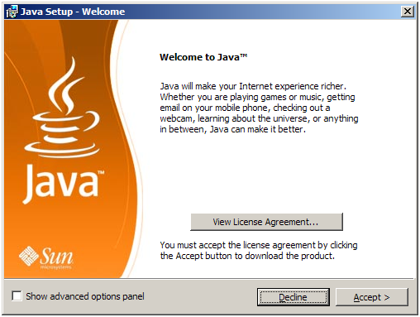

1. ~~Click~~ **~~Finish~~** ~~in the last screen to complete the Java installation process.~~

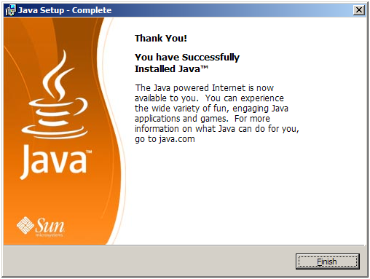

1. ~~Install Java Advanced Imaging I/O Tools 1.1 for JRE – this will automatically start when the Java installation has finished. Proceed with the installation and accept all of the default answers.~~

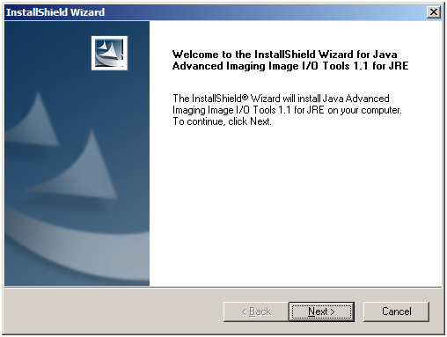

1. ~~Install Java Advanced Imaging 1.1.3 for JRE. This installation will automatically begin once Java Advanced Imaging I/O Tools 1.1 for JRE has completed. Proceed with the installation and accept all of the default answers.~~

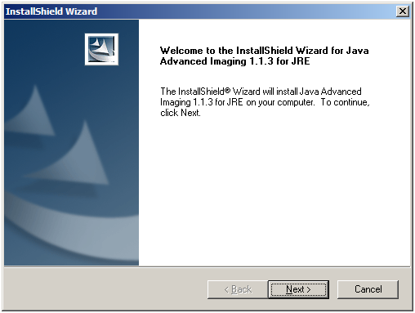

1. ~~Disable the Java Update Agent:~~
   1. ~~Open the Windows Control Panel (~~**~~Start | Control Panel~~**~~).~~
   2. ~~In the window, click the~~ **~~Java~~** ~~icon.~~
   3. ~~In the Java Control Panel dialog box, click the~~ **~~Update~~** ~~tab.~~
   4. ~~Clear the~~ **~~Check for Updates Automatically~~** ~~check box, and when the Warning dialog displays, click~~ **~~Never Check~~**~~.~~
   5. ~~Click~~ **~~OK~~**~~.~~
2. ~~Delete the JavaInstallEngines.bat file from the desktop.~~
3. ~~If you want to use the Importer, the Query/Retrieve application, install Laurel Bridge DICOM Server Runtime license. For information about the license and the procedure, see~~ *~~3.7 Laurel Bridge DICOM Server Runtime License Setup~~*~~.~~

## 3.6 Installing the MAG*3.0*123 DICOM Gateway (new)

**Before you install the DICOM Gateway:**

* Check to ensure the logon user has a \Documents and Settings\[Administrator]\Local Settings\Temp folder.
* Review the patch description for patch-specific instructions, particularly if you are updating the DICOM Gateway software.

**If you are updating the DICOM Gateway, perform these steps before you start the installation:**

1. Log into the computer on which the DICOM Gateway is installed as a local administrator.
2. If you are updating the DICOM Gateway, ensure that Caché is running by checking the Windows taskbar and ensuring that the Caché cube is blue. (Version information on the DICOM Gateway can only be updated if Caché is running.)



1. If you are updating the DICOM Gateway and if you have not already done so, for each active menu process/telnet window on the Gateway:
   * Stop the process (use CTRL+C if needed). (Clicking only closes the window; it does not stop the process.)



* + Navigate to the main DICOM Gateway menu and enter **5** (Quit).

1. Copy the MAG3_0P123_DICOM_SetUp.exe file to the **C:** drive on the DICOM Gateway that you are upgrading.

**To install the DICOM Gateway:**

The DICOM Gateway installation *.exe file should be on the **C:\**drive of the target computer (which includes its desktop).

**Note**: Make sure that the MAG*3.0*99 DICOM Gateway is installed before you begin the MAG*3.0*123 DICOM Gateway installation. The MAG*3.0*123 DICOM Gateway is a partial Gateway installation and must be installed on top of the MAG*3.0*99 DICOM Gateway.

1. Double-click MAG3_0P123_DICOM_SetUp.exe to start the InstallShield wizard, and wait until the installation procedure is extracted. This may take a few minutes.

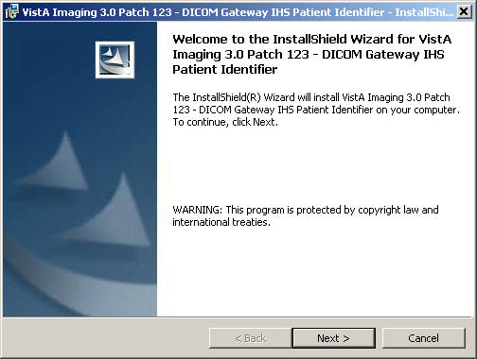

1. In the Customer Information screen, type your name in the **User Name** field and the name of your organization in the **Organization** field.

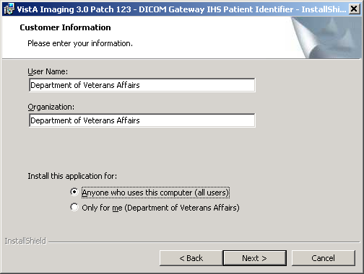

1. Click **Next** to continue.
2. In the Setup Type dialog box, accept the default selection, **Complete**. Then, click **Next**.

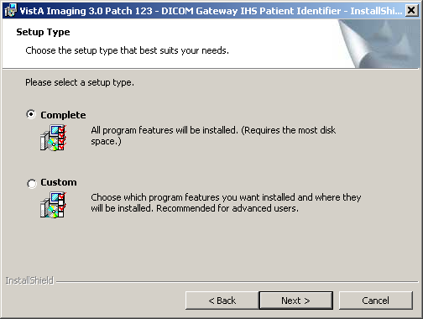

1. In the Ready to Install the Program screen that displays, click **Install**.

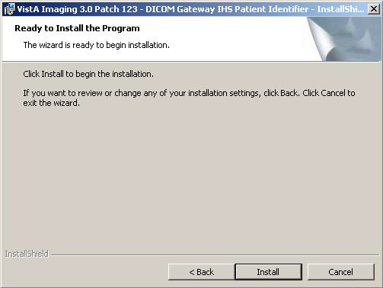

While the installation is proceeding, the status of the installer will be displayed in a progress window. Do not click any buttons while this window is visible (the only button available is **Cancel**, and clicking it will discontinue the installation).

As the installer works its way through the various installation steps, the progress-bar will fill up. The total duration of the installation may vary from about a minute (newer, faster computer) to about 10 minutes (older, slower computer).

When the installation is complete, the last window displays.

1. Click **Finish** to complete the installation of the new DICOM Gateway software.

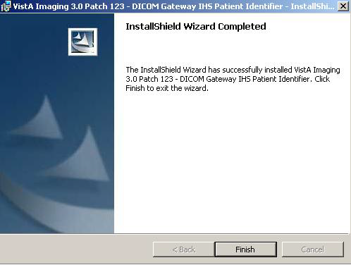

**Do the following on the updated Gateway to complete the installation and setup process:**

1. Run option 4-2-2 and verify that all configuration settings have been retained.
2. When prompted, specify whether the DICOM Gateway is installed at a Department of Veterans Affairs (VA) site or an Indian Health Services (IHS) site.

* For VA sites, press Enter to accept the default, **V**.
* For IHS sites, type **I** and press Enter.

Is this gateway installed in VA (V)or IHS (I)? V//

1. Start all normal processes on the updated DICOM Gateway**.**

## ~~Laurel Bridge DICOM Server Runtime License Setup~~

### ~~How the License Works~~

~~You must obtain a license key for the Laurel Bridge DCF Local Server Run-time DICOM software to use the Importer application or the Query/Retrieve application.~~

~~Each computer on requires a separate license. If the computer already has a license installed, there is no need to obtain a new one. Because the license is keyed to the computer’s MAC address, the license cannot be transferred from one computer to another. As a result, the Laurel Bridge software will no longer function if the network card or if the entire computer is replaced. In these situations, Laurel Bridge needs to be contacted in order to a transfer the license to the new system and get a new key.~~

**~~Note~~**~~: The Laurel Bridge DCF Local Server Run-time DICOM software is installed in C:\DCF_Runtime.~~

### ~~Installing the License~~

1. ~~After obtaining the license, download the license key using the instructions provided by Laurel Bridge.~~
2. ~~On the DICOM Gateway on which you want to use the Importer or the Query/Retrieve application, choose~~ **~~Start | All Programs | VistA Imaging Programs | DICOM | QueryRetrieve | Install RunTime License~~**~~.~~

**~~Note~~**~~: If the MAG*3.0*53 was installed on the computer and if the Importer is enabled on the computer, you will have the menu option~~ **~~Start | All Programs | VistA Imaging Programs | DICOM | Laurel Bridge | Install RunTime License~~**~~.~~

1. ~~In the Laurel Bridge DICOM Toolkit License Installer dialog box, click~~ **~~Browse~~**~~.~~
2. ~~In the File Open dialog box, navigate to where the license is stored, select the license file, then click~~ **~~Open~~**~~.~~
3. ~~In the Laurel Bridge DICOM Toolkit License Installer dialog box, click~~ **~~Load~~**~~.~~
4. ~~In the CMD shell, at the~~ **~~C:\>~~** ~~prompt, type~~ **~~dcf_info –C~~**~~. You should get a “valid” license response, as illustrated:~~

~~C:\>dcf_info -C~~

~~valid~~

~~Licensed version - Expires in 0 days.~~

~~C:\>~~

## Further Set-Up

Further set-up and configuration of the VistA Imaging DICOM Gateway is divided into two areas:

* Configuration of the Caché system
* Configuration of the VistA Imaging DICOM Gateway application

Cache and DICOM Gateway configuration are described in the following sections. After performing these steps, which are required only for initial setup, you can enable additional applications, such as the Importer and Query/Retrieve.

~~If you plan to implement the optional Query/Retrieve application or the Importer, you may also need to:~~

* ~~Perform additional setup. See~~ *~~Appendix I Importer Setup~~* ~~and~~ When all is said and done, the decision should be the clinicians, not the development teams.~~for details.~~
* ~~Obtain a Laurel Bridge DICOM Server Runtime License. See~~ *~~Laurel Bridge DICOM Server Runtime License Setup~~* ~~for details.~~
* ~~Install the Java Engine. See~~ When all is said and done, the decision should be the clinicians, not the development teams.~~for details.~~

### Configuring the Caché System

For the configuration of the Caché system, there is an icon in the system tray (usually located on the lower right side of the display) that gives access to the various management functions in Caché. This icon is usually called the “Caché Cube.”

When Caché is inactive, this icon is grey:



When Caché is active, this icon is blue:



Click this icon to show the menu for manipulating the Caché system; e.g., to start Caché, right-click the grey cube and select “**Start Caché**”:

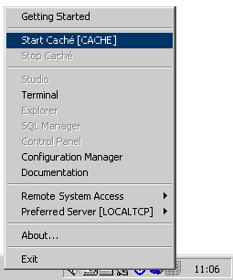 **→** 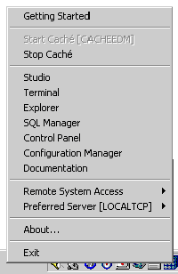

**Note**: Once Caché is started, the icon will change from grey to blue, and the selection of available menu options will change.

**Note**: Once Caché has been installed using the automated procedure shown in the previous sections, it will start automatically each time the computer is re-booted. Under normal circumstances, the end user will not have to take action to start or stop the Caché system. Additional processes, such as listener and telnet sessions, must be started to make the gateway fully operational.

The various options related to configuration of the Caché system are described in the documentation that comes with the Caché system and are provided through the menu that is shown above. Some configuration options are accessed through the menu option labeled **Configuration Manager**; some options are accessed through the menu option labeled **Control Panel** (grayed-out on the menu shown, this menu option is accessible only when Caché is running).

**Note**: Printed documentation about Caché is available through its vendor (InterSystems Corp.). The menu option labeled **Documentation** (see above) provides a searchable online version of all information that is available in printed form.

### Configuration of the VistA Imaging DICOM Gateway Application

Configuration of the VistA Imaging DICOM Gateway Application is performed using the menu options in the VistA Imaging DICOM Gateway application itself. The most important parameters are maintained using menu option **4-2-2** (Update Gateway Configuration Parameters), described later in this document.

Gateway Configuration and DICOM Master Files

1 Display Gateway Configuration Parameters

2 Update Gateway Configuration Parameters

3 Update AETITLE.DIC

4 Update INSTRUMENT.DIC

5 Update MODALITY.DIC

6 Update PORTLIST.DIC

7 Update SCU_LIST.DIC

8 Update WORKLIST.DIC

9 Reinitialize All the DICOM Master Files

10 Create Shortcuts for Instruments

11 Validate Access/Verify Codes for Modality Worklist

12 Display Versions and/or Time Stamps of Components

## Creating a Caché License

Licenses for Caché may be provided in a number of ways. If a license is provided in the form of a file, all that is needed is to copy that file into the x:\CacheSys\mgr directory, where x represents the disk on which Caché is installed.

E.g. If a license is received as an attachment to an e-mail message, save the attachment in the appropriate directory:

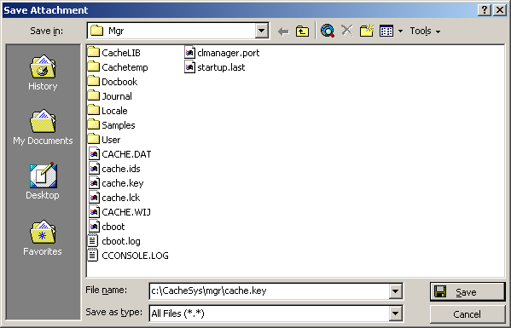

If the license information was received in a different format, use the Caché License Manager Wizard to enter the license.

To start the License Manager Wizard, right-click the Caché Cube (either blue or grey). Select **Configuration Manager**.

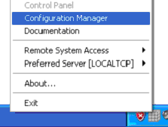 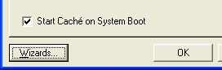

When the window for the Configuration Manager appears, click the **Wizards** button (left lower corner).

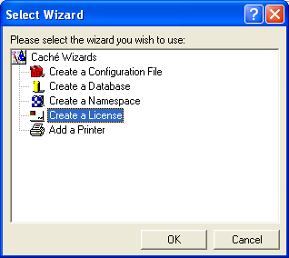

In the next window that pops up, select the line labeled “Create a License” and then click the **OK** button. The window for the actual data entry will appear:

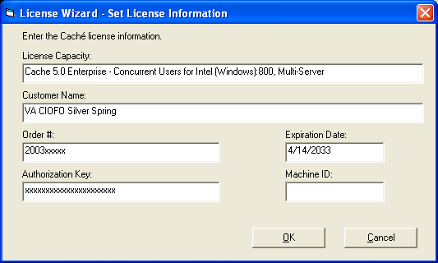

Fill in all fields as appropriate, and then click the **OK** button.

After the window has closed, click the **OK** button in the Configuration Manager window.

## Security Issues

This section highlights some general issues that are relevant during the installation of the VistA Imaging DICOM Gateway software. Detailed information about security issues related to the VistA Imaging DICOM Gateway is documented in the VistA Imaging Security Manual.

### Application-Related Passwords

To set up definitions for application-related passwords for the VistA Imaging DICOM Gateway, first start up Caché (if necessary) and then click the (blue) Caché Cube. Select **Terminal**.

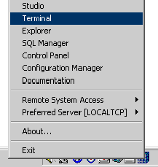

A new window will open. This “console” window will provide direct (programmer’s) access to the Caché environment that supports the VistA Imaging DICOM Gateway.

**Note 1:** In the sample text below, the text “**password**” appears several times. For each instance, use a site-specific password that is appropriate. Passwords must be six or more characters in length and must consist of a combination of letters and numbers. Passwords are not case-insensitive.

**Note 2:** When an end-user logs on using the password for “**Print/View Only,**” the only menu options that will be available are those that cannot modify the database.

**Note 3:** Use different passwords for ACCESS code, VERIFY code, PROGRAMMER ACCESS code, PRINT/VIEW ONLY code, and SUPPORT code.

Conduct the following dialog:

USER> **D ^%CD <Enter>**

Namespace: DICOM

You're in namespace DICOM

Default directory is c:\dicom\cache\

DICOM> **Do INIT^MAGDLOGN <Enter>**

Enter new ACCESS code: **password <Enter>**

Re-enter ACCESS code (to make sure I got it right): **password <Enter>**

Enter new VERIFY code: **password <Enter>**

Re-enter VERIFY code (to make sure I got it right): **password <Enter>**

Enter new PROGRAMMER ACCESS code: **password <Enter>**

Re-enter PROGRAMMER ACCESS code (to make sure I got it right): **password <Enter>**

Enter new PRINT/VIEW ONLY code: **password <Enter>**

Re-enter PRINT/VIEW ONLY code (to make sure I got it right): **password <Enter>**

Enter new SUPPORT code: **password <Enter>**

Re-enter SUPPORT code (to make sure I got it right): **password <Enter>**

DICOM>

**Note**: Normally, a session will start up in the namespace “**DICOM**”. The first step of this dialog is needed only after a session has changed to a different namespace.

### Access to Networked Disk Drives

Some processes in the Caché system run in the background, i.e., they are started in a way that makes them independent of the user who is currently logged on into the Windows operating system. To ensure that these processes have access to any disk drives that need to be accessible to the VistA Imaging DICOM Gateway application software, credentials need to be set up that will be used by these background processes.

In Cache Version 5.0, these credentials are set up using Caché itself. In Caché version 5.1, these credentials are set up using the Windows Control Panel.

#### Credentials for Caché 5.0

In order to set up credentials for background processes, right-click the Caché Cube (either blue or grey). Select **Configuration Manager**.

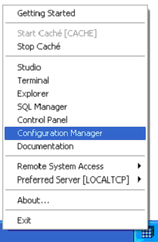

In the window that appears, select the tab labeled **Advanced** (the right-most tab).

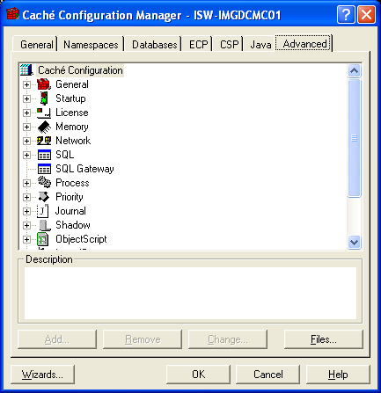

In the window for Advanced Configuration Management, scroll down until the definition tree for **Input/Output** becomes visible. Click the  icon, so that the tree will expand:

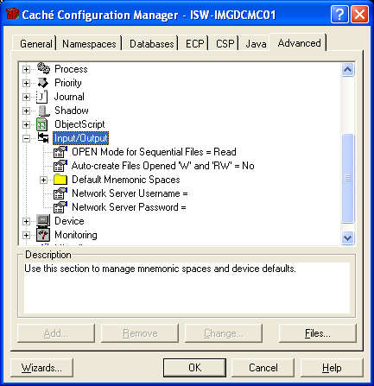

Double-click the line for the **Network Server Username**. A new window will open:

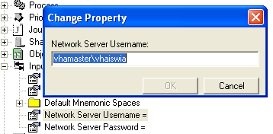

Enter the username to be used for background processes. This username must be the fully qualified name for the Windows Operating System (not a VistA access code); most sites have set up a special user name like **VHAvv\VHAxxxIA** or **VHAvv\VHAxxxIU** (where **vv** is replaced with the VISN number and **xxx** is replaced with the three-letter abbreviation for the name of the site) for this purpose.

When the proper user-name is entered, click the **OK** button.

The edit-window will be closed.

Next, double-click on the line for the **Network Server Password**. A new window will open:

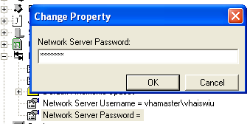

Enter the password for the username entered above. Note that passwords are not echoed.

When the proper password is entered, click the **OK** button.

The edit-window will be closed.

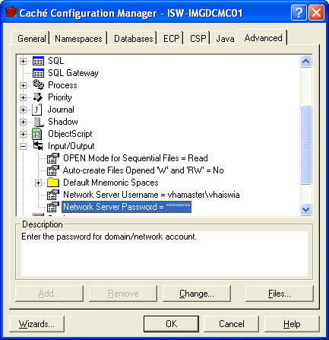

Finally, click the **OK** button.

If Caché is running (blue cube) while this change is made, since this is a change that affects the complete Caché system operation, the Caché system will restart itself after this change has been made.

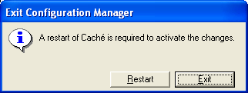

Click the **Restart** button to make this change effective.

**Note**: VA policy requires that end-user passwords be changed on a regular basis. Because of this, it is recommended to use the special user **VHAvv\VHAxxxIA** for this purpose, since the password of this special user should be set up so that it does not expire. In either case, when the password of this user is changed, be sure to update this setting accordingly. Otherwise, background processes will no longer have access to networked disk shares.

Next, it is important to verify that appropriate privileges are granted to the username that was selected above.

From the **Start Menu**, select **Control Panel** 🡪 **Administrative Tools** 🡪 **Services**.

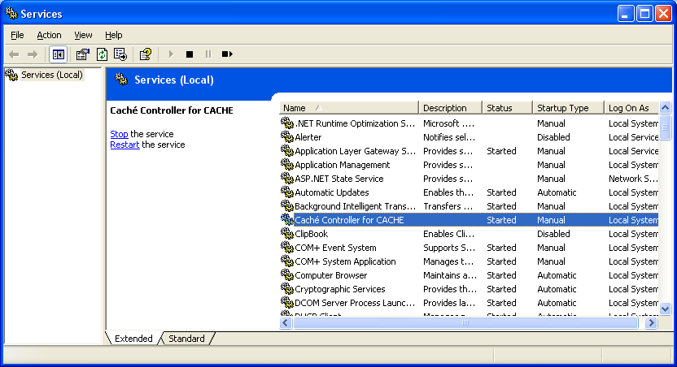

Right-click on **Caché Controller for CACHE**, and select **Properties**.

Select the **Log On** tab.

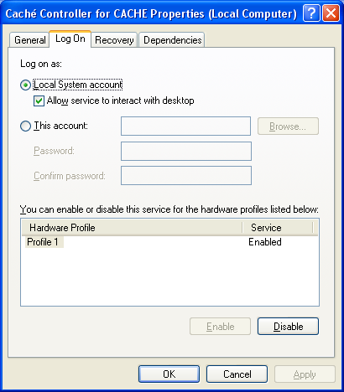

Make sure that the radio button is selected for **Local System Account**, and that the checkbox for **Allow service to interact with desktop** is checked.

Click the **OK** button and close the windows for **Services** and **Administrative Tools**.

#### More Privileges

When Caché is restarted, the following message may appear:

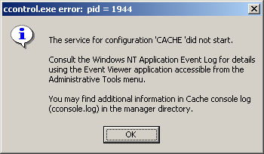

This message may appear in any version of Caché. This message usually means that the credentials that were entered in the previous step belong to a username that has no administrative privileges on the current computer.

If a different user should be selected, repeat the steps from the previous sections to enter the correct credentials.

If the selected user should be an administrator on the current computer, go back to the Windows Control Panel, and double-click **Users and Passwords**.

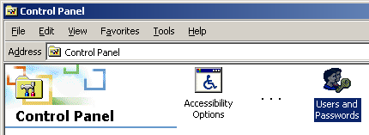

In the next dialog window, first click the **Advanced** tab, then click **Advanced**.

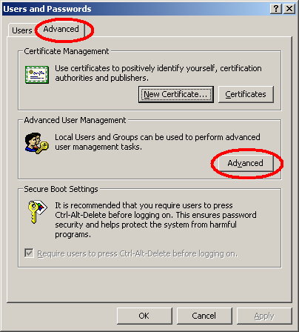

In the next window, click **Groups** and then double-click **Administrators**.

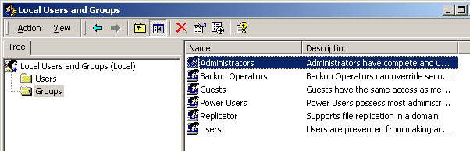

Next, click **Add**:

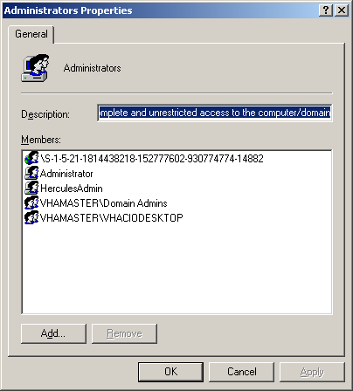

and add the name of the selected user in the dialog window that follows.

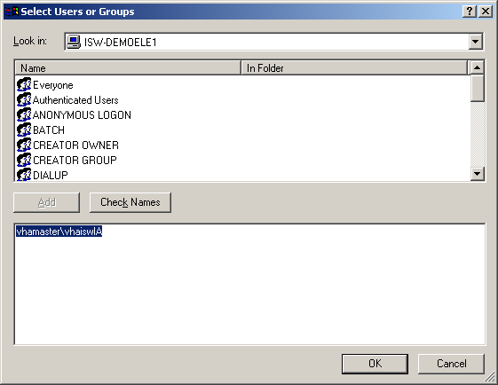

When the username is entered, click **OK** the appropriate number of times, and exit the remaining windows by clicking the exit button ().



## ~~Starting Application Routines~~

~~The various programs that are part of the VistA Imaging DICOM Gateway can be started from the Microsoft Windows Start Menu:~~

~~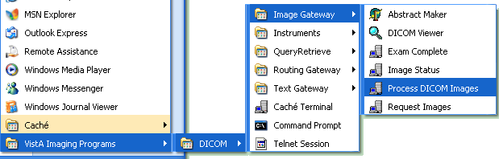~~

~~Tto execute any of the programs, click , navigate to~~ **~~VistA Imaging Programs~~**~~, then to~~ **~~DICOM~~**~~, then to the appropriate sub-system, and then to the appropriate application program.~~

~~See~~ *~~Appendix A~~* ~~for more information about this menu.~~

## Installation Error Messages

Below follows a list of error messages that may occur during installation. Typically, each of these error messages will indicate a lack of privileges or a lack of resources:

An installation must be performed by a system manager who has appropriate privileges to install software within the operating system (i.e., must be a Windows Administrator).

If networked resources are used during an installation, the all systems must be connected using a stable network.

The target system must have sufficient disk space to receive the software that is to be installed (at least 300MB of free disk space)

The messages itemized below may be produced during an installation. If any of these messages appear, contact Customer Support for assistance.

Unable to create batch file for (un)registering OCX files.

Could not close batch file (for processing OCX files).

Unable to process OCX files.

Unable to create batch file.

WriteLine to batch file failed (select ISS file).

Could not close batch file (select ISS file).

Unable to update ISS file.

Unable to run Caché Silent Install

Could not close file "xxx".

Could not perform Caché Silent Install: xxx

Unable to stop Caché.

Unable to create batch file to purge temporary files.

Unable to Purge Temporary Files for Caché Installation.

Unable to restart Caché.

Unable to create ZSTU routine file.

Unable to create batch file to load ZSTU routine.

Unable to import ZSTU routine.

Cannot import ZSTU routine

Cannot Read message in xxx

Unable to import ZSTU routine  
xxx

Unable to create batch file to load DICOM application routines.

Unable to import DICOM application routines.

Cannot import DICOM application routines

Cannot Read message in xxx

Unable to import DICOM application routines  
xxx

Unable to purge obsolete global variables.

Unable to create DICOM Global Variable Save file.

Unable to create batch file to load DICOM Global Variables.

Unable to import DICOM global variables.

Cannot import DICOM application routines

Unable to stop Caché.

Unable to create batch file to load DICOM Global Variables.

Unable (re)initialize Text Data Directories.

Unable to run Master File Update.

Unable to obtain status of Master File Update

Cannot locate notepad.exe.

Unable to display error log from Master File Update.

Unable to save DICOM_Look_Here in Registry.

Unable to save DICOM_Cache_Drive in Registry.

Unable to save DICOM_Text_Drive in Registry.

Unable to save DICOM_Image_Drive in Registry.

Unable to save DICOM_Dictionary_Drive in Registry.

Unable to save DICOM_Text_Drive in Registry.

Error in Set Up:  
Destination for Text Data is invalid.  
Selected destination is "x"  
should be "xxx".  
Destination for Image Data is invalid.  
Selected destination is "xxx"  
should be "xxx".  
Destination for DICOM Dictionary Data is invalid.  
Selected destination is "xxx"  
should be "xxx".  
Aborting installation...

Cannot Find Caché Configuration File  
xxx

Cannot Create New Caché Configuration File  
xxx

Cannot delete file "xxx"  
Status code is nnn = xxx

Cannot Create New Host File  
xxx

Cannot Create New Host File  
xxx

Cannot copy shortcut for  
xxx  
nnn = xxx

## End of First Phase of Installation

At this point, the express set-up of the software is complete. Continue with Chapter 4, which provides definitions for a number of site-specific parameters.

# 

# Site-Specific Set-Up

This chapter describes how to build the Master File Dictionaries for the DICOM applications.

All of the examples in this chapter assume that the master files are stored in the **\DICOM\Dict** directory on an Windows file server that is mounted as a networked drive and accessed using the letter **F:**.

The format and content of the master files is described in Appendix B.

## Site-Specific Parameters

The master files contain dictionary and configuration information that is used by the DICOM applications. Those master files that contain static dictionary information should not be modified (e.g. the DICOM Element Dictionary). Files containing site-specification configuration information must be customized before proceeding (e.g., list of instruments present at a site).

The master files are located in the directory **\DICOM\Dict**. The local modifications to be made to these files are described in *Appendix B Master Files*. The files to be modified are:

* AE_Title.DIC
* Instrument.DIC
* Modality.DIC
* Portlist.DIC
* SCU_list.DIC
* Worklist.DIC
* Route.dic (described in the Routing User Guide)

## Local Modifications

Reference MAG*3.0*118 Planning and Installation Instructions for changes required to Instrument.dic and Modality.dic.

The contents of **Instrument.DIC**, **Modality.DIC**, **Portlist.DIC**, **Worklist.DIC** **SCU_list.DIC,** and **Routing.DIC** need to be modified to reflect the equipment that is present at the site. See Appendix B for details on the contents of these files.

Make any modifications that are needed to these files, and then continue with the steps below.

## Configure the Legacy DICOM Gateway and Load the DICOM Dictionaries

The following subsections describe the process of completely configuring a VistA Imaging DICOM Gateway, including loading all the dictionaries.

**Note:** Individual portions of the VistA Imaging DICOM Gateway can be selectively updated as well. This operation is described in the VistA Imaging DICOM Gateway User Manual.

Create a new session (click on the blue Caché cube, and select **Terminal**), then use the menu to start the program:

If the Caché Terminal session starts in Programmer Mode (with the DICOM> prompt), enter the following MUMPS command:

DICOM> **Do ^MAGDLOGN <Enter>**

********************************************************************************

** VistA DICOM Interface **

** **

** The Food and Drug Administration classifies this software as a medical **

** device. Modification of this software may result in an adulterated **

** medical device, the use of which is considered to be a violation of **

** US Federal Statutes. Federal law restricts this device to use by or **

** on the order of either a licensed practitioner or persons lawfully **

** engaged in the manufacture, support, or distribution of the product. **

** **

** The information in this system is further protected by the Privacy Act **

** of 1974 (PL93-579). Unauthorized access to or use of this system is a **

** serious violation of Federal Law. Violators will be prosecuted. **

** **

** Use of this software is monitored. **

********************************************************************************

Login using M-to-M RPC Broker Server "10.2.29.246" on Port 4800

ACCESS CODE: (use an access code that is valid on the VistA system)

VERIFY CODE: (use a verify code that is valid on the VistA system)

** WARNING**WARNING**WARNING**

"This U.S. Government computer system is for official use only. The files

on this system include Federal records that contain sensitive information.

All activities on this system may be monitored to measure network

performance and resource utilization; to detect unauthorized access to or

misuse of the system or individual files and utilities on the system,

including personal use; and to protect the operational integrity of the

system. Further use of this system constitutes your consent to such

monitoring. Misuse of or unauthorized access to this system may result in

criminal prosecution and disciplinary, adverse, or other appropriate

action."

**WARNING** WARNING** WARNING**

MISUSE OF THIS SYSTEM AND INFORMATION IN THIS SYSTEM IS A FEDERAL CRIME

==========================================================================

ISW-IMGDEMO1

Welcome to the VistA Imaging Demo System!

Press <Enter> to continue

From this point, proceed with menu option 4-2-2:

**4** System Maintenance

**→ 2** Gateway Configuration and DICOM Master Files

**→ → 2** Update Gateway Configuration Parameters

### Name of System

The system title is a short character string that appears on the top of the main DICOM application menu. Examples:

“Moscow DICOM Image Server System #3”

“New Orleans DICOM Text Gateway and Background Processor”

Please enter the system title: **IMAGUSER's Workstation <Enter>**

### Location of DICOM Gateway

The configuration program will query the VistA system in order to obtain a list of the locations that are operational for the site. When a DICOM Gateway is part of a site that has only one location, the software will merely display the name of that location, and not ask the end-user for any input, e.g.:

This Gateway is located at COLUMBIA, MO (#543)

Otherwise, the end-user will be asked to identify the name of the location for which the DICOM Gateway in question will be operating.

### DICOM Data Directories

The DICOM data directories are located on the local system, and are used to hold both the DICOM text and image files. D:\DICOM is typically the DICOM data directory. However, you may select another device letter (C:-Z:).

Please enter the device letter for

the DICOM text directory: d:// **d <Enter>**

Please enter the device letter for

the DICOM image directories: d:// **d <Enter>**

### Percentage of Free Disk Space

The software will cease storing image files when the amount of free disk space drops below a certain threshold. The usual value for this threshold is **15%**.

Please enter the percentage of free disk space

required to allow storage of image files: 15%// **15 <Enter>**

### DICOM Dictionary Directory

The DICOM dictionary directory is usually on a networked system, and is used to hold DICOM master files. F:\DICOM is typically the DICOM dictionary directory. You may select any other device letter, however.

Enter the device letter for

the DICOM dictionary directory: c:// **f <Enter>**

### Communication Channels

Communication channels are used to broadcast VistA event data. A separate channel is needed for each different destination. For instance, event data may be sent to both a commercial PACS and to one or more Modality Worklist service class providers (for example a Mitra Broker or a DeJarnette MediShare). Each destination must have its own event channel ***n*** and a dedicated c:\dicom\data***n*** subdirectory.

The number of communication channels must be between 1 and 9.

Please enter the number of communication channels 2// **2 <Enter>**

### DICOM Image Gateway

If this system is to be configured as a VistA DICOM Image Gateway, the answer to this question must be **Yes**. If this system is to be configured otherwise, answer **No**.

Note: A VistA DICOM Gateway may be configured as a Text Gateway, an Image Gateway, a Routing Processor, or any combination thereof.

Will this system be a DICOM Image Gateway? YES// **y <Enter>**

### DICOM Text Gateway

If this system is to be configured as a VistA DICOM Text Gateway, to support the Modality Worklist and/or send event messages to a commercial **P**icture **A**rchiving and **C**ommunication **S**ystem (PACS), the answer to this question must be **Yes**. If this system is to be configured otherwise, answer **No**.

**Note**: A VistA DICOM Gateway may be configured as a Text Gateway, an Image Gateway, a Routing Processor, or any combination thereof.

Will this system be a DICOM Text Gateway? YES// **y <Enter>**

### DICOM Routing Processor

If this DICOM Gateway is to be configured as a VistA DICOM Routing Processor, the answer to this question must be **Yes**. If this system is to be configured otherwise, answer **No**.

**Note**: A VistA DICOM Gateway may be configured as a Text Gateway, an Image Gateway, a Routing Processor, or any combination thereof.

Will this system be a DICOM Routing Processor? YES// y <Enter>

### Auto-Routing Active

If one of the DICOM Gateways at this site is being used as a Routing Processor, the answer to this question must be **Yes**. If no automated routing is to occur at this site, the answer to this question must be **No**.

**Note**: When the answer to this question is set to **Yes**, queue-entries will be created for automated routing. If no Routing Processor is active at the site, these queue entries will accumulate and never be processed or purged.

For detailed information about setting up a DICOM Gateway to perform automated routing, see the VistA Imaging Routing User Guide.

### Radiology

If this DICOM Gateway is to be configured as a computer that processes Radiology exams, the answer to this question must be **Yes**. If this system is to be configured otherwise, answer **No**.

**Note**: A VistA DICOM Gateway may be configured as one that processes Radiology exams, one that handles Consults, or one that supports both.

### Consults

If this DICOM Gateway is to be configured as a computer that processes Consults, the answer to this question must be **Yes**. If this system is to be configured otherwise, answer **No**.

**Note**: A VistA DICOM Gateway may be configured as one that processes Radiology exams, one that handles Consults, or one that supports both.

### Send Text to commercial PACS

If this VistA DICOM Text Gateway is to be configured to send messages to either a commercial PACS or a Modality Worklist provider (for example, a Mitra Broker or a DeJarnette MediShare), the following question should be answered with **Yes**. Otherwise, answer **No**.

Send text to a commercial PACS, Mitra Broker, et cetera? n// **n <Enter>**

### Receive EXAM COMPLETE Message from commercial PACS

The EXAM COMPLETE message is sent by some commercial PACS to signal that all the images for a study have been acquired and are ready to be sent to VistA. The EXAM COMPLETE message then serves as a trigger for VistA to pull the images from the commercial PACS. Other commercial PACS do not use the EXAM COMPLETE message, but autoroute their images to VistA.

If a commercial PACS is going to transmit EXAM COMPLETE messages to VistA that indicate all the images in a study are ready to be sent, answer **Yes** to this question. Otherwise, answer “**No**.”

Is a PACS going to send Exam Complete messages to VistA? NO// **n <Enter>**

### Kind of PACS

If the previous question is answered with “**Yes**,” an additional question will be asked:

Select the kind of commercial PACS at this site

-----------------------------------------------

1 - GE Medical Systems PACS with Mitra PACS Broker

2 - GE Medical Systems PACS with ACR-NEMA Text Gateway

3 - eMed Technology Corporation PACS

4 - Other commercial PACS

What kind of a PACS?

Enter the sequence number for the kind of PACS that is present at the site.

### Modality Worklist Provider

If this Text Gateway is to be configured to provide the “Modality Worklist” capability, answer **Yes** to this question. Otherwise, answer **No**.

Will this system be a Modality Worklist Provider? y// **<Enter>** yes

### Send CPT Modifiers

With Radiology Package patch RA*5*10, modifier codes are included when CPT codes are transmitted. These modifier codes` may be sent to PACSs and modalities via DICOM as a two-character suffix to a procedure code (*nnnn****-xx***). The usual configuration is to include the modifier suffix.

If the modifier suffices are to be included in messages, answer **Yes** to this question. If these suffixes are to be omitted, answer **No**.

If the site is going to use VistARad, enter **Yes**. If it is going to use a commercial PACS, check with the vendor to see if it can support CPT-Modifiers.

Send CPT Modifiers? Yes // <Enter**>** Yes

### Dashes in SSN sent to PACS

The DICOM Text Gateway can be configured to include or not include dashes in Social Security Numbers sent to a PACS. If the PACS can handle dashes in Social Security Numbers, enter **Yes**. If it cannot handle them, enter **No**.

Include DASHES in Social Security Numbers sent to PACS? YES// **<Enter> YES**

**Note**: Dashes can also be suppressed in Modality Worklist. See Section B.4.5.

### TCP/IP Address for VistA

In order to connect to the VistA system using the MUMPS-to-MUMPS Kernel Broker, the DICOM Gateway must know the TCP/IP address of the VistA system. Enter the site-specific address.

Enter the network address for the main VistA HIS: 10.11.12.13//

The address may be entered as the numeric address (in those cases that the connection must be with a specific processor) or to the “human-readable” name that is set up in the domain name server.

### TCP/IP Port for MUMPS-to-MUMPS Broker

To connect to the VistA system using the MUMPS-to-MUMPS Kernel Broker, the DICOM Gateway must know the TCP/IP port number on which the Broker is listening on the VistA system. Enter the site-specific port-number.

Enter the network port number for the main VistA HIS: 4800//

### Mail Group

When significant operational issues arise, the DICOM Gateway will send e-mail messages to a site-specific mail-group. Enter the e-mail address for the site-specific mail-group.

**Note 1**: A DICOM Gateway sends e-mail using the standard SMTP protocol, ***not*** through MailMan. If a mail-group within MailMan needs to receive these e-mail messages, the name of this mail-group cannot include any space characters.

**Note 2**: A site may or may not decide to include addresses in this mail-group that cause a pager to be activated.

Send emergency e-mail notices to: DICOM@site.med.va.gov//

### Display Patient Name

A DICOM Image Gateway presents an activity log while it is processing images. This activity log includes information that contains patient identifiers. When this display is visible from a public area, it is necessary to suppress the privacy-sensitive details.

When these details are to be suppressed (i.e., displayed as a series of asterisks), the answer to this question must be **No**. If these details are allowed to be visible, the answer to this question can be **Yes**.

Display Patient Name/ID in Image Processing? NO//

### Access Code for Modality Worklist

When an external entity sends a Modality Worklist request to a DICOM Gateway, the DICOM Gateway is usually able to respond to the request using information that is stored on the Gateway itself. In some cases, the DICOM Gateway will need to query the VistA system for details to report back to the requester. When the DICOM Gateway makes such a request to the VistA system, it will use the access code that is specified as the answer to this question.

**Note**: The response to this question is treated as a password; i.e., it is not displayed on the monitor of the end-user.

Access Code for Modality Worklist //

### Verify Code for Modality Worklist

When an external entity sends a Modality Worklist request to a DICOM Gateway, the DICOM Gateway is usually able to respond to the request using information that is stored on the Gateway itself. In some cases, the DICOM Gateway will need to query the VistA system for details to report back to the requester. When the DICOM Gateway makes such a request to the VistA system, it will use the access code that is specified as the answer to this question.

**Note**: The response to this question is treated as a password (i.e., it is not displayed on the monitor of the end-user).

Verify Code for Modality Worklist //

### Modality Worklist Port Numbers

Normally, modality worklist requests are processed through TCP/IP port number 60010. Some sites have equipment that uses a different port number, and which cannot be configured to use any other port number. In order to support such equipment, it is possible to define additional port numbers for modality worklist processors.

Currently, there is a Modality WorkList processor for

the following port:

60010

Change? [A/D/N] N// **? <Enter>**

Enter one of the following:

No if no (additional) change is to be made

Add <number> to add a listener for a port

Delete <number> to remove a listener for a port

Note that valid port numbers are integers between 1 and 65535.

Note that the listener for port 60010 may not be removed.

Currently, there is a Modality WorkList processor for

the following port:

60010

Change? [A/D/N] N// **a 104 <Enter>**

Currently, there are Modality WorkList processors for

the following ports:

104

60010

Change? [A/D/N] N// **d 104 <Enter>**

Currently, there is a Modality WorkList processor for

the following port:

60010

Change? [A/D/N] N//

### E-Mail Post Office

The Department of Veterans Affairs has three virus-checking post offices set up for nationwide e-mail. The post office that should be selected for this setting should be the one to which the site has the best network-connection. There are six possible responses for this question:

* **0**: use the local VistA system (default)
* **1**: use the Virus-Checking Office in Silver Spring, MD at 10.2.27.92
* **2**: use the Virus-Checking Office in Hines, IL at 10.3.27.92
* **3**: use the Virus-Checking Office in San Francisco, CA at 10.6.27.92
* **4**: use VA-Forum at 10.2.29.131
* or enter the TCP/IP address of the system to be used.

Which post-office will this computer use? **smtp.va.gov <Enter>**

**Note**: VA policy on the usage of e-mail post offices has changed several times while this documentation was being prepared. At the time this documentation is being written, the only value that is allowed to be entered for this parameter is “**smtp.va.gov**”.

Consult with your ISO for the VA’s current policy on this issue.

### E-Mail Post Office Port Number

Define the port number for the E-Mail Post Office when prompted:

Which port number will this computer use for e-mail? 25//

Email is transmitted using SMTP protocol. Normally, this protocol uses port number 25. In some cases, a different port number may have been set up at the site.

**Note**: The port number should be between 1 and 65,535:  
 1 <= port number <= 65,535.

For more information about E-Mail Post Office, see the section *E-Mail Post Office*.

### ~~Enabling the IMPORTER~~

~~Specify whether the DICOM Gateway will use the IMPORTER application when prompted:~~

~~Use the IMPORTER instead of "DICOM Correct"? YES// ?~~

~~If you answer YES, the DICOM Gateway will use the IMPORTER application instead of DICOM Correct to import DICOM objects. The IMPORTER can also be used for importing DICOM objects from properly formatted CDs/DVDs.~~

~~A Laurel Bridge Server Runtime License must be installed on the DICOM Gateway~~

~~to run the IMPORTER application.~~

### 4.3. 29 Specifying the Agency (new)

If you are setting up a new DICOM Gateway or if you have just upgraded and existing DICOM Gateway to the MAG*3.0*123 DICOM Gateway, when you run option 4-2-2, you are prompted to specify whether the DICOM Gateway is installed at a Department of Veterans Affairs (VA) site or an Indian Health Services (IHS) site.

Is this gateway installed in VA (V)or IHS (I)? V//

If you get this prompt, do one of the following:

* For VA sites, press Enter to accept the default, V.
* For IHS sites, type I and press Enter.

## Loading the DICOM Dictionaries

The DICOM Dictionaries are constructed by populating a number of Fileman globals with data from the master files. Appendix B contains a detailed description of each master file. The format and contents of the resulting subtrees in global variable ^MAGDICOM(2006.5xx) are described in the (online) FileMan Data Dictionaries.

Sites should make changes to the master files only for the site-specific DICOM Dictionaries. The information in the global variable themselves should not be manually modified, as it will be overwritten the next time the master file is loaded.

In order to start loading the dictionaries, select menu option **4-2-9**:

**4** System Maintenance

→ **2** Gateway Configuration and DICOM Master Files

→ → **9** Reinitialize All the DICOM Master Files

Ready to build all of the DICOM Master Files? y// **<Enter>** yes

### DICOM Data Element Dictionary

During this step, the contents of the file **ELEMENT.DIC** are loaded into global variable **^MAGDICOM(2006.51,…)**.

The contents of the master file **ELEMENT.DIC** may not be modified by the site.

Building the DICOM Element Dictionary -- ^MAGDICOM(2006.51)

Ready to read dictionary file "f:\DICOM\Dict\ELEMENT.DIC"? y// **y <Enter>**

### DICOM Message Template Dictionary

During this step, the contents of the file **TEMPLATE.DIC** are loaded into global variable **^MAGDICOM(2006.52,…)**.

The contents of the master file **TEMPLATE.DIC** may not be modified by the site.

Building the DICOM Message Template Dictionary -- ^MAGDICOM(2006.52)

Ready to read dictionary file "d:\DICOM\Dict\TEMPLATE.DIC"? y// **<Enter>** yes

*** PASS 1 STARTED ***

*** PASS 2 STARTED ***

- DONE -

### DICOM Unique Identifier Dictionary

During this step, the contents of the file **UID.DIC** are into global variable **^MAGDICOM(2006.53,…)**.

The contents of the master file **UID.DIC** may not be modified by the site.

Building the DICOM UID Dictionary -- ^MAGDICOM(2006.53)

Ready to read dictionary file "f:\DICOM\Dict\UID.DIC"? y// **y <Enter>**

### Extended SOP Negotiation Table

During this step, the Extended SOP (Service Object Pair) Negotiation Table is loaded into global variable **^MAGDICOM(2006.531,…)**.

Updating the extended SOP negotiation table... done!

### DICOM PDU Types

During this step, the PDU (Protocol Data Unit) table is loaded into global variable **^MAGDICOM(2006.54,…)**.

Updating the PDU TYPE table... done!

### Imaging Service Dictionary

During this step, the Imaging Service Dictionary is loaded into global variable **^MAGDICOM(2006.589,…)**.

Updating the Imaging Service table...

done!

### DICOM HL7 Segment and Field Dictionary

During this step, the contents of the file **HL7.DIC** are loaded into global variable **^MAGDICOM(2006.57,…)**.

The site may not modify the contents of the master file **HL7.DIC**.

Building the DICOM HL7 dictionary in ^MAGDICOM(2006.57)

Ready to read dictionary file "f:\DICOM\Dict\HL7.dic"? y// **y <Enter>**

done!

### Instruments

During this step, the contents of the file **INSTRUMENT.DIC** are loaded into global variable **^MAGDICOM(2006.581,…)**.

The contents of the master file **INSTRUMENT.DIC** must be customized for the site.

Building the Instrument Dictionary -- ^MAGDICOM(2006.581)

Ready to read dictionary file "f:\DICOM\Dict\INSTRUMENT.DIC"? y// **y <Enter>**

### Modalities

During this step, the contents of the file **MODALITY.DIC** are loaded into global variable **^MAGDICOM(2006.582,…)**.

The contents of the master file **MODALITY.DIC** must be customized for the site.

Building the Modality Type Dictionary -- ^MAGDICOM(2006.582)

Ready to read dictionary file "f:\DICOM\Dict\MODALITY.DIC"? y// **y <Enter>**

### CT Conversion History

During this step, the contents of the file **CT_PARAM.DIC** are loaded into global variable **^MAGDICOM(2006.5821,…)**.

The contents of the master file **CT_PARAM.DIC** may not be customized for the site.

Building the CT Conversion History Dictionary -- ^MAGDICOM(2006.5821)

Ready to read dictionary file "f:\DICOM\Dict\CT_PARAM.DIC"? y// **y <Enter>**

### Modality Worklist

During this step, the contents of the file **WORKLIST.DIC** are loaded into global variable

**^MAGDICOM(2006.583,…)**.

The contents of the master file **WORKLIST.DIC** must be customized for the site.

Building the Modality Worklist Dictionary -- ^MAGDICOM(2006.583)

Ready to read dictionary file "f:\DICOM\Dict\WORKLIST.DIC"? y// **y <Enter>**

### Port Numbers for Text Gateway sending messages to PACS

During this step, the contents of the file **PORTLIST.DIC** are loaded into global variable **^MAGDICOM(2006.584,…)**.

The contents of the master file **PORTLIST.DIC**, if used, must be customized for your site.

Building the TCP/IP Provider Port Dictionary -- ^MAGDICOM(2006.584)

Ready to read dictionary file "f:\DICOM\Dict\PORTLIST.DIC"? y// **y <Enter>**

### User Application Parameters

During this step, the contents of the file **SCU_LIST.DIC** are loaded into global variable **^MAGDICOM(2006.585,…)**.

The contents of the master file **SCU_LIST.DIC** must be customized for the site.

Building the User Application Dictionary -- ^MAGDICOM(2006.585)

Ready to read dictionary file "f:\DICOM\Dict\SCU_LIST.DIC"? y// **y <Enter>**

### Provider Application Dictionary

During this step, the contents of the file **SCP_LIST.DIC** are loaded into global variable **^MAGDICOM(2006.586,…)**.

The contents of the master file **SCP_LIST.DIC** may not be modified by the site.

Building the Provider Application Dictionary -- ^MAGDICOM(2006.586)

Ready to read dictionary file "f:\DICOM\Dict\SCP_LIST.DIC"? y// **y <Enter>**

### Application Entity Title Dictionary

During this step, the contents of the file AE_TITLE.DIC are loaded into global variable ^MAGDICOM(2006.588,…).

The contents of the master file AE_TITLE.DIC must be customized for the site.

Building the Application Entity Title Dictionary -- ^MAGDICOM(2006.588)

Ready to read dictionary file "C:\DICOM\DICT\AE_TITLE.dic"? y// **yes** **<Enter>**

### Data Transfer

The master file named **Modality.DIC** references several other dictionary files that contain lists of additional data elements to be displayed on a diagnostic workstation. These “data transfer” dictionaries are loaded during this step.

Ready to build the "Data Transfer" Dictionaries? y// **y <Enter>**

-- DICOM Master File Build completed successfully --

## Automatically Generating Instrument Shortcut Icons

Menu option **4-2-10** (Create Shortcuts for Instruments) may be executed to generate gateway shortcut icons. (Instrument icons will no longer be generated).

[DCM,DCM]>**d ^MAGDMFIC <Enter>**

Do you want to edit the 'HOSTS' file? Y// <Enter**>**

Done.

[DCM,DCM]>

The program first builds all shortcuts (in sub-directories of x:\DICOM\Icons\…) and then offers the installer the option to add a number of definitions to the “hosts” file. This file defines the aliases for the various TCP/IP addresses that may be needed for communication between the various pieces of equipment.

The program will open two Notepad windows, one for the file called “Hosts” and one for the file called “add.tmp”. These are shown on the next two figures.

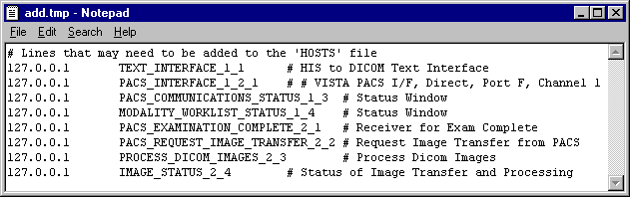

The user performing the installation can cut and paste lines with definitions from the window labeled “add.tmp” to the window labeled “hosts”. When done editing, save and close the window labeled “hosts”, and then close the window labeled “add.tmp”.

## Adding DICOM Application Entities to the HOSTS file

When a DICOM Application Entity connects to a VistA Imaging DICOM Gateway, the gateway attempts to determine the network identity (i.e., the IP address) that is making the connection. It does this by invoking the operating system function gethostbyaddr(). This works most efficiently when the IP address of the instrument is registered in the VistA Imaging DICOM Gateway’s “**HOSTS**” file (The full name of this file is typically **c:\Windows\System32\ Drivers\etc\hosts**).

Each DICOM Application Entity needs to be added to the hosts file so that the gateway can quickly resolve names when TCP/IP connections are created. For each instrument (and each separate Modality Worklist service class user), add the IP address and mnemonic to the “**HOSTS**” file.

The following is an example from of a “HOSTS” file.

127.0.0.1 localhost

111.222.333.40 GECT1 # GE High Speed CTI, Room F24

111.222.333.41 GEADW # GE Advantage Workstation F24

111.222.333.42 GEMR # GE Signal MRI, Room Mobile Trailer

#End of File

## M Security – Programmer Access Code and Tied Terminal Table

As a final step, access to the login prompt will be restricted by making all access through telnet lines tied to the VistA DICOM login program.

**Note 1:** In the sample text below, the text “**password**” appears several times. For each instance, use a site-specific password that is appropriate. Passwords must be six or more characters in length and must consist of a combination of letters and numbers.

**Note 2:** When an end-user logs on using the password for “**Print/View Only**”, the only menu options that will be available are those that cannot modify the database.

**Note 3:** Use different passwords for ACCESS code, VERIFY code, PROGRAMMER ACCESS code, PRINT/VIEW ONLY code, and SUPPORT code.

**Note 4:** This Access and Verify code is for stand-alone maintenance of the DICOM gateway only, and cannot be used for production. No remote procedure calls can be used with this maintenance Access and Verify code.

[DICOM]>**Do INIT^MAGDLOGN <Enter>**

Enter new ACCESS code: **password <Enter>**

Re-enter ACCESS code (to make sure I got it right): **password <Enter>**

Enter new VERIFY code: **password <Enter>**

Re-enter VERIFY code (to make sure I got it right): **password <Enter>**

Enter new PROGRAMMER ACCESS code: **password <Enter>**

Re-enter PROGRAMMER ACCESS code (to make sure I got it right): **password <Enter>**

Enter new PRINT/VIEW ONLY code: **password <Enter>**

Re-enter PRINT/VIEW ONLY code (to make sure I got it right): **password <Enter>**

Enter new SUPPORT code: **password <Enter>**

Re-enter SUPPORT code (to make sure I got it right): **password <Enter>**

[DICOM]>

## Personal Preferences

Once the above setup procedures are completed, a few more steps may be taken to cosmetically adjust the appearance of the VistA Imaging DICOM Gateways.

Since the VistA Imaging DICOM Gateway software uses many windows that will be simultaneously open, screen space on the monitor is at a premium. The current recommended resolution is 1280 by 1024 pixels, and, sometimes that is still not enough. As a result, it is recommended to turn off all “frills” on directory windows: turn off all toolbars, all status bars, and don’t use “web-view” (All of these are by themselves interesting additions, but for the purpose of a DICOM Gateway, they just take up a lot of display space, and don’t offer any value in return). However, do leave the task bar that is usually at the bottom of the screen.

**Note**: Any customizations described in this section should be repeated for each VistA Imaging DICOM Gateway, so that all stations will present a similar appearance.

In order to make the final adjustments to the desktop, log in with the user name that will be used to log in to VistA from the current workstation (it is recommended that this name be **VHAvv\VHAxxxIA**).

Remove any icons that are left over from installation procedures; e.g., *Install Service Pack <nn>*, from all profiles (including the profile called “All Users”).

At this point, all software and data is installed on the PC. This chapter describes a number of procedures that may be performed to validate that the installation software is correct and complete.

Please refer to **Appendix A** for detailed instructions for defining shortcuts.

The installation should have added a number of programs to the Windows Start menu.

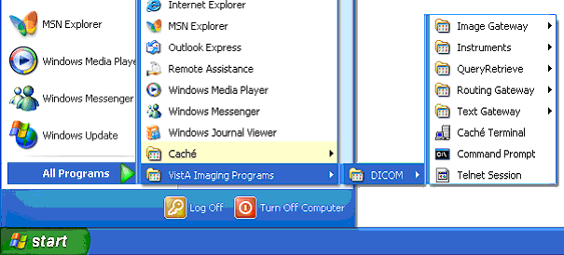

Follow the various menu trees to view all menu options that are made available.

Depending on the purpose of the gateway, one or more of these folders will be used for the day-to-day operation. See the VistA Imaging DICOM Gateway User Manual for further details on these icons and folders.

~~The installation procedure has created a folder named~~ **~~\DICOM\Icons\Instruments~~** ~~on the text data disk. Some sites prefer to have the instruments separated out into multiple folders by gateway system, so that each folder contains only those instruments that are assigned to a specific gateway. Other sites prefer to turn off the “auto arrange” feature on the directory windows, and manually arrange the icons in the windows so that the selection for a specific machine can be made visible by scrolling and sizing the window.~~

~~If a site prefers to separate the folders for the various computers, a straightforward way to achieve this separation is to create subfolders in C;\Documents and Settings\All Users\Start Menu\Programs\VistA Imaging Programs\DICOM\Instruments where each reflects one of the gateways; e.g., \DICOM\Icons\Instruments\DIG1 through \DICOM\Icons\ Instruments\DIG4 if there are four image gateways. The icons for the various instruments can then be moved easily into the directories for the assigned gateways.~~

~~The icons for the various instruments are initially all the same. The folders~~ **~~\DICOM\Icons (Letters)~~** ~~and~~ **~~\DICOM\Icons (VA Logo)~~** ~~contain additional icons that may be used to designate the various instruments in a more specific manner.~~

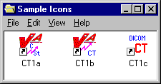

## Recommended Icons

The installation process creates a number of icons for the benefit of the end-user. A typical site will use only a subset of these icons. It is recommended that a site customize the windows that are described above. Usage of the various icons will depend on the tasks that are run from the system. The table below shows which gateway tasks relate to which icons.

| **Icon** | **Text G/W** | **Text G/W with PACS** | **Image G/W** | **Image G/W with PACS** | **Combined Text and Image G/W** | **Combined Text and Image G/W with PACS** |
| --- | --- | --- | --- | --- | --- | --- |
| Command Prompt | X | X | X | X | X | X |
| Text Gateway | X | X | -- | -- | X | X |
| PACS Interface | X | X | -- | -- | X | X |
| PACS Communication Status | -- | X | -- | -- | -- | X |
| Modality Worklist Status | X | X | -- | -- | X | X |
| Examination Complete | -- | -- | -- | X | -- | X |
| Request Images | -- | -- | -- | X | -- | X |
| Process DICOM Images | -- | -- | X | X | X | X |
| Image Status | -- | -- | X | X | X | X |
| DICOM Viewer | -- | -- | X | X | X | X |

# 

# KIDS Package to Install in the VistA System

This chapter describes the installation of the “KIDS” package that is to be installed into a VistA system to support the VistA Imaging DICOM Gateway that will be running on satellite PCs. The complete KIDS installation is detailed in the VistA Imaging Installation Guide. Specific details pertinent to the DICOM Gateway are covered here.

The name of the KIDS package will be in the VistA Imaging namespace (“MAG”). Review the VistA Imaging Installation Guide for an example of the KIDS installation.

Installation of the KIDS package “VistA Imaging” is required to establish the files needed for DICOM image acquisition and for DICOM text Gateway. It establishes the global variable (^MAGDHL7) used for providing information to an outside PACS vendor and for providing a modality worklist to a radiology instrument. Data dictionaries and menu options are also created to assist in manual correction of images that failed to be processed during the initial image download for the Radiology and Medicine modalities.

The following sections describe those parts of the KIDS installation on the VistA system that pertain to the operation of the DICOM Gateway.

## VistA -PACS Radiology Interface Setup Instructions

The following steps are required to establish the global variable (^MAGDHL7) used for providing radiology order information to an outside PACS vendor and for providing a modality worklist to radiology devices. These steps are performed on the VistA system using Fileman utility. Apply one step at a time to allow testing changes and tracking errors before applying all changes. It is imperative that you follow the instructions precisely -- especially if you are not installing in a test account.

### Step 1

Use Fileman Enter/Edit to edit file 771 (HL7 APPLICATION PARAMETER) and update the FACILITY NAME field for the following entries RA-CLIENT-IMG, RA-SERVER-IMG and MAGD-CLIENT. Also, ensure that the ACTIVE\INACTIVE field is set to active for entries RA-SERVER-IMG, MAGD-CLIENT, MAG COMRCL PACS and MAG VISTA IMGNG.

### Step 2

Follow the instructions in sections *5.3 Change Subscribers* and 5.4 *Entering Facility Names for Sending and Receiving Applications for PACS Messaging* to subscribe to the appropriate HL7 Radiology event drivers (either V2.1 or V2.4) and associate the appropriate facility name with Imaging’s PACS protocols.

### Step 3

Activate the triggering of HL7 messages during Radiology exam registration by entering RA-SERVER-IMG into the SENDING APPLICATION field of the RA REG 2.4 protocol entry.

Select OPTION: **EN <Enter>**TER OR EDIT FILE ENTRIES

INPUT TO WHAT FILE: ACCESSION// **101 <Enter>**  PROTOCOL (1710 entries)

EDIT WHICH FIELD: ALL// **SENDING APPLICATION <Enter>**

THEN EDIT FIELD:

Select PROTOCOL NAME: **RA REG 2.4 <Enter>** Rad/Nuc Med exam registered

SENDING APPLICATION: **RA-SERVER-IMG <Enter>**

Once this step is complete, entries should start populating file 772 and file 2006.5 (global variable ^MAGDHL7). You can test by using the Radiology options to register an exam. For each exam case registered, an entry will be set in file 2006.5.

### Step 4

Select the **EXAMINATION STATUS** for each Imaging type that should trigger the “examined” HL7 message. The HL7 will only be triggered once for an exam – when the exam has been upgraded to the status with the **GENERATE EXAMINED HL7 MESSAGE** field set to **Yes**. (Examination Status file #72).

**Example:**

>**D P^DII <Enter>**

VA FileMan 22.0

Select OPTION: **ENT <Enter>**ER OR EDIT FILE ENTRIES

INPUT TO WHAT FILE: PROTOCOL// **72 <Enter>** EXAMINATION STATUS

(55 entries)

EDIT WHICH FIELD: ALL// **8 <Enter>** GENERATE EXAMINED HL7 MESSAGE

THEN EDIT FIELD: <Enter**>**

Select EXAMINATION STATUS: **EXAMINED <Enter>**

1 EXAMINED GENERAL RADIOLOGY

2 EXAMINED ULTRASOUND

3 EXAMINED MAGNETIC RESONANCE IMAGING

4 EXAMINED NUCLEAR MEDICINE

5 EXAMINED CARDIOLOGY STUDIES (NUC MED)

Press <RETURN> to see more, '^' to exit this list, OR

CHOOSE 1-5: **1 <Enter>** EXAMINED GENERAL RADIOLOGY

GENERATE EXAMINED HL7 MESSAGE: YES// <Enter**>**

### Step 5

Follow step 3, and apply to protocol RA EXAMINED 2.4 instead of RA REG 2.4.

Select OPTION: **EN <Enter>**TER OR EDIT FILE ENTRIES

INPUT TO WHAT FILE: **101 <Enter>** PROTOCOL

EDIT WHICH FIELD: **SENDING APPLICATION <Enter>**

Select PROTOCOL NAME: **RA EXAMINED 2.4 <Enter>**

SENDING APPLICATION: **RA-SERVER-IMG <Enter>**

Once this step is complete, entries should start populating file 772 and file 2006.5 (MAGDHL7 global). You can test by using the Radiology options to edit an exam. For each exam case edited that is upgraded to the status with the GENERATE EXAMINED HL7 MESSAGE field set to yes, an entry will be set in file 2006.5 (Usually this for all cases that has been upgraded to examined).

### Step 6

Apply the step outlined for steps3 for the RA CANCEL 2,4 protocol.

INPUT TO WHAT FILE**: 101 <Enter>** PROTOCOL

EDIT WHICH FIELD: **SENDING APPLICATION <Enter>**

Select PROTOCOL NAME: **RA CANCEL 2.4 <Enter>**

SENDING APPLICATION: **RA-SERVER-IMG <Enter>**

Use the Radiology option to cancel a radiology case. An entry for each canceled case should be entered into files 772 & 2006.5.

### Step 7

Apply step 3 for the **RA RPT** 2.4 protocol.

INPUT TO WHAT FILE: **101 <Enter>**  PROTOCOL

EDIT WHICH FIELD: **SENDING APPLICATION <Enter>**

Select PROTOCOL NAME: **RA RPT 2.4 <Enter>**

SENDING APPLICATION: **RA-SERVER-IMG <Enter>**

Use the Radiology option to produce a verified report. Only verified reports will create entries in files 772 and 2006.5.

**Reminder**: If any errors occur, the DHCP-PACS Radiology interface can be stopped by taking the following steps:

1. Removing the SENDING APPLICATION and SUBSCRIBERS entries from the protocol causing the error.
2. Log a Remedy ticket or contact the VA support group. Include a copy of the error trap with the ticket.

## VistA -PACS ADT Interface Setup Instructions

**Note: This section is relevant for sites interfacing to a Commercial PACS system.**

The following are the instructions for establishing the interface to provide a mechanism for notifying the PACS system regarding changes in ADT events.

### Step 1

Use FileMan to set the field PACS INTERFACE SWITCH to ON in the IMAGING SITE PARAMETERS file (#2006.1).

> **Do P^DII <Enter>**

VA FileMan 22.0

Select OPTION: **EN <Enter>** TER OR EDIT FILE ENTRIES

INPUT TO WHAT FILE: IMAGING SITE PARAMETERS// **2006.1 <Enter>**

IMAGING SITE PARAMETER (1 entry)

EDIT WHICH FIELD: ALL// **PACS INTERFACE SWITCH <Enter>**

THEN EDIT FIELD: **<Enter>**

Select IMAGING SITE PARAMETERS NAME: **your** **site name <Enter>**

PACS INTERFACE SWITCH: **1 <Enter>** ON PACS INTERFACE

Select IMAGING SITE PARAMETERS NAME: **<Enter>**

Select OPTION: **<Enter>**

>

### Step 2

Routine ^MAGDHLE invokes INIT^HLTRANS which checks for the existence of “PACS GATEWAY” entry in the NON-DHCP APPLICATION PARAMETER file (#770).

First, the following entry needs to be established in the HL7 APPLICATION PARAMETER file (#771):

NAME**: PAC** **GATEWAY**

ACTIVE/INACTIVE: **ACTIVE**

Then the following entry must be created in the NON-DHCP APPLICATION PARAMETER file (#770):

NAME**: PACS** **GATEWAY**

NON-DHCP FACILITY NAME: *your facility name*

DHCP STATION NUMBER: *your facility number*

DHCP APPLICATION: **PAC GATEWAY** <<Pointer to file 771.

And then the entry for PAC GATEWAY entry in file 771 can be renamed to PACS GATEWAY.

Use FileMan to perform this set-up:

> **Do P^DII** **<Enter>**

VA FileMan 22.0

Select OPTION: **en <Enter>** TER OR EDIT FILE ENTRIES

INPUT TO WHAT FILE: **771 <Enter>** HL7 APPLICATION PARAMETER (139 entries)

EDIT WHICH FIELD: ALL// <Enter>

Select HL7 APPLICATION PARAMETER NAME: **PAC GATEWAY <Enter>**

Are you adding 'PAC GATEWAY' as

a new HL7 APPLICATION PARAMETER (the 140TH)? No// **Y <Enter>** (Yes)

ACTIVE/INACTIVE: **AC <Enter>** ACTIVE

FACILITY NAME: **^ <Enter>**

Select HL7 APPLICATION PARAMETER NAME: **<Enter>**

Select OPTION: **en <Enter>** TER OR EDIT FILE ENTRIES

INPUT TO WHAT FILE: HL7 APPLICATION PARAMETER// **770 <Enter>**

HL7 NON-DHCP APPLICATION PARAMETER (2 entries)

EDIT WHICH FIELD: ALL// **<Enter>**

Select HL7 NON-DHCP APPLICATION PARAMETER NAME: **PACS GATEWAY <Enter>**

Are you adding 'PACS GATEWAY' as

a new HL7 NON-DHCP APPLICATION PARAMETER (the 3RD)? No// **Y <Enter>** (Yes)

HL7 NON-DHCP APPLICATION PARAMETER DHCP STATION NUMBER: **<*your station number*> <Enter>**

HL7 NON-DHCP APPLICATION PARAMETER NON-DHCP FACILITY NAME: **<*your facility name*> <Enter>**

HL7 NON-DHCP APPLICATION PARAMETER DHCP APPLICATION: **PAC GATEWAY <Enter>** ACTIVE

DHCP STATION NUMBER: **<*your facility number*>** // **<Enter>**

NON-DHCP FACILITY NAME: **<*your facility name*>** // **<Enter>**

MAXIMUM BLOCK SIZE: **^ <Enter>**

Select HL7 NON-DHCP APPLICATION PARAMETER NAME: **<Enter>**

Select OPTION: **en <Enter>** TER OR EDIT FILE ENTRIES

INPUT TO WHAT FILE: HL7 NON-DHCP APPLICATION PARAMETER// **771 <Enter>**

HL7 APPLICATION PARAMETER (140 entries)

EDIT WHICH FIELD: ALL// **.01 <Enter>** NAME

THEN EDIT FIELD: **<Enter>**

Select HL7 APPLICATION PARAMETER NAME: **PAC GATEWAY <Enter>** ACTIVE

NAME: PAC GATEWAY// **PACS GATEWAY <Enter>**

Select HL7 APPLICATION PARAMETER NAME:  **<Enter>**

Select OPTION: **<Enter>**

### Step 3

The ADT changes are trigged by a protocol running off the MAS Event driver. You must add the MAGD DHCP-PACS ADT EVENTS protocol to the DGPM Movements Events protocol.

> **Do P^DII <Enter>**

VA Fileman 22.0

Select OPTION: **en <Enter>** TER OR EDIT FILE ENTRIES

INPUT TO WHAT FILE: IMAGING WORKSTATIONS// **101 <Enter>**  PROTOCOL

EDIT WHICH FIELD: ALL// **ITEM <Enter>**

1 ITEM (multiple)

2 ITEM TEXT

CHOOSE 1-2: **1 <Enter>**

EDIT WHICH ITEM SUB-FIELD: ALL// **<Enter>**

THEN EDIT FIELD: **<Enter>**

Select PROTOCOL NAME: **DGPM MOVEMENT EVENTS <Enter>**

Select ITEM: IB CATEGORY C BILLING// **MAGD DHCP-PACS ADT EVENTS <Enter>**

NOTIFICATION DHCP-PACS ADT EVENT

MNEMONIC: ^ **<Enter>**

Select PROTOCOL NAME: **<Enter>**

Select OPTION: **<Enter>**

>

This completes the creation of the items necessary for the PACS ADT interface. Use the PIMMS option to Admit, Transfer and Discharge a patient to test the cross-reference setting. During the update processing, on any of these three transactions, the system will spawn off a background task that will execute the cross-reference routine and display the following on the screen:

*** HL7 TASK FOR PACS ***

If successful, the HL7 messages for the events will be recorded in the PACS MESSAGES file (#2006.5).

## Change Subscribers

As referenced from Section 5.1, use the instructions in this section to update subscribe the HL7 Radiology Imaging Subscriber Protocols to the Radiology version 2.4 event driver protocols. (As explained in the NOTE in the screen dialog box, these instructions could also be used to subscribe to the Radiology version 2.1 event driver protocols if for some reason it were deemed necessary not to use HL7 2.4.)

1. Use the Imaging System Manager (MAG SYS MENU) setup options. Type the bolded responses.

DVA>**D ^XUP**

Setting up programmer environment

This is a TEST account.

Terminal Type set to: C-VT320 48 LINE

Select OPTION NAME: **MAG SYS MENU** Imaging System Manager Menu

HL7 Imaging HL7 Messaging Maintenance ...

IX Image Index Conversion Menu ...

LS Edit Network Location STATUS

TR Telereader Menu ...

Ad hoc Enterprise Site Report

Delete Image Group

Enter/edit Reason

Imaging Database Integrity Checker Menu ...

Imaging Site Reports ...

Select Imaging System Manager Menu Option: **HL7** Imaging HL7 Messaging Maintenance

RHL7 Maintain Subscriptions to Radiology HL7 Drivers

IHE Configure IHE-Based HL7 Interface to PACS

Select Imaging HL7 Messaging Maintenance Option: **R**HL7 Maintain Subscriptions to

Radiology HL7 Drivers

MAGD SEND ORM protocol found...

MAGD SEND ORU protocol found...

RA CANCEL protocol found...

RA EXAMINED protocol found...

RA REG protocol found...

RA RPT protocol found...

RA CANCEL 2.4 protocol found...

RA EXAMINED 2.4 protocol found...

RA REG 2.4 protocol found...

RA RPT 2.4 protocol found...

Enter the desired version of HL7: **2.4** HL7 Version 2.4

*[NOTE: Enter 2.1 instead of 2.4 above if you wish to subscribe to the Version 2.1 protocols.]*

Subscribing to HL7 version 2.4 protocols...

Protocol RA CANCEL has been unsubscribed from...

Protocol RA EXAMINED has been unsubscribed from...

Protocol RA REG has been unsubscribed from...

Protocol RA RPT has been unsubscribed from...

Protocol RA CANCEL 2.4 has been subscribed to...

Protocol RA EXAMINED 2.4 has been subscribed to...

Protocol RA REG 2.4 has been subscribed to...

Protocol RA RPT 2.4 has been subscribed to...

1. Select option **IHE** to enter name and address information for the HL7 PACS interface (if you are using a commercial PACS), and to turn on HL7 version 2.4 messaging to the VistA DICOM Gateway.
   1. You are presented with the sending application name and receiving application name. These are the names that will be sent in the MSH Segment of the HL7 messages that are transmitted to PACS (if used) and to the VistA DICOM Gateway. (See also the *PACS CONFIGURATION NOTES* following.)

* Ordinarily, you will not wish to change either of these names and will enter NO when prompted to change them.
* If you wish to change either of these names, enter **YES** when prompted.
  1. You are then asked to enter the TCP/IP address and port number for the logical link. This information defines where VistA HL7 will send the ADT messages. If you are not using a commercial PACS, leave the TCP/IP address and port number blank. If you need help finding the correct values to enter at these prompts, please consult your site’s PACS Administrator or HL7 Specialist.
  2. Finally, you will be asked whether you want to turn on the IHE-based interface. You must answer **YES** if you wish HL7 version 2.4 messages to be sent from VistA to PACS (if used) and to the DICOM Gateway. If you do not wish HL7 version 2.4 messages to be sent from VistA to PACS (if used) and to the DICOM Gateway, enter **NO**.

The following is a sample of the prompts you will see when you select option **IHE**. The bolded text is what you need to type. Note that the IP address and port number are examples and you should enter the ones that apply to your PACS. If you are not using a commercial PACS, leave the IP address and port number blank.

  RHL7 Maintain Subscriptions to Radiology HL7 Drivers

IHE Configure IHE-Based HL7 Interface to PACS

Select Imaging HL7 Messaging Maintenance Option: **IHE** Configure IHE-Based HL7 Interface to PACS

HL7 PACS Interface Configuration

Sending application name: MAG VISTA IMGNG

Receiving application name: MAG COMRCL PACS

Do you wish to change either of these names? **NO**

Please enter the TCP/IP address and port number for the logical link.

TCP/IP ADDRESS: **www.xxx.yyy.zzz** <enter the address that applies to your PACS>

TCP/IP PORT: **nnnnn** <enter the port number that applies to your PACS>

Enter Y or YES below to turn the IHE-based HL7 PACS interface ON;

enter N or NO to turn the interface OFF.

IHE PACS HL7 INTERFACE ACTIVE: **Y** YES

|  |  |
| --- | --- |
| **PACS CONFIGURATION NOTES** | PACS must be configured to accept in field *MSH-3-Sending Application* the value of “Sending application name:” shown in the preceding sample, and to return this value in field *MSH-5-Receiving Application* when sending replies.  PACS must be configured to accept in field *MSH-5-Receiving Application* the value of “Receiving application name:” shown in the preceding sample, and to return this value in field *MSH-3-Sending Application* when sending replies.  For both these values, follow your PACS manufacturer’s configuration instructions. |

### Radiology HL7 Protocols and Imaging Subscribers

If HL7 Version 2.4 is in use, Imaging subscribers will be attached to Radiology event drivers for HL7 V2.4 messaging as shown below.

**NAME: RA REG 2.4**

ITEM TEXT: Rad/Nuc Med exam registered (v2.4 HL7)

TYPE: event driver CREATOR: HENDERSON,MIKE

PACKAGE: RADIOLOGY/NUCLEAR MEDICINE

DESCRIPTION: This protocol is triggered whenever a Radiology/Nuclear

Medicine exam is registered. It executes code that creates an HL7 ORM message

consisting of PID, PV1, ORC, OBR, OBX and ZDS segments. The message contains

all relevant information about the exam, including procedure, time of

registration, procedure modifiers, CPT modifiers, patient allergies, and

clinical history.

This protocol is used to trigger v2.4 compliant HL7 messages.

TIMESTAMP: 61846,30525 SENDING APPLICATION: RA-SERVER-IMG

TRANSACTION MESSAGE TYPE: ORM EVENT TYPE: O01

VERSION ID: 2.4

RESPONSE PROCESSING ROUTINE: D MAIN^RAHLACK

SUBSCRIBERS: MAGJ PREFETCH/SEND ORM

SUBSCRIBERS: MAGD SEND ORM

**NAME: RA EXAMINED 2.4**

ITEM TEXT: Rad/Nuc Med examined case (v2.4 HL7)

TYPE: event driver CREATOR: HENDERSON,MIKE

PACKAGE: RADIOLOGY/NUCLEAR MEDICINE

DESCRIPTION: This protocol is triggered whenever a Radiology/Nuclear

Medicine exam has been edited by the user. It executes code that creates an

HL7 ORM message consisting of PID, PV1, ORC, OBR, OBX and ZDS segments. This

message contains all relevant information about the exam, including procedure,

time of registration, procedure modifiers, CPT modifiers, patient allergies,

and clinical history.

This protocol is used to trigger v2.4 compliant HL7 messages.

TIMESTAMP: 61846,30525 SENDING APPLICATION: RA-SERVER-IMG

TRANSACTION MESSAGE TYPE: ORM EVENT TYPE: O01

VERSION ID: 2.4

RESPONSE PROCESSING ROUTINE: D MAIN^RAHLACK

SUBSCRIBERS: MAGD SEND ORM

**NAME: RA CANCEL 2.4**

ITEM TEXT: Rad/Nuc Med exam cancellation (v2.4 HL7)

TYPE: event driver CREATOR: HENDERSON,MIKE

PACKAGE: RADIOLOGY/NUCLEAR MEDICINE

DESCRIPTION: This protocol is triggered whenever a Radiology/Nuclear

Medicine exam is cancelled. It executes code that creates an HL7 ORM message

consisting of PID, PV1, ORC, OBR, OBX and ZDS segments. The message contains

all relevant information about the exam, including procedure, time of

cancellation, procedure modifiers, CPT modifiers, patient allergies and

clinical history.

This protocol is used to trigger v2.4 compliant HL7 messages.

TIMESTAMP: 61846,30525 SENDING APPLICATION: RA-SERVER-IMG

TRANSACTION MESSAGE TYPE: ORM EVENT TYPE: O01

VERSION ID: 2.4

RESPONSE PROCESSING ROUTINE: D MAIN^RAHLACK

SUBSCRIBERS: MAGD SEND ORM

**NAME: RA RPT 2.4**

ITEM TEXT: Rad/Nuc Med report released/verified (v2.4 HL7)

TYPE: event driver CREATOR: HENDERSON,MIKE

PACKAGE: RADIOLOGY/NUCLEAR MEDICINE

DESCRIPTION: This protocol is triggered whenever a Radiology/Nuclear

Medicine report enters into a status of Verified or Released/Not Verified. It

executes code that creates an HL7 ORU message consisting of PID, OBR and OBX

segments. The message contains relevant information about the report,

including procedure, procedure modifiers, diagnostic code, interpreting

physician, impression text and report text.

This protocol is used to trigger v2.4 compliant HL7 messages.

TIMESTAMP: 61846,30525 SENDING APPLICATION: RA-SERVER-IMG

TRANSACTION MESSAGE TYPE: ORU EVENT TYPE: R01

VERSION ID: 2.4

RESPONSE PROCESSING ROUTINE: D MAIN^RAHLACK

SUBSCRIBERS: MAGD SEND ORU

## Entering Facility Names for Sending and Receiving Applications for PACS Messaging

Within the VistA HL7 package, the correct facility names need to be associated with the MAG VISTA IMGNG sending application and with the MAG COMRCL PACS receiving application. This section provides instructions on how to do this.

You associate the facility names with the sending and receiving applications using the HL7 menu system. You must have access to the HL7 menus to set the facility names for the sending and receiving applications.

1. Assign the correct facility name to the MAG VISTA IMGNG sending application as follows:
   1. From the main menu, select option **HL7 MAIN MENU** and enter the underlined values illustrated in the following sample.

Event monitoring menu ...

Systems Link Monitor

Filer and Link Management Options ...

Message Management Options ...

Interface Developer Options ...

Site Parameter Edit

HLO HL7 (Optimized) MAIN MENU ...

Select HL7 Main Menu Option: INterface Developer Options

EA Application Edit

EP Protocol Edit

EL Link Edit

VI Validate Interfaces

Reports ...

Select Interface Developer Options Option: EA Application Edit

Select HL7 APPLICATION PARAMETER NAME: MAG VISTA IMGNG ACTIVE

An entry screen like this one will appear:

HL7 APPLICATION EDIT

--------------------------------------------------------------------

NAME: MAG VISTA IMGNG ACTIVE/INACTIVE: ACTIVE

FACILITY NAME: VA-WOIFO COUNTRY CODE: USA

HL7 FIELD SEPARATOR: HL7 ENCODING CHARACTERS:

MAIL GROUP:

* 1. Change the value of the **FACILITY NAME** field to indicate the facility in which VistA is installed. The value you specify will be transmitted to PACS in the field MSH-4-Sending Facility.

|  |  |
| --- | --- |
| **PACS CONFIGURATION NOTES** | PACS must be configured to accept the value specified for the FACILITY NAME field in field MSH-4-Sending Facility when receiving messages, and to return this value in field MSH-6-Receiving Facility when sending replies.  Follow your PACS manufacturer’s configuration instructions to configure your PACS in this manner. |

* 1. After changing the **FACILITY NAME** field, save your changes and exit the form.

1. Assign the correct facility name to the MAG COMRCL PACS receiving application as follows:
   1. From the HL7 APPLICATION PARAMETER NAME menu option, select **MAG COMRCL PACS**.

Select HL7 APPLICATION PARAMETER NAME: **MAG COMRCL PACS** ACTIVE

An entry screen like this one will appear.

HL7 APPLICATION EDIT

--------------------------------------------------------------------

NAME: MAG COMRCL PACS ACTIVE/INACTIVE: ACTIVE

FACILITY NAME: CPACS FACILITY COUNTRY CODE: USA

HL7 FIELD SEPARATOR: HL7 ENCODING CHARACTERS:

MAIL GROUP:

* 1. Change the value of the **FACILITY NAME** field to indicate the facility in which PACS is installed. This value will be transmitted to PACS in field MSH-6-Receiving Facility.

|  |  |
| --- | --- |
| **PACS CONFIGURATION NOTES** | PACS will need to be configured to accept this value in field MSH-6-Receiving Facility when receiving messages, and to return this value in field MSH-4-Sending Facility when sending replies.  Follow your PACS manufacturer’s configuration instructions to configure your PACS in this manner. |

* 1. After changing the **FACILITY NAME** field, save your changes and exit the form.

## Service Account

Some processes on a DICOM Gateway are executed in typical “user oriented” sessions: the user logs in, performs a task, and logs out. However, the tasks that embody the main purpose of the DICOM Gateway run for a long time, typically weeks or months on end, and are intended to keep functioning without any human interaction.

Since these tasks need to be started at some point in time, a (fully privileged) user will log in, and request the menu option that starts the long-running task. From that point on, the task will run and will continue to run until stopped by a system manager.

When the network connection between the DICOM Gateway and the VistA Hospital Information System is interrupted, the DICOM Gateway will recover from this situation, and will periodically attempt to reconnect (at 5 minute intervals). Once the connection is re-established, the DICOM Gateway will continue processing where it left off when the connection was interrupted.

The following situation may arise:

1. A user logs in with valid credentials.
2. The user starts a long-running task on a DICOM Gateway.
3. Several weeks later, the user change his/her access or verify code on VistA.
4. Some time after that, the DICOM Gateway loses its connection with VistA and starts making attempts to reconnect.

At this point, the credentials that the user provided to the DICOM Gateway (and that the DICOM Gateway will continue to use when attempting to reconnect to the VistA system) will no longer be valid, and attempts to reconnect will fail.

Since it is essential that the DICOM Gateway be capable of continuing to perform its function, without human interaction, a site can establish a special “service account” for which the access and verify codes will not expire. When a DICOM Gateway cannot reestablish a network connection as a result of the scenario described above, the DICOM Gateway will:

1. Send an e-mail message to a local mail group warning site management that valid credentials need to be re-established.
2. Use the “service account” to continue processing, until a human is available to re-establish valid credentials on the DICOM Gateway.

If a site wishes to establish such a service account, first use the Kernel Tools to establish the account, then conduct a dialog like the following:

VISTA>**d P^DII <Enter>**

VA FileMan 22.0

Select OPTION: **en <Enter>** TER OR EDIT FILE ENTRIES

INPUT TO WHAT FILE: // **2006.1 <Enter>** IMAGING SITE PARAMETERS

(2 entries)

EDIT WHICH FIELD: ALL// **DICO <Enter>**

1 DICOM GATEWAY ACCESS CODE

2 DICOM GATEWAY VERIFY CODE

CHOOSE 1-2: **1 <Enter>** DICOM GATEWAY ACCESS CODE

THEN EDIT FIELD: **DICO <Enter>**

1 DICOM GATEWAY ACCESS CODE

2 DICOM GATEWAY VERIFY CODE

CHOOSE 1-2: **2 <Enter>** DICOM GATEWAY VERIFY CODE

THEN EDIT FIELD: **<Enter>**

Select IMAGING SITE PARAMETERS INSTITUTION NAME: **`1 <Enter>** <your site name>

DICOM GATEWAY ACCESS CODE: <hidden>// **xxaccxx_123 <Enter>**

DICOM GATEWAY VERIFY CODE: <hidden>// **xxverxx_456 <Enter>**

Select IMAGING SITE PARAMETERS INSTITUTION NAME: **<Enter>**

Select OPTION: **<Enter>**

VISTA>

# 

# Appendix A Creating Shortcuts

## A.1 Shortcuts

In the Microsoft Windows operating systems, the end-user may communicate with the operating system in a number of ways. One of the methods of starting a program is to double-click an icon that is “linked” to the program. Such icons are also called “shortcuts,” “links” or “aliases”. As a part of the installation procedure, the VistA Imaging DICOM Gateway Installation program will define a number of shortcuts that give access to the various programs that are used by the VistA Imaging DICOM Gateway.

The installation program will create a number of icons in the Windows Start menu.

## A.2 Defining a Shortcut

A shortcut has a number of parameters. These parameters can be defined and modified by right-clicking the icon. When the mouse is clicked, a menu will appear, and one of the options on this menu is “**Properties**.”

Once the **Properties** menu option is selected, a new window will open. In this window, select the tab labeled “Shortcut” to gain access to the next window. The subsequent window can be used to modify any of the parameters about the shortcut.

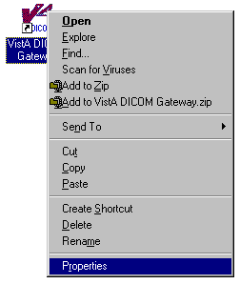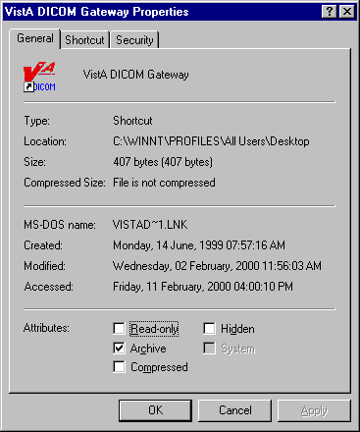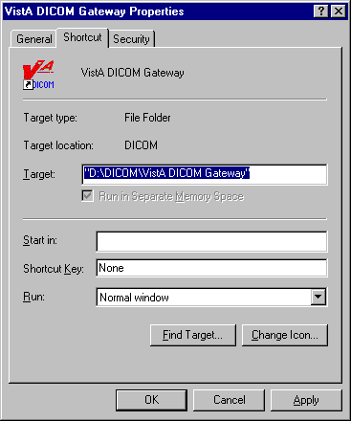

## A.3 Shortcuts for the VistA Imaging DICOM Gateway

The shortcuts for the VistA Imaging DICOM Gateway may be accessed by right-clicking the  button in the Windows menu bar. When this button is activated in this way, a menu will display. On this menu, click **Open All Users**.

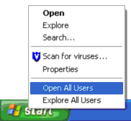

This option causes a directory window to be opened. In this window, navigate to the subdirectory that holds the shortcuts for the VistA Imaging DICOM Gateway:

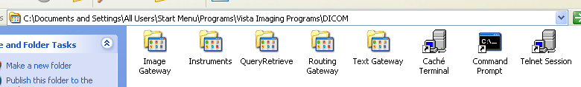

(First, double click the directory icon for **Programs**, then for **VistA Imaging Programs,** and then for **DICOM**).

## A.4 Directory Tree Containing Shortcuts

The installation program will define the following tree of shortcuts for easy access to the software. In this diagram, a number of abbreviations are used:

**%SystemRoot%** = The path-prefix for the directory that holds the Microsoft Windows operating system, typically “**c:\winnt\**” or “**c:\Windows\**”.

**d1** = The drive on which the data is installed, typically “**c**”.

**d2** = The drive on which the common software is installed, typically “**c**”.

**d3** = The drive on which the Caché database is installed, typically “**c**”.

**d4** = The drive on which the text data is being stored, typically “**c**”.

**d5** = The drive on which the image data is being stored, typically “**c**”.

|

+---**Telnet Session**

| Points to: d2:\Program Files\VistA\Imaging\DICOM\MAG_Telnet.exe

|

+---**Caché Terminal**

| Points to: d2:\Program Files\VistA\Imaging\DICOM\MAG_Telnet.exe

| Parameters: 127.0.0.1

|

+---**Command Prompt**

| Points to: %SystemRoot%\System32\cmd.exe

| Working Directory: %temp%

|

+---**DICOM Text Gateway**

| |

| +---**Process Text Messages**

| | Points to: d2:\Program Files\VistA\Imaging\DICOM\MAG_Telnet.exe

| | Parameters: TEXT_GATEWAY_1_1

| |

| +---**PACS Status**

| | Points to: d2:\Program Files\VistA\Imaging\DICOM\MAG_Telnet.exe

| | Parameters: PACS_COMMUNICATIONS_STATUS_1_3

| |

| +---**Modality Worklist Status**

| Points to: d2:\Program Files\VistA\Imaging\DICOM\MAG_Telnet.exe

| Parameters: MODALITY_WORKLIST_STATUS_1_4

|

+---**DICOM Image Gateway**

| |

| +---**Exam Complete**

| | Points to: d2:\Program Files\VistA\Imaging\DICOM\MAG_Telnet.exe

| | Parameters: PACS_EXAM_COMPLETE_2_1

| |

| +---**Request Images**

| | Points to: d2:\Program Files\VistA\Imaging\DICOM\MAG_Telnet.exe

| | Parameters: PACS_REQUEST_IMAGE_TRANSFER_2_2

| |

| +---**Process DICOM Images**

| | Points to: d2:\Program Files\VistA\Imaging\DICOM\MAG_Telnet.exe

| | Parameters: PROCESS_DICOM_IMAGES_2_3

| |

| +---**Image Status**

| | Points to: d2:\Program Files\VistA\Imaging\DICOM\MAG_Telnet.exe

| | Parameters: IMAGE_STATUS_2_5

| |

| +---**DICOM Viewer**

| Points to: d2:\Program Files\VistA\Imaging\DCMView\MAG_DCMView.exe

| Working Directory: d5:\DICOM

| Icon: d2:\Program Files\VistA\Imaging\DCMView\Viewer1.ico

|

+---**DICOM Routing Gateway**

| |

| +---**Start Transmitter**

| | Points to: d2:\Program Files\VistA\Imaging\DICOM\MAG_Telnet.exe

| | Parameters: START_TRANSMITTER_3_1

| |

| +---**Start Rule Evaluator**

| Points to: d2:\Program Files\VistA\Imaging\DICOM\MAG_Telnet.exe

| Parameters: START_EVALUATOR_3_3

|

+---**DICOM Instruments**

|

+---**Default**

Points to: d2:\Program Files\VistA\Imaging\DICOM\MAG_CStore.exe

Working Directory: d2:\Program Files\VistA\Imaging\DICOM

Parameters: localhost 60000 default

Icon: d1:\DICOM\Icons\MAG_CStore.ico, image # 0

# Appendix B Master Files

## B.1 Overview

The VistA Imaging DICOM Gateway uses a number of tables to drive certain parameterized procedures within the VistA Imaging DICOM Gateway software. These tables are populated from the data in a set of ASCII text files. In the context of the VistA Imaging DICOM Gateway, these text files are called “master files.”

Common usage within the Department of Veterans Affairs is to use the term “file” for a subtree of a global variable in MUMPS. The master files that are described in this chapter, however, are files in the more traditional sense: entities that live in directories within an operating system. To minimize confusion about the meaning of the term “file,” this chapter will reserve the term “file” for entities outside of MUMPS, and the term “table” for databases within a MUMPS environment.

## B.2 Master Files

The VistA Imaging DICOM Gateway uses a number of FileMan tables to drive the VistA Imaging DICOM Gateway software. These FileMan tables are populated from ASCII text data stored in master files located in a directory named **F:\DICOM\Dict**, (in this document, the drive-letter **F:** is used; see sections 3.3 and 3.4). The actual name for this directory is stored by the VistA Imaging DICOM Gateway software as data in **^MAGDICOM(2006.563,1,“DICT PATH”)**.

### B.2.1 Master File Menu Options

The menu of the VistA Imaging DICOM Gateway has a number of options that each import one, some or all of the master files. These menu options are:

4. System Maintenance

🡪 2. Gateway Configuration and DICOM Master Files

🡪 🡪 1. Display Gateway Configuration Parameters

🡪 🡪 2. Update Gateway Configuration

🡪 🡪 3. Update AETITLE.DIC

🡪 🡪 4. Update Instrument.DIC

🡪 🡪 5. Update Modality.DIC

🡪 🡪 6. Update PortList.DIC

🡪 🡪 7. Update SCU_List.DIC

🡪 🡪 8. Update WorkList.DIC

🡪 🡪 9. Reinitialize All the DICOM Master Files

🡪 🡪 10. Create Shortcuts for Instruments

🡪 🡪 11. Validate Access/Verify Codes for Modality Worklist

🡪 🡪 12. Display Versions and/or Time Stamps of Components

There are two groups of master files: static ones that are the same for all sites, and site-configurable ones that must be edited at each site.

### B.2.2 General Formatting Issues

* In all master files, lines that start with a number sign (“#”) are comment lines.
* Text lines that do not start with a number sign contain dictionary data.
* While updating master files, blank lines and comment lines will be ignored.

**Note**: The final line in any master file must be followed by an “end-of-line” control sequence (carriage return and line feed). If the final “end-of-line” control sequence is missing, the line will be invisible to the software that updates the master files. To prevent this problem, all distributed versions of the master files end with the following comment line:

# End of File<CR><LF>

## B.3 Static Master Files

This section describes the format and contents of the static master files, which are part of the release distribution of the VistA Imaging.

Static master files in this category contain data that is the same for all sites. These files may not be modified by the sites (reference VA directive and FDA warning).

The following files are included in the release:

| **File Name** | **FileMan Table** | **MUMPS Routine** | **Comment** |
| --- | --- | --- | --- |
| CT_PARAM.dic | 2006.5821 | ^MAGDMFB7 | Contains list of image processing rules for historical CT images. |
| DataGECT.DIC | 2006.511  sub 2006.5112 | ^MAGDIR4 | Contains list of data-items to be shown on diagnostic workstation displays. |
| Data_CR.DIC | 2006.511  sub 2006.5112 | ^MAGDIR4 | Contains list of data-items to be shown on diagnostic workstation displays. |
| DataMisc.DIC | 2006.511  sub 2006.5112 | ^MAGDIR4 | Contains list of data-items to be shown on diagnostic workstation displays. |
| Data_MRI.DIC | 2006.511  sub 2006.5112 | ^MAGDIR4 | Contains list of data-items to be shown on diagnostic workstation displays. |
| Element.DIC | 2006.51 | ^MAGDMFB2 | Contains DICOM Standard data elements. |
| HL7.DIC | 2006.57 | ^MAGDMFB7 | Contains list of HL7 message templates. |
| SCP_List.DIC | 2006.586 | ^MAGDMFB9 | Contains lists of parameters for Provider Applications |
| Template.DIC | 2006.52 | ^MAGDMFB3  ^MAGDMFB4 | Contains templates for DICOM messages. |
| UID.DIC | 2006.53 | ^MAGDMFB5 | Contains list of unique DICOM identifiers. |

### B.3.1 Element.DIC

The file **Element.DIC** contains the DICOM data dictionary. As part of the installation process, this file is read by routine **^MAGDMB2** and is used to construct the FileMan table **DICOM Data Element Dictionary** (File 2006.51, stored in **^MAGDICOM(2006.51,…)**).

In a DICOM data stream, every data element is identified by a four-byte binary “tag” consisting of a two-byte group field and a two-byte element field. The tag value is usually represented by two groups of four hexadecimal digits, separated by a comma (group, element, e.g. 0010,21B0 for Additional Patient History). Odd-numbered groups denote private elements and are accompanied by an explicit owner identification code.

The file **Element.DIC** contains three kinds of records:

The first is the “group” record, which for odd-numbered groups defines the owner identification code for private elements. Following the group record are one or more “element” records that define each element and its set of attributes. Some of the element records are followed by optional “value” records, which define the legal set of enumerated values or defined terms for the element.

The values of an element are “enumerated values” when the value of that element may be one of an explicitly specified set of standard values, which shall not be extended by implementers.

The values of an element are “defined terms” when the value of that element may be one of an explicitly specified set of standard values, which may be extended by implementers.

The formats for the different record types are as follows:

|  |  |
| --- | --- |
| • Group Record: | <group> | <group owner> | <group title> |
| • Element Record: | <tag> | <element name> | <value representation> | <multiplicity> | <value flag> | <retired flag> |
| • Value Record: | <tag> | <permitted value> |
| The different fields are defined below: | |
| <group> | The group identifier, expressed in four hexadecimal digits. |
| <group owner> | Blank for groups that are defined in the DICOM standard, and otherwise contains the name of or a mnemonic for the owner of the group. |
| <group title> | A name for the group for documentation purposes. |
| <tag> | Identifies the group and element(s), the value may contain hexadecimal digits and several wildcard characters. |
| <element name> | The name of the element (case-sensitive). |
| <value representation> | The 2-letter data type mnemonic. |
| <multiplicity> | Identifies the (maximum) number of values that may be passed at a time. |
| <retired flag> | An identifier that denotes that the element is no longer current. |
| <permitted value> | The enumerated value or defined term, along with its meaning. |

Example:

0010||Patient Information

0010,0000|Group Length|UL|1||

0010,0010|Patient's Name|PN|1||

0010,0020|Patient ID|LO|1||

0010,0021|Issuer of Patient ID|LO|1||

0010,0030|Patient's Birth Date|DA|1||

0010,0032|Patient's Birth Time|TM|1||

0010,0040|Patient's Sex|CS|1|E|

0010,0040|M=male

0010,0040|F=female

0010,0040|O=other

0039|VA DHCP|Admission, Discharge, and Transfer Information Shadow

0039,0000|Group Length|UL|1||

0039,0010:1:00FF|Owner of Group|LO|1||

0039,xx10|Current Patient Location Sequence|SQ|1||

0039,xx20|Patient's Institutional Residence Sequence|SQ|1||

When a <tag> contains an “x,” this means that it is a private element and the same definition applies to all tags that have any hexadecimal digit in the position of that “x.”

When a tag contains a value of the format <start>:<step>:<end>, this means that the same definition applies to all values covered by that range definition.

The information in Element.DIC is extracted directly from the DICOM standard (element definitions are specified in **Part 6: Data Dictionary (PS 3.6)**; lists of permitted values are specified in **Part 3: Information Object Definitions (PS 3.3)**).

The data from this file is stored in MUMPS in the following structure:

^MAGDICOM(2006.51,d0,0) = group , element [ , owner ] ^ name ^ VR ^ mult ^ flag

^MAGDICOM(2006.51,d0,1,d1,0) = value ^ meaning

^MAGDICOM(2006.51,“B”, group element [owner], d0) = “”

^MAGDICOM(2006.51,d0,1,“B”,value,d1) = “”

### B.3.2 HL7.DIC

The file **HL7.DIC** contains the definitions of the recognized HL7 messages. As part of the installation process, this file is read by routine **^MAGDMB7** and is used to construct the FileMan table **DICOM HL7 SEGMENT** (File 2006.57, stored in **^MAGDICOM(HL7,…)**).

The routine **^MAGDHRP** uses the values in this table to produce a formatted HL7 message listing.

Each record consists of two pieces. The first piece is either the HL7 segment identifier (if it is alphanumeric), or it contains the HL7 segment field number (if it is numeric). The second piece is text that defines either the name of the segment or the name of the field.

Example of an HL7 segment with its fields:

PID|Patient Identification Segment

1|Set ID - Patient ID

2|Patient ID (External ID)

3|Patient ID (Internal ID)

4|Alternate Patient ID

5|Patient Name

6|Mother's Maiden Name

7|Date of Birth

8|Sex

9|Patient Alias

10|Race

11|Patient Address

12|Country Code

13|Phone Number - Home

14|Phone Number - Business

15|Language - Patient

16|Marital Status

17|Religion

18|Patient Account Number

19|SSN Number - Patient

20|Driver's Lic Num - Patient

21|Mother's Identifier

22|Ethnic Group

The data from this file is stored in MUMPS in the following structure:

^MAGDICOM(“HL7”,d0,0) = segment ^ name of segment

^MAGDICOM(“HL7”,d0,1,d1,0) = name of element

^MAGDICOM(“HL7”,“B”,segment,d0) = “”

### B.3.3 CT_PARAM.DIC

The file **CT_PARAM.DIC** contains the definitions of historical CT parameters used by VA sites that are supported by the VistA Imaging DICOM Gateway. The primary purpose of this file is for CT images processed before installation of Imaging Patch 30. (In images processed after the installation of Patch 30, image processing rules are saved into the image’s .txt file, and the CT_PARAM.DIC file is not used.)

There is one type of record in **CT_PARAM.DIC**.

|  |  |
| --- | --- |
| • Application Record: | <Site Code> | <Manufacturer>|<Model>|<Latest Date Saved>|<Image Processing Rules> |
| The different fields in this record are defined below: | |
| <Site Code> | Also known as the Institution Code. |
| <Manufacturer> | The manufacturer of the equipment producing the images; element (0008,0070). |
| <Model> | The manufacturer’s model name for the equipment; element (0008,1090). |
| <Latest Date Saved> | The last date this specific image processing rule was set or changed in Modality.dic. |
| <Image Processing Rules> | Control the conversion of the image from DICOM to Targa file format. |

Example of entries in CT_PARAM.DIC:

442|TOSHIBA|AQUILION|9-Jun-2006|b12 a2048 f0 c4095

442|TOSHIBA|ASTEION|25-Feb-2005|b12

442|PHILIPS|BRILLIANCE16|14-Jul-2006|

442|GE MEDICAL SYSTEMS|HISPEED|4-May-2004|b12 a1000 f0 c4095

442|GE MEDICAL SYSTEMS|HISPEED CT/I|9-Jun-2006|b12 f0

442|GE MEDICAL SYSTEMS|LIGHTSPEED16|9-Jun-2006|b12 f0 c4095

442|PHILIPS|MX8000|9-Jun-2006|b12

442|PHILIPS|MX8000 IDT 16|9-Jun-2006|b12 f0 c4095

442|PICKER INTERNATIONAL, INC.|PQ5000|9-Jun-2006|b12 a1000 f0 c4095

### B.3.4 SCP_List.DIC

The file **SCP_List.DIC** contains the definitions of the applications that are supported by the VistA Imaging DICOM Gateway operating in the role of a **S**ervice **C**lass **P**rovider (SCP). As part of the installation process, this file is read by routine **^MAGDMB9** and is used to construct the FileMan table **Provider Application List** (File 2006.586, stored in **^MAGDICOM(2006.586,…)**).

There are three kinds of records in the file **SCP_List.DIC**. The first is the “application” record, which identifies the name of the VistA service class provider. Following the application record are one or more “service” records defining the services that may be utilized. Following a “service” record, there is at least one “transfer syntax” record, defining how information may be exchanged.

|  |  |
| --- | --- |
| • Application Record: | <called AE title> | <application name> |
| • Service Record: | | <SOP Class> |
| • Transfer Syntax Record: | | | <syntax> |
| The different fields are defined below: | |
| <called AE title> | The title of the called VistA provider (SCP) application entity. |
| <application name> | The name that VistA uses to refer to the DICOM application. |
| <SOP Class> | The name of the DICOM service object pair (SOP). |
| <syntax> | is the name of a supported transfer syntax |

Currently, there are three possible transfer syntaxes:

1. Implicit VR, Little Endian
2. Explicit VR, Little Endian
3. JPEG Baseline (Process 1):Default Lossy JPEG 8 Bit Compression

Example of entries in SCP_LIST.DIC:

# VistA Service Class Providers

# <VistA Application Entity Title> | <application name>

# | <supported SOP class>

#

VISTA_WORKLIST|VistA Modality Worklist

|Verification SOP Class

||Implicit VR Little Endian

|Modality Worklist Information Model – FIND

||Implicit VR Little Endian

#

VISTA_STORAGE|VistA Storage

|Verification SOP Class

||Explicit VR Little Endian

||Implicit VR Little Endian

|Computed Radiography Image Storage

||Explicit VR Little Endian

||Implicit VR Little Endian

|CT Image Storage

||Explicit VR Little Endian

||Implicit VR Little Endian

|Ultrasound Multi-frame Image Storage (retired)

||Explicit VR Little Endian

||Implicit VR Little Endian

The data from this file is stored in MUMPS in the following structure:

^MAGDICOM(2006.586,d0,0) = AE Title ^ Application name

^MAGDICOM(2006.586,d0,1,d1,0) = SOP Class UID ^ SOP Class Name

^MAGDICOM(2006.586,d0,1,d1,1,d2,0)

= Transfer Syntax UID ^ Transfer Syntax Name

^MAGDICOM(2006.586,“B”,AE Title,d0) = “”

^MAGDICOM(2006.586,d0,1,“B”,SOP Class UID,d1) = “”

^MAGDICOM(2006.586,d0,1,d1,1,“B”,Transfer Syntax UID,d2) = “”

### B.3.5 Template.DIC

The file **Template.DIC** contains model definitions of the messages that are supported by the VistA Imaging DICOM Gateway. As part of the installation process, this file is read by routines **^MAGDMB3** and **^MAGDMFB4** and is used to construct the file **F:\DICOM\ Dict\Template.TMP** and the FileMan table **DICOM Message Template Dictionary** (File 2006.52, stored in **^MAGDICOM(2006.52,…)**).

DICOM data elements are the attributes of the Service Classes and the Information Object Definitions. The service classes and information object definitions are joined together to form the Service-Object Pair (SOP) classes. The SOP classes are the high-level communications message protocol units of DICOM.

The file **Template.DIC** defines the way that the DICOM data elements are combined to make up the SOP Classes. The file **Template.DIC** contains attributes of the service classes, the information object definition modules, and the SOP classes. Because the same set of attributes is often repeated in several different SOP classes, the gateway master file update software uses a macro facility so that the attributes can be defined once and used multiple times. The file **Template.DIC** is expanded by the macro facility (routine **^MAGDMFM4**) to create the file **Template.TMP**, which contains the model of each DICOM message. The routine **^MAGDMFB3** routine invokes **^MAGDMFM4** to expand the macros, and then reads the resulting file **F:\DICOM\ Dict\Template.TMP** to populate the FileMan table in global variable ^MAGDICOM(2006.52).

The format for the macro definitions is as follows:

{$define <name of macro>}

<body of macro>

{$end <name of macro>}

The macro facility performs simple text replacement. When a macro is invoked, the invocation is replaced by the macro text. The format for a macro invocation is {<name of macro>}. The macro invocation is replaced with <body of macro> in the expanded text. Macros may be nested.

The <body of macro> (i.e., the macro text) consists of a sequence of DICOM Element Records and (optional) Macro Invocation Records. The formats for these two types of records are as follows:

|  |  |
| --- | --- |
| • Element Record: | <element name> | <tag> | <group owner> | <SCP/SCU Type> |<default value> |
| • Macro Invocation: | {<name of macro>} |
| The different fields are defined below: | |
| <element name> | The case-sensitive name of the element. |
| <tag> | The group and element numbers, in (gggg,eeee) hexadecimal format. |
| <group owner> | The name/mnemonic for the owner of the group. |
| <SCP/SCU Type> | The SCP and SCU DICOM Type (1, 1C, 2, 3, etc.). |
| <default value> | The default value of the element in the message. |

Example of a macro definition:

{$define N-EVENT-REPORT-RQ}

Affected SOP Class UID|(0000,0002)||1/1|

Command Field|(0000,0100)||1/1|0100H

Message ID|(0000,0110)||1/1|

Priority|(0000,0700)||1/1|

Data Set Type|(0000,0800)||1/1|0003H

Affected SOP Instance UID|(0000,1000)||1/1|

Event Type ID|(0000,1002)||1/1|

{$end N-EVENT-REPORT-RQ}

Macros are used for building model message templates.

A message template consists of four different types of records. The “template” record identifies the beginning of the message template. The “SOP” record defines the SOP class for the template. The “element” and “macro invocation” records define the element attributes of the template. The different fields for the “template” and “sop” records are defined below:

|  |  |
| --- | --- |
| • Template Record: | $TEMPLATE | <message name> | <DIMSE> | <typename> | <typeid> |
| • SOP Record: | $SOP | <SOP class name> |
| • Element Record: | <element name> | <tag> | <group owner> | <SCP/SCU Type> | <default value> |
| • Macro Invocation: | {<name of macro>} |
| The different fields for the “template” and “sop” records are defined below: | |
| <message name> | The name of the template. |
| <DIMSE> | The DICOM Message Service Element. |
| <typename> | The DICOM Event Type Name. |
| <typeid> | The DICOM Event Type Id. |
| <SOP class name> | The case-sensitive name of the SOP class defined in the UID.DIC file. |

**Note**: Refer to the **DICOM standard, Part 4 Service Class Specifications (PS 3.4)** for the definition of the DICOM terms.

Example of a template definition:

$TEMPLATE|PATIENT DEMOGRAPHIC CHANGE|N-EVENT-REPORT|Patient Updated|3|

$SOP|VA Detached Patient Management SOP Class

{N-EVENT-REPORT-RQ}

Instance Creation Date|(0008,0012)||-/2|

Instance Creation Time|(0008,0013)||-/2|

Instance Creator UID|(0008,0014)||-/2|

{Patient Data}

{Message Handle}

The element information in the file **Template.DIC** is extracted directly from the DICOM standard, **Part 6: Data Dictionary (PS 3.6)** and **Part 7:Message Exchange (PS 3.7)**. The list of attributes comes from **Part 3: Information Object Definitions (PS 3.3)** and **Part 7:Message Exchange (PS 3.7)**.

See <http://medical.nema.org/dicom/> for more information about the DICOM standard.

The data from this file is stored in MUMPS in the following structure:

^MAGDICOM(2006.52,d0,0) = Title ^ DIMSE ^ SOP Class ^ Type Name ^ Type ID

^MAGDICOM(2006.52,d0,1,d2,0) = tag ^ name ^ SCP type / SCU type ^ Value ^ Pointer

^MAGDICOM(2006.52,“B”,Title,d0) = “”

### B.3.6 UID.DIC

The file **UID.DIC** contains the definitions of the unique identifiers for SOP classes, transfer syntax’s and class instances for the DICOM standard. As part of the installation process, this file is read by routine **^MAGDMB5** and is used to construct the FileMan table **DICOM UID Dictionary** (File 2006.53, stored in **^MAGDICOM(2006.53,…)**).

DICOM uses a unique object identification scheme based upon ISO-9834-3. This standard uses numeric fields separated by periods that are assigned in a left-to-right hierarchical fashion in order to allow uniqueness. All DICOM standard UIDs have the root **1.2.840.10008**, and UIDs generated by the VA have the root **1.2.840.113754**.

The file **UID.DIC** contains all the pre-defined UID values that are used by the VistA DICOM applications.

The file UID.DIC contains two types of records:

|  |  |
| --- | --- |
| • UID Record: | <UID Value> | <UID Name> | <UID Type> | <Reference> | <Function> |
| • Meta Record | | <UID Value> | <UID Name> |
| When a UID identifies a Meta SOP Class, the record for the Meta SOP Class will be followed by one or more Meta records. In such a case, each Meta record defines one UID that identifies a SOP class that is a member of the Meta SOP class. | |
| The different fields are defined below: | |
| <UID Value> | The unique period delimited numeric string that represents the value of the UID |
| <UID Name> | The text name for the UID; 1:1 mapping between <UID Value> and <UID NAME>. |
| <UID Type> | Indicates the usage for the UID. |
| <Reference> | Documents where the UID is officially defined. |
| <Function> | Identifies which UIDs are supported by VistA Storage (for example, S for Storage). |

Example of some UID definitions:

1.2.840.10008.1.1|Verification SOP Class|SOP Class|Part 4|*

1.2.840.10008.3.1.2.1.4|Detached Patient Management Meta SOP Class

|Meta SOP Class|Part 4|

|1.2.840.10008.3.1.2.1.1|Detached Patient Management SOP Class

|1.2.840.10008.3.1.2.2.1|Detached Visit Management SOP Class

1.2.840.113754.3.1.2.1.4|VA Detached Patient Management Meta SOP Class

|Meta SOP Class|Part 4|S

|1.2.840.113754.3.1.2.1.1|VA Detached Patient Management SOP Class

|1.2.840.113754.3.1.2.2.1|VA Detached Visit Management SOP Class

The UID information in the file **UID.DIC** is extracted directly from the DICOM Standard, **Part 6: Data Dictionary (PS 3.6)** and material supplied by the Imaging Project.

The data from this file is stored in MUMPS in the following structure:

^MAGDICOM(2006.53,d0,0) = Name ^ UID Code ^ Type ^ Reference

^MAGDICOM(2006.53,d0,1,d1,0) = Name ^ UID Code

^MAGDICOM(2006.53,“B”,Name,d0)= “”

^MAGDICOM(2006.53,“C”,UID Code,d0) = “”

^MAGDICOM(2006.53,d0,1,“B”,Name,d1) = “”

^MAGDICOM(2006.53,d0,1,“C”,UID Code,d1) = “”

### B.3.7 Additional Data

Certain DICOM elements are extracted from the DICOM image header and copied into the “about image” text file when an image is processed. These data items are then displayed on the diagnostic workstation with the image.

Different items may be selected and displayed for different modalities. Currently, the following files with lists of additional data-items are available:

* DataGECT.DIC (specific for CT equipment from General Electric and others)
* Data_CR.DIC (specific for CR equipment)
* DataMisc.DIC (general for any other equipment)
* Data_MRI.DIC (specific for MRI equipment)

In these files, each line that defines a data-item consists of two parts: the first part identifies an attribute tag and the second part specifies an attribute name, e.g.:

0008,0070|Manufacturer

The data from these files is stored in MUMPS in the following structure:

^MAGDICOM(2006.511,d0,0) = filename

^MAGDICOM(2006.511,d0,1,d1,0)=tag ^ name

^MAGDICOM(2006.511,“B”,filename,d0) = “”

#### B.3.7.1 DataMisc.DIC

The file DataMisc.DIC contains a list of general-purpose elements to be displayed. These data-items are:

0008,0008|Image Type

0008,0023|Image Date

0008,0033|Image Time

0008,0060|Modality

0008,0070|Manufacturer

0008,0080|Institution Name

0008,1010|Station Name

0008,1090|Manufacturer's Model Name

0018,0010|Contrast/Bolus Agent

0018,0015|Body Part Examined

0018,5100|Patient Position

0020,0010|Study ID

0020,0011|Series Number

0020,0012|Acquisition Number

0020,0013|Image Number

0020,0032|Image Position (Patient)

0028,0004|Photometric Interpretation

0028,0010|Rows

0028,0011|Columns

0028,0030|Pixel Spacing

0028,0101|Bits Stored

0028,0102|High Bit

0028,0103|Pixel Representation

0028,1052|Rescale Intercept

0028,1053|Rescale Slope

**Note**: In the following lists, the highlighted lines are additional fields.

#### B.3.7.2 DataGECT.DIC

The data-items for CTs from General Electric (and other manufacturers) are:

0008,0008|Image Type

0008,0023|Image Date

0008,0033|Image Time

0008,0060|Modality

0008,0070|Manufacturer

0008,0080|Institution Name

0008,1010|Station Name

0008,1090|Manufacturer's Model Name

0018,0010|Contrast/Bolus Agent

0018,0015|Body Part Examined

0018,0050|Slice Thickness

0018,0060|KVP

0018,1100|Reconstruction Diameter

0018,1120|Gantry/Detector Tilt

0018,1150|Exposure Time

0018,1151|X-ray Tube Current

0018,1190|Focal Spot(s)

0018,1210|Convolution Kernel

0018,5100|Patient Position

0020,0010|Study ID

0020,0011|Series Number

0020,0012|Acquisition Number

0020,0013|Image Number

0020,0032|Image Position (Patient)

0020,0060|Laterality

0020,1040|Position Reference Indicator

0020,1041|Slice Location

0028,0004|Photometric Interpretation

0028,0010|Rows

0028,0011|Columns

0028,0030|Pixel Spacing

0028,0101|Bits Stored

0028,0102|High Bit

0028,0103|Pixel Representation

0028,1052|Rescale Intercept

0028,1053|Rescale Slope

#### B.3.7.3 Data_CR.DIC

The data-items for CRs are:

0008,0008|Image Type

0008,0023|Image Date

0008,0033|Image Time

0008,0060|Modality

0008,0070|Manufacturer

0008,0080|Institution Name

0008,1010|Station Name

0008,1090|Manufacturer's Model Name

0018,0010|Contrast/Bolus Agent

0018,0015|Body Part Examined

0018,1004|Plate ID

0018,1400|Acquisition Device Processing Description

0018,1405|Relative X-ray Exposure

0018,5100|Patient Position

0018,6000|Sensitivity

0020,0010|Study ID

0020,0011|Series Number

0020,0012|Acquisition Number

0020,0013|Image Number

0020,0032|Image Position (Patient)

0028,0004|Photometric Interpretation

0028,0010|Rows

0028,0011|Columns

0028,0030|Pixel Spacing

0028,0101|Bits Stored

0028,0102|High Bit

0028,0103|Pixel Representation

0028,1052|Rescale Intercept

0028,1053|Rescale Slope

#### B.3.7.4 Data_MRI.DIC

The data items for MRIs are:

0008,0008|Image Type

0008,0023|Image Date

0008,0033|Image Time

0008,0060|Modality

0008,0070|Manufacturer

0008,0080|Institution Name

0008,1010|Station Name

0008,1090|Manufacturer's Model Name

0018,0010|Contrast/Bolus Agent

0018,0015|Body Part Examined

0018,0020|Scanning Sequence

0018,0080|Repetition Time

0018,0081|Echo Time

0018,0083|Number of Averages

0018,0091|Echo Train Length

0018,1310|Acquisition Matrix

0018,5100|Patient Position

0020,0010|Study ID

0020,0011|Series Number

0020,0012|Acquisition Number

0020,0013|Image Number

0020,0032|Image Position (Patient)

0028,0004|Photometric Interpretation

0028,0010|Rows

0028,0011|Columns

0028,0030|Pixel Spacing

0028,0101|Bits Stored

0028,0102|High Bit

0028,0103|Pixel Representation

0028,1052|Rescale Intercept

0028,1053|Rescale Slope

## B.4. Site-Specific Master Files

This section describes the format and contents of the site-specific master files.

Currently, the following files exist:

| **File Name** | **FileMan Table** | **Comment** |
| --- | --- | --- |
| AETITLE.DIC | 2006.588 | MAGDICOM |
| Instrument.DIC | 2006.581 | Contains list of operational instruments. |
| Modality.DIC | 2006.582 | Contains list of parameters for handling modalities. |
| Portlist.DIC | 2006.584 | Contains list of port numbers for handling instruments. |
| SCU_List.DIC | 2006.585 | Contains lists of parameters for User Applications. |
| Worklist.DIC | 2006.583 | Contains list of parameter for Modality Worklist handling. |
| DICOM HEALTHCARE PROVIDER SERVICE | 2006.5831 | Contains mapping of Request Services (^GMR(123.5)) to Image Index For Specialty/Subspecialty (^MAG(2005.84)) |

The contents of the files in this section need to be customized to reflect the actual attributes used at the site.

**Note**: These changes should be made to the text file dictionaries in **DICOM\Dict** only. The software will load this information from these dictionary files into the global variables, overwriting any previously saved information.

**Note:** in the .dic files, leading and trailing spaces are ignored when the data is imported into the database. This makes it possible to align information for easier reading:

#

RADIOLOGY ||RAD| RAD |LONG|Local Vista Modality Worklist provider

DENTAL ||CON| DENT |LONG|Local dental worklist provider

OPHTHALMOLOGY ||CON| OPHTH |LONG|Local eye care worklist provider

OPTOMETRY ||CON| OPTOM |LONG|Local optometry worklist provider

CARDIOLOGY ||CON| CARDIO |LONG|Local cardiology worklist provider

#

### B.4.1 AETITLE.DIC

The file APPLICATION ENTITY TITLE (#2006.588) on the DICOM Gateway provides aliases for APPLICATION ENTITY TITLES stored in the global ^MAGDICOM (2006.588) and AE_TITLE.DIC file.

DICOM negotiation requests now require known Called Application Entity Titles so that acceptable presentation contexts in SCP_LIST.DIC can be properly identified.

AE_TITLE.DIC is an Application Entity Title dictionary. The AE_TITLE.DIC is used to map the Called Application Entity Title of a DICOM negotiation request to the alias that identifies the VistA Application Entity Title name for the SCP. This is used for looking up acceptable presentation contexts in SCP_LIST.DIC. The Called Application Entity Title for a DICOM request must either be the VistA Application Entity Title name for the SCP defined in SCP_LIST.DIC (for example, “VistA_Storage”) or else one defined in AE_TITLE.DIC as an alias for the VistA one. Otherwise, the DICOM negotiation request will be rejected.

The default Mallinckrodt SEND_IMAGE.EXE Called Application Entity Title “DICOM_STORAGE” is mapped to “VistA_Storage” in the distributed version of AE_TILE.DIC as shown below. (The mapping is not case-sensitive.)

The AE_TITLE.DIC is also used to record names associated with Application Entity Titles. (For example, “Walter Reed AMC” is the site name for the Application Entity Title “OS1WRAMC”.)

Add any entries to AE_TITLE.DIC (none may be needed) and run Menu Option 4-2-3.

# Last edited 30 July 2008, 11:43 am

#

# Application Entity Title

# <Application Entity Title> | <VistA Application Title Alias> | <Site Name>

#

# This entry is for Mallinckrodt Send_Image

DICOM_STORAGE|VistA_Storage|VistA Imaging Testing

#

# Put your entries here

#

#

# end of file

### B.4.2 Instrument.DIC

The file **Instrument.DIC** contains the definitions of the various image acquisition devices that the site uses. Menu Option 4.2.4, Update INSTRUMENT.DIC, reads this file to populate the Instrument Dictionary file (#2006.581). This is done as part of the installation process, and whenever operational information has changed at the site.

Use the VistA Imaging DICOM Gateway menu to update this master file as follows:

4. System Maintenance

🡪 2. Gateway Configuration and DICOM Master Files

🡪 🡪 4. Update Instrument.DIC

Each image producing instrument must send its images to a VistA storage provider. In the VistA DICOM Image Gateway, there is a separate storage provider process running on a dedicated network port for each instrument that produces images. The file **Instrument.DIC** lists each image producing instrument and its dedicated communications port, along with its corresponding imaging service.

An entry in the file **Instrument.DIC** is formatted as follows:

<mnemonic> | <description> | <institution name> | <imaging service> | <port> [ | <machine ]

The different fields are defined below:

<mnemonic> A short code for the instrument created by the site (it must be unique). Typically abbreviations like **CR1**, **CT2**, **NM, GI-FLUORO**, and so forth.

<description> Free text describing the instrument and its location.

<institution name> The name of the institution (as defined in Piece(^DIC(4,ien,0),”^”,1)). It also may be the site ID or may be left null (default is the site of the DICOM Gateway).

<imaging service> Indicates where the orders and reports are placed on the hospital information system (“RAD” or “CON” – see below)

<port> The network communications port number (this must be unique, see Appendix E)

<machine> Identifies the Image Gateway computer that will receive image files from this instrument (optional parameter, free text)

Example of a portion of the INSTRUMENT.DIC file:

# Computed Radiography

CR1|Fuji AC3 CR, Room 2156|Wilmington, DE|RAD|60050|ISWIMGDIG1

CR2|Fuji AC3 CR, Room 2160 (Chest)|Wilmington, DE|RAD|60051|ISWIMGDIG3

CR3|Fuji AC3 CR, Cubby, 2145 Hallway|Wilmington, DE|RAD|60052

#

# Computed Tomography

CT1|GE High Speed Advantage, Room 2142|Wilmington, DE|RAD|60060|ISWIMGDIG1

#

In the previous example, please observe that there are **four** different instruments and **two** different modalities.

The site must create an entry in the file **Instrument.DIC** for each piece of equipment that is going to produce images and send them to VistA. Otherwise, the DICOM Gateway cannot acquire the images from the equipment.

Please note that the port numbers must be unique for every instrument. Use a unique port even where several different VistA DICOM Image Gateways are used. Making the port numbers unique, makes it possible to redirect the output of any image producing instrument to a different VistA DICOM Image Gateway by adding a second IP address to the gateway. The recommended port number scheme is included in Appendix E.

Names of institutions must be spelled exactly, as in the Institution File (File number 4, stored in ^DIC(4,...)). These names are processed in a case-insensitive fashion. Only the part of the name before the first comma needs to match the value in the institution file. Any other punctuation characters that occur in that part of the official name must appear in the value that is entered here.

If no name is specified for the name of an institution, the default value from the gateway site will be used.

Names of imaging services must be either “**RAD**,” for radiology, or “**CON**,” for Healthcare Providers (consults).

**Note**: The names must be spelled in all upper-case characters.

The optional sixth parameter identifies the Image Gateway to which the instrument will transmit its image files. DICOM Gateways are identified by the host-name of their computer. Host-names are typically assigned by IRM and site management, and usually follow VA-wide naming conventions.

**Note**: The value in this sixth parameter is used only by menu option **4-2-10** (Create Shortcuts for Instruments). When this menu option creates the batch-file that starts all C-Store “listeners”, it will include only those instruments that are marked as specific to the machine on which this menu option is executed.

A sample file **Instrument.Sample** is supplied with the VistA Imaging DICOM Gateway distribution, and may be edited by adding and/or deleting the pound signs (“#”). During an initial installation, this sample file is renamed to **Instrument.DIC**. When performing an upgrade, the existing copy of this file will remain unaffected. Information from the sample file may be manually transferred to the operational master file at the discretion of the site.

#### ~~B.4.2.1 Icons for Instruments~~

~~Normally, icons will be generated for all instruments at the end of an installation when the program ^MAGDMFIC is run. The Site Manager can then adjust the icons in the window to show only those storage providers that are actually being used on the current PC.~~

~~When set-up parameters need to be modified for one of these icons, it is important to know the values that should be entered. The typical values for each of these icons are shown below.~~

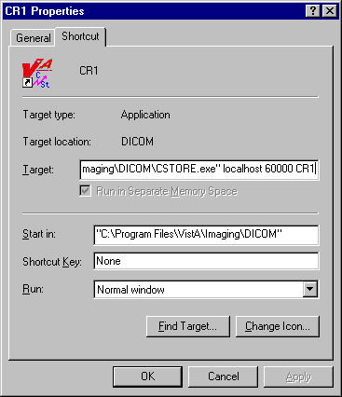

~~In the example above, the complete value for “target” would be:~~

**~~"C:\Program Files\VistA\Imaging\DICOM\MAG_CSTORE.exe" localhost 60000 CR1~~**

**~~Note:~~**  ~~The quotes around the path-name for the C-Store program are required.~~

~~The entry for “Target” should link the icon to the “C-Store” program, and specify the parameters:~~

* ~~IP-address is always “~~**~~localhost~~**~~” (never modify this value).~~
* ~~Port number is always~~ **~~60000~~** ~~(never modify this value).~~
* ~~Instrument name is the abbreviation for the instrument, e.g. “~~**~~CR1~~**~~” (only modify this value to reflect changes made in the master file~~ **~~Instrument.DIC~~**~~).~~

~~The icon can be changed to be more descriptive for the type of instrument. For CRs, the distributed system provides two sample icons:~~



~~The end-user may select any other icon that would be more descriptive of the instrument.~~

### B.4.3 Modality.DIC

The file **Modality.DIC** contains the definitions of the parameters that the DICOM Gateway needs to process image files, store them on the file server, and associate them with the patient record. Menu Option 4.2.5, Update MODALITY.DIC, reads this file to populate the Modality Type Dictionary File (#2006.582). This is done as part of the installation process and whenever operational information has changed at the site.

Use the VistA Imaging DICOM Gateway menu to update this master file as follows:

4. System Maintenance

🡪 2. Gateway Configuration and DICOM Master Files

🡪 🡪 5. Update Modality.DIC and Data*.DIC

#### B.4.3.1 Image Processing Overview

After the gateway acquires images, it has to process them and incorporate them into the patient medical record. The rules for processing the images produced by each different kind of modality are stored in the file **Modality.DIC**.

Each time the gateway processes an image, it does the following:

1. Extracts the patient and study information from the image header.
2. Looks up the study on VistA using the patient and study information from the image header.
3. Creates the image abstract (also known as thumbnail or icon).
4. Processes the image according to the image format and parameters specified in the field <image processing rules> in the file **Modality.DIC**. Images can be stored in their original DICOM format or converted in TARGA (*.TGA) format. For more information, see section *B.4.3.2.1 Image Processing Rules*.
5. Saves image attributes from the header in a text (*.TXT) file.

#### B.4.3.2 Assigning Field Values for the Modality Dictionary

The file **Modality.DIC** determines how the DICOM Gateway stores images. The structure of each record is:

Modality Record: <mfgr> | <model> | <modality> | <image processing rules> | <accession number code> | <text data code>| <text data file> | <imaging service>

The different fields are:

<mfgr> The manufacturer of the equipment producing the images; element (0008,0070).

<model> The manufacturer’s model name for the equipment; element (0008,1090).

<modality> The official DICOM defined term for the modality; element (0008,0060).

<image processing rules> The rules that control the format in which the image is stored. For more information about the syntax of the image processing rules, see section *B.4.3.2.1 Image Processing Rules*.

<accession number code> The name of the M routine used to extract the accession number from image header. The typical value is **CORRECT^MAGDIR3**.

<text data code> The M routine for outputting text data (*.TXT) for diagnostic workstation. This is how Hounsfield units are calculated for CT images.

<text data file> A text file that lists DICOM attributes to output as text (*.TXT) for diagnostic workstation (see *B.3.7 Additional Data* for a description of the format of a text data file).

<imaging service> A parameter that indicates where the orders and reports are placed on the hospital information system. The value is either **RAD** for radiology or **CON** for consult. It is used to select imaging service-specific processing.

The file **Modality.DIC** includes defaults as well as entries for different modalities. If there is no definition for the specific device, the DICOM Gateway uses the default definitions.

**Note:** There can be multiple entries for an instrument, if the instrument produces more than one type of image.

There are several types of default definitions:

* The general default modality definition must always be present in the file **Modality.dic** and should never be modified.

DEFAULT| DEFAULT|DEFAULT|<DICOM>|CORRECT^MAGDIR3||DATAMISC.DIC|RAD

* You can also set up modality-specific defaults for each modality type, as noted below and illustrated in the example. Including these definitions, while optional, is strongly recommended so that individual modalities can be converted to DICOM storage one at a time. Additional examples can be found in the **Modality.sample** file provided during installation.

DEFAULT| DEFAULT|CR|R8/<DICOM>|CORRECT^MAGDIR3||DATAMISC.DIC|RAD

* In addition to the default definitions, you can set up or continue using modality-specific definitions by manufacturer, model, and modality as illustrated in the following example.

ACME, Inc.|Coyotes Rule|CT|<DICOM>|CORRECT^MAGDIR3||DATAGECT.DIC|RAD

The DICOM Gateway applies the modality definitions in the following order of specificity:

1. Manufacturer, model, and modality
2. General by modality type
3. General

If there is a specific modality definition for a modality, manufacturer, and model, these settings will apply to that modality. If such a definition is missing, the default setting for the modality type for the modality will apply. If this setting is also missing, the general default definition will apply.

We recommend using the defaults for all modalities. Use device-specific definitions only for devices if the images from these devices do not display properly when stored in DICOM format. For more information, see *B.4.3.2.1 Image Processing Rules.*

The MODALITY.DIC entry for the image acquisition device should specify “**<DICOM>**” in the <image processing rules> field when the image should be stored in DICOM format. Typically, the entry should specify “**CORRECT^MAGDIR3**” in the <accession number code> field. The “RoadRunner” example illustrates this:

# Examples:

#

# ACME CT Company|BETA|CT|b12 f0|GECT^MAGDIR3|GECTHISA^MAGDIR4A|datagect.dic|**RAD**

#

# RoadRunner, INC|Beep-Beep|OT|**<DICOM>**|**CORRECT^MAGDIR3**||datamisc.dic|**CON**

#

# end of file

The next example shows a configuration to handle a CT study containing both standard and Secondary Capture images. The normal CT SOP Class-based images will process into a Targa images. The accompanying Secondary Capture SOP Class-based image will process but stay as a DICOM image. The trigger to accomplish this is the <SC> pseudo modality type.

# Examples:

#

Roadrunner, Inc.|Beep-Beep|CT|b12 a1000 f0 c4095|LONGCASE^MAGDIR3||datagect.dic|RAD

Roadrunner, Inc.|Beep-Beep|<SC>|<DICOM>|CORRECT^MAGDIR3||DATAMISC.DIC|RAD

#

# end of file

The <SC> pseudo-modality code can only be used for scanners that support the SOP classes listed below. (Note: These objects can only be saved as DICOM, not as TGA.):

* 1.2.840.10008.5.1.4.1.1.7 (Secondary Capture Image Storage)
* 1.2.840.10008.5.1.4.1.1.7.2 (Multi-frame Grayscale Byte Secondary Capture Image Storage)
* 1.2.840.10008.5.1.4.1.1.7.3 (Multi-frame Grayscale Word Secondary Capture Image Storage)
* 1.2.840.10008.5.1.4.1.1.7.4 (Multi-frame True Color Secondary Capture Image Storage)

##### B.4.3.2.1 Image Processing Rules

Images are converted from the DICOM format to the Targa format by the program MAG_DCMTOTGA.EXE. The image processing rules are parameters of MAG_DCMTOTGA.EXE and control the conversion process. The rules are specified in the master file **Modality.DIC**. They are not case-sensitive.

Two sets of rules, separated by a slash (/), can be placed in the <image processing rules> field of the modality record. When two sets of rules are present in the same record, the first set of rules defines the reduced size image. The second set defines the full size image that the diagnostic workstation uses.

The value **<DICOM>** in a rule indicates that the DICOM Gateway should store the full size images in DICOM format (with a .DCM extension). When the value **<DICOM>** is not present in the rule, the DICOM Gateway stores the full size image with a .BIG extension.

In addition to the full size image, the DICOM Gateway can produce a reduced Targa image (with a .TGA extension). The framing and reduction factors in the modality record define the Targa image.

The following table explains the framing and reduction parameters and their values:

**A***nnn* Add *nnn* to each pixel (before the minimum/maximum check is performed).

**B***nnn*\* Specifies the number of bits in the original pixel.

**C***nnn* Ceiling (maximum) pixel value; any value > *nnn* is replaced by *nnn.*

**F***nnn* Floor (minimum) pixel value; any value < *nnn* is replaced by *nnn.*

**I** Invert each pixel.

**O***nnn*\* Byte offset in the DICOM file to the image.

**R1** Reduce the size of the image file by outputting the low-order byte of a two-byte pixel.

**R2** Reduce the size of the image file by two by shifting two-byte pixels into one-byte pixels.

**R4** Reduce the size of the image by four by combining four pixels into one two-byte pixel.

**R8** Reduce the size of the image by eight by combining four pixels into one one-byte pixel.

**R16** Reduce the size of the image by sixteen by combining sixteen pixels into one two-byte pixel.

**R32** Reduce the size of the image by thirty-two by combining sixteen pixels into one one-byte pixel.

**S***nnn* Subtract *nnn* from each pixel (unsigned arithmetic, executed before add is performed).

**X***nnn*\* X-dimension of the image (horizontal width or the number of columns).

**Y***nnn*\* Y-dimension of the image (vertical height or the number of rows).

When it processes an image, the DICOM Gateway validates the image processing rules. This is necessary to ensure that the original copy of the image is not altered during storage and is essential for compliance with DICOM Level 2 archive standards. Images, like CR and DX, can only have <DICOM> or no parameter in **Modality.dic** for the full size image. The image processing rules for such images cannot have reduction and framing parameters. In addition to this, the reduced image associated with these types of images, must have a valid reduction factor (**Rnn**), where **nn** represents a reduction value with one to two digits. The reduced image may also have framing parameters defined.

The following examples are valid and will be accepted.   
(Please note that these are partial entries shortened for simplicity.)

ACME, Inc.|Coyotes Rule|CR|

ACME, Inc.|Coyotes Rule|CR|<DICOM>

ACME, Inc.|Coyotes Rule|CR| R8/

ACME, Inc.|Coyotes Rule|CR| R8/<DICOM>

ACME, Inc.|Coyotes Rule|CR|b10 f0 c1023 R8/

ACME, Inc.|Coyotes Rule|CR|b10 f0 c1023 R8/<DICOM>

The following rules define syntax of in the **Modality.dic** file:

* The backslash can be followed ***only by*** <DICOM>. That is, the backslash cannot be followed by a reduction factor, a framing factor, or a space.
  + When the backslash is followed by <DICOM>, the image will be processed in DICOM format. Its full size image will be stored with a .DCM extension and its reduced size image will have a TGA extension.
  + When the backslash is ***not*** followed by <DICOM>, the image will be processed in Targa format. Its full size image will be stored with a .BIG extension and its reduced size image will have a TGA extension.
* The framing and reduction parameters should ***precede*** the backslash.
* When there is a backslash, the reduction factor should be specified. That is, a backslash should ***always*** be preceded by a reduction factor. The backslash should not be used when a reduction factor is not specified.

The following examples are *not* valid and will be rejected.

ACME, Inc.|Coyotes Rule|CR| /<DICOM>

ACME, Inc.|Coyotes Rule|CR| R8/R8

ACME, Inc.|Coyotes Rule|CR| R8/R8<DICOM>

ACME, Inc.|Coyotes Rule|CR|b10 f0 c1023 R8/|b10 f0

ACME, Inc.|Coyotes Rule|CR|b10 f0 c1023 R8/ b10 f0 <DICOM>

ACME, Inc.|Coyotes Rule|CR| R8/<DICOM><DICOM>

###### B.4.3.2.1.1 Typical Values for Image Conversion Parameters

| **Parameter Value** | **Equipment** |
| --- | --- |
| <DICOM> | Images stored in VistA in DICOM format, exactly as they were received from the instrument. |
| b8 | Acuson, Sequoia, US |
| b12 f0 c4095 | ADAC, *, NM |
| b12 f0 c4095 | ADAC, Solus, NM |
| b12 f0 c4095 | ADAC, Vertex, NM |
| b12 f0 c4095 R8/ or  b12 f0 c4095 R8/<DICOM> | AGFA, ADC 5145, CR |
| b8 | Aspect Electronics, Inc., Access Acquisition Module, US and OT |
| b8 f0 | ATL, 8500-0030-01 (HDI 3000, Pegasus Level 8), US |
| b10 f0 c1023 R8/ or  b10 f0 c1023 R8/<DICOM> | DeJarnette Research Systems, ImageShare CR, CR |
| b10 f0 c1023 R8/ or  b10 f0 c1023 R8/<DICOM> | DeJarnette Research Systems, Imageshare Fuji CR Acquisition Station, CR |
| b8 | Diasonics, *, US |
| b10 | GE Medical Systems, DLX, XA |
| b8 | GE Medical Systems, DRS, RF |
| b12 f0 | GE Medical Systems, Genesis CT9800 QHL, CT |
| b12 f0 | GE Medical Systems, Genesis HiSpeed RP, CT |
| b12 f0 | GE Medical Systems, Genesis Jupiter, CT |
| b12 f0 | GE Medical Systems, Genesis Signa, MR |
| b12 f0 | GE Medical Systems, HiSpeed CT/i, CT |
| b12 f0 | GE Medical Systems, HiSpeed RP, CT |
| a1000 b12 f0 c4095 | GE Medical Systems, ProSpeed, CT |
| b12 f0 | GE Medical Systems, Rhapsode, CT |
| b12 f0 c4095 R8 | Lumisys, *, CR, CT, NM, OT, RAD, SC and US |
| b12 f0 c4095 R8 | Lumisys, LS75, CR, CT, MR, MRI, NM, OT, RAD, SC and US |
| b12 f0 c4095 | Picker International, Inc., AX000, MR |
| b12 f0 c4095 | Picker International, Inc., Edge 1.5T, MR |
| b16 a1000 f0 c4095 | Picker International, Inc., Polaris, CT |
| b12 a1000 f0 c4095 | Picker International, Inc., PQ2000, CT |
| b12 a1000 f0 c4095 | Picker International, Inc., PQ2000, SC |
| b12 a1000 f0 c4095 | Picker International, Inc., PQ5000, CT |
| b12 a1000 f0 c4095 | Picker International, Inc., PQ5000, SC |
| b12 a1000 f0 c4095 | Picker International, Inc., PQ6000, CT |
| b12 a1000 f0 c4095 | Picker International, Inc., PQS, CT |
| b12 a1000 f0 c4095 | Picker International, Inc., PQS, SC |
| b12 a1000 f0 c4095 | Picker International, Inc., VOXEL, CT |
| b12 a1000 f0 c4095 | Picker International, Inc., VOXELQ, CT |
| b8 | VAMC Image Acquisition Corporation, VA Image Camera, OT |

The parameter value for the AGFA CR and the Fuji CR (labeled above as “DeJarnette Research Systems Imageshare”) consists of two parts. The first part is used to create the clinician’s down-sampled image file and the second is used to create the full diagnostic resolution image file, which could either be a file in DICOM format or a file with a .BIG extension.

##### B.4.3.2.2 Accession Number Extraction Subroutines

The names of the MUMPS routines for extracting the accession number from the image header, and for outputting formatted text for display on the diagnostic workstation, are defined by the VistA Imaging Project.

Possible names of subroutines that extract Accession Numbers are:

| **Line Tag^Routine** | **Description** |
| --- | --- |
| CORRECT^MAGDIR3 | DICOM for Consults and Procedures (native DICOM format) |
| IGNORE^MAGDIR3 | Ignore Image |
| STUDYUID^MAGDIR3 | Get from a VistA-generated Study Instance UID |
| GEMSPACS^MAGDIR3 | GE Medical Systems PACS |
| PQ2000^MAGDIR3 | Picker PQ 2000 CT |
| GECTHISA^MAGDIR3 | GE High Speed Advantage CT |
| GEDRS^MAGDIR3 | GE Digital Radiography System |
| LONGCASE^MAGDIR3 | Long Case Number |
| PIDCASE^MAGDIR3 | PID after SSN |
| PIDCASE2^MAGDIR3 | PID after // |
| STUDYID^MAGDIR3 | Study ID with Long Case Number |
| ADACNM^MAGDIR3 | ADAC Nuclear Medicine |
| SERDESC^MAGDIR3 | ADAC Nuclear Medicine, Solus |
| PNAME^MAGDIR3 | After Patient Name |
| MEDCASE^MAGDIR3 | Medicine Capture |

###### B.4.3.2.2.1 Typical Values for Accession Number Subroutine

| **Parameter Value** | **Equipment** |
| --- | --- |
| PNAME^MAGDIR3 | Accuson, Sequoia, US |
| LONGCASE^MAGDIR3 | ADAC, *, NM |
| LONGCASE^MAGDIR3 | ADAC, Solus, NM |
| LONGCASE^MAGDIR3 | ADAC, Vertex, NM |
| LONGCASE^MAGDIR3 | AGFA, ADC 5145, CR |
| PIDCASE^MAGDIR3 | Aspect Electronics, Inc., Access Acquisition Module, US and OT |
| LONGCASE^MAGDIR3 | ATL, 8500-0030-01 (HDI 3000, Pegasus Level 8), US |
| LONGCASE^MAGDIR3 | DeJarnette Research Systems, ImageShare CR, CR |
| LONGCASE^MAGDIR3 | DeJarnette Research Systems, Imageshare Fuji CR Acquisition Station, CR |
| PNAME^MAGDIR3 | Diasonics, *, US |
| STUDYID^MAGDIR3 | GE Medical Systems, DLX, XA |
| GEDRS^MAGDIR3 | GE Medical Systems, DRS, RF |
| LONGCASE^MAGDIR3 | GE Medical Systems, Genesis CT9800 QHL, CT |
| GECTHISA^MAGDIR3 | GE Medical Systems, Genesis HiSpeed RP, CT |
| GECT^MAGDIR3 | GE Medical Systems, Genesis Jupiter, CT |
| LONGCASE^MAGDIR3 | GE Medical Systems, Genesis Signa, MR |
| LONGCASE^MAGDIR3 | GE Medical Systems, HiSpeed CT/i, CT |
| GECTHISA^MAGDIR3 | GE Medical Systems, HiSpeed RP, CT |
| LONGCASE^MAGDIR3 | GE Medical Systems, ProSpeed, CT |
| LONGCASE^MAGDIR3 | GE Medical Systems, Rhapsode, CT |
| LONGCASE^MAGDIR3 | Lumisys, *, CR, CT, NM, OT, RAD, SC and US |
| LONGCASE^MAGDIR3 | Lumisys, LS75, CR, CT, MR, MRI, NM, OT, RAD, SC and US |
| PQ2000^MAGDIR3 | Picker International, Inc., AX000, MR |
| PQ2000^MAGDIR3 | Picker International, Inc., Edge 1.5T, MR |
| PQ2000^MAGDIR3 | Picker International, Inc., Polaris, CT |
| PQ2000^MAGDIR3 | Picker International, Inc., PQ2000, CT |
| PQ2000^MAGDIR3 | Picker International, Inc., PQ2000, SC |
| LONGCASE^MAGDIR3 | Picker International, Inc., PQ5000, CT |
| PQ2000^MAGDIR3 | Picker International, Inc., PQ5000, CT |
| LONGCASE^MAGDIR3 | Picker International, Inc., PQ5000, SC |
| PQ2000^MAGDIR3 | Picker International, Inc., PQ5000, SC |
| PQ2000^MAGDIR3 | Picker International, Inc., PQ6000, CT |
| PQ2000^MAGDIR3 | Picker International, Inc., PQS, CT |
| PQ2000^MAGDIR3 | Picker International, Inc., PQS, SC |
| PQ2000^MAGDIR3 | Picker International, Inc., VOXEL, CT |
| PQ2000^MAGDIR3 | Picker International, Inc., VOXELQ, CT |
| IGNORE^MADGIR3 | (skip this image) |

**Note**: There are multiple possibilities for the same modality, depending on whether the image was sent directly or via a commercial PACS.

##### B.4.3.2.3 Text Data Subroutines - Setup

Possible names of subroutines that generate extra text data are:

| **Line Tag^Name** | **Description** |
| --- | --- |
| GECT^MAGDIR4A | General Electric CTs |
| PICKERCT^MAGDIR4A | Picker CTs |
| PHILIPCT^MAGDIR4A | Philips CTs |
| GELCA^MAGDIR4A | General Electric LCA DLX |

###### B.4.3.2.3.1 Typical Values for Data Extraction Subroutine

| **Parameter Value** | **Equipment** |
| --- | --- |
| (none) | Accuson, Sequoia, US |
| (none) | ADAC, *, NM |
| (none) | ADAC, Solus, NM |
| (none) | ADAC, Vertex, NM |
| (none) | AGFA, ADC 5145, CR |
| (none) | Aspect Electronics, Inc., Access Acquisition Module, US and OT |
| (none) | ATL, 8500-0030-01 (HDI 3000, Pegasus Level 8), US |
| (none) | DeJarnette Research Systems, ImageShare CR, CR |
| (none) | DeJarnette Research Systems, Imageshare Fuji CR Acquisition Station, CR |
| (none) | Diasonics, *, US |
| GELCA^MAGDIR4A | GE Medical Systems, DLX, XA and RF |
| GECT^MAGDIR4A | GE Medical Systems, Genesis CT9800 QHL, CT |
| GECT^MAGDIR4A | GE Medical Systems, Genesis HiSpeed RP, CT |
| GECT^MAGDIR4A | GE Medical Systems, Genesis Jupiter, CT |
| GECT^MAGDIR4A | GE Medical Systems, Genesis Signa, MR |
| GECT^MAGDIR4A | GE Medical Systems, HiSpeed CT/i, CT |
| GECT^MAGDIR4A | GE Medical Systems, HiSpeed RP, CT |
| GECT1000^MAGDIR4A | GE Medical Systems, ProSpeed, CT |
| GECT^MAGDIR4A | GE Medical Systems, Rhapsode, CT |
| (none) | Lumisys, *, CR, CT, NM, OT, RAD, SC and US |
| (none) | Lumisys, LS75, CR, CT, MR, MRI, NM, OT, RAD, SC and US |
| (none) | Picker International, Inc., AX000, MR |
| (none) | Picker International, Inc., Edge 1.5T, MR |
| PickerCT^MAGDIR4A | Picker International, Inc., Polaris, CT |
| PickerCT^MAGDIR4A | Picker International, Inc., PQ2000, CT |
| PickerCT^MAGDIR4A | Picker International, Inc., PQ2000, SC |
| PickerCT^MAGDIR4A | Picker International, Inc., PQ5000, CT |
| PickerCT^MAGDIR4A | Picker International, Inc., PQ5000, SC |
| PickerCT^MAGDIR4A | Picker International, Inc., PQ6000, CT |
| PickerCT^MAGDIR4A | Picker International, Inc., PQS, CT |
| PickerCT^MAGDIR4A | Picker International, Inc., PQS, SC |
| PickerCT^MAGDIR4A | Picker International, Inc., VOXEL, CT |
| PickerCT^MAGDIR4A | Picker International, Inc., VOXELQ, CT |

##### B.4.3.2.4 Text Data File – Setup

Possible names of files with DICOM elements to be output as text data are:

|  |  |
| --- | --- |
| **Name** | **Description** |
| DataGECT.dic | General Electric CTs |
| Data_CR.dic | CR Units |
| DataMisc.dic | Miscellaneous |
| Data_MRI.dic | MRI Units |

###### B.4.3.2.4.1 Typical Values for Text Data Extraction Element List

| **Parameter Value** | **Equipment** |
| --- | --- |
| datamisc.dic | Accuson, Sequoia, US |
| datamisc.dic | ADAC, *, NM |
| datamisc.dic | ADAC, Solus, NM |
| datamisc.dic | ADAC, Vertex, NM |
| datamisc.dic | AGFA, ADC 5145, CR |
| datamisc.dic | Aspect Electronics, Inc., Access Acquisition Module, US and OT |
| datamisc.dic | ATL, 8500-0030-01 (HDI 3000, Pegasus Level 8), US |
| datamisc.dic | DeJarnette Research Systems, ImageShare CR, CR |
| datamisc.dic | DeJarnette Research Systems, Imageshare Fuji CR Acquisition Station, CR |
| datamisc.dic | Diasonics, *, US |
| datamisc.dic | GE Medical Systems, DLX, XA and RF |
| datagect.dic | GE Medical Systems, Genesis CT9800 QHL, CT |
| datagect.dic | GE Medical Systems, Genesis HiSpeed RP, CT |
| datagect.dic | GE Medical Systems, Genesis Jupiter, CT |
| datagect.dic | GE Medical Systems, Genesis Signa, MR |
| datagect.dic | GE Medical Systems, HiSpeed CT/i, CT |
| datagect.dic | GE Medical Systems, HiSpeed RP, CT |
| datagect.dic | GE Medical Systems, ProSpeed, CT |
| datagect.dic | GE Medical Systems, Rhapsode, CT |
| datamisc.dic | Lumisys, *, CR, CT, NM, OT, RAD, SC and US |
| datamisc.dic | Lumisys, LS75, CR, CT, MR, MRI. NM, OT, RAD, SC and US |
| datamisc.dic | Picker International, Inc., AX000, MR |
| datamisc.dic | Picker International, Inc., Edge 1.5T, MR |
| datagect.dic | Picker International, Inc., Polaris, CT |
| datagect.dic | Picker International, Inc., PQ2000, CT |
| datagect.dic | Picker International, Inc., PQ2000, SC |
| datagect.dic | Picker International, Inc., PQ5000, CT |
| datagect.dic | Picker International, Inc., PQ5000, SC |
| datagect.dic | Picker International, Inc., PQ6000, CT |
| datagect.dic | Picker International, Inc., PQS, CT |
| datagect.dic | Picker International, Inc., PQS, SC |
| datagect.dic | Picker International, Inc., VOXEL, CT |
| datagect.dic | Picker International, Inc., VOXELQ, CT |

#### B.4.3.3 Example of a MODALITY.DIC File

This section provides an example of a portion of a MODALITY.DIC file.

DEFAULT| DEFAULT|DEFAULT|<DICOM>|CORRECT^MAGDIR3||DATAMISC.DIC|RAD

DEFAULT| DEFAULT|CR|R8/<DICOM>|CORRECT^MAGDIR3||DATAMISC.DIC|RAD

GE MEDICAL SYSTEMS|DLX|XA|b10

…|STUDYID^MAGDIR3|GELCA^MAGDIR4A|datamisc.dic

Picker International, Inc.|PQ2000|CT|b12 a1000 f0 c4095

…|PQ2000^MAGDIR3|PICKERCT^MAGDIR4A|datagect.dic

Picker International, Inc.|PQ2000|SC|b12 a1000 f0 c4095

…|PQ2000^MAGDIR3|PICKERCT^MAGDIR4A|datagect.dic

DeJarnette Research Systems|Imageshare Fuji CR Acquisition Station|CR|

…|b10 f0 c1023 R8/|LONGCASE^MAGDIR3||datamisc.dic

LUMISYS|*|CR|b12 f0 c4095 R8/|LONGCASE^MAGDIR3||datamisc.dic

EyeCamera|ACME|RoadRunner|VL|<DICOM>|CORRECT^MAGDIR3||datamisc.dic

**Note 1:** The general default value, which should not be deleted or modified, specifies that all objects are stored in their original DICOM format. The gateway uses the settings for all instruments and settings for which there are no other entries in Modality.DIC.

**Note 2:** There are two entries for the Picker CT. Each image from the unit is processed as an individual file. The first entry in the file **Modality.DIC** is for processing the CT images themselves. The second entry is for the processing of the reference or scout image, which is identified as being a secondary capture (SC) modality image.

**Note 3:** The Fuji CR has two sets of image processing rules, the first for the reference quality image (reduce 8:1 by combining four 10-bit pixels into one 8-bit pixel), and the second for the full-resolution diagnostic quality image.

**Note 4:** The headers of the files produced by the LUMISYS film scanner do not contain a model field.

#### B.4.3.4 Setting Up the MODALITY.DIC File

The defaults in the modality master file, **Modality.DIC,** are set so the DICOM Gateway will store images in DICOM format. We recommend using defaults for all modalities and devices except when the images do not display correctly. In such cases, you should add an entry for the specific device to store the images in Targa format.

The file **Modality.Sample**, which is included with the DICOM Gateway, contains the general default definition and default definitions for some modalities. You can edit the sample file by adding or deleting the pound signs (“#”), which indicate comments. When the DICOM Gateway is first installed, the sample file is renamed to **Modality.DIC**. When performing an upgrade, the existing copy of **Modality.DIC** remains unaffected.

If you are upgrading to Patch 99, in which the new image processing defaults are introduced, you must transfer the general default definition from the sample file to the operational master file. The general default definition is:

DEFAULT| DEFAULT|DEFAULT|<DICOM>|CORRECT^MAGDIR3||DATAMISC.DIC|RAD

You should then set up defaults for all modalities to store images in DICOM. You can use the default modality definitions in the sample file to guide you. The following are examples of default definitions.

DEFAULT| DEFAULT |CT|<DICOM>|CORRECT^MAGDIR3||DATAMISC.DIC|RAD

DEFAULT| DEFAULT |CR|R8/<DICOM>|CORRECT^MAGDIR3||DATAMISC.DIC|RAD

DEFAULT| DEFAULT |DX|R16/<DICOM>|CORRECT^MAGDIR3||DATAMISC.DIC|RAD

DEFAULT| DEFAULT |OT|<DICOM>|CORRECT^MAGDIR3||DATAMISC.DIC|RAD

DEFAULT| DEFAULT |US|<DICOM>|CORRECT^MAGDIR3||DATAMISC.DIC|RAD

The defaults in **Modality.Sample** are set to store images in their original DICOM format. Some image viewers may have trouble displaying images in DICOM format from certain devices. Such devices should be configured to store images in Targa format. If you are upgrading to Patch 99, the operational master file, **Modality.dic**, already contains these definitions. When the modality master file contains a device-specific definition, the device-specific definition overrides the defaults. You must comment out the device-specific definition for the defaults to be used.

To comment out a definition add the pound sign “#” before the record.

**#**ACME, Inc.|Coyotes Rule|CT|<DICOM>|CORRECT^MAGDIR3||DATAGECT.DIC|RAD

To activate a definition, remove the pound sign.

ACME, Inc.|Coyotes Rule|CT|<DICOM>|CORRECT^MAGDIR3||DATAGECT.DIC|RAD

If you are upgrading to Patch 99, after you set up the defaults for all modalities in **Modality.dic**, we recommend you comment out the definitions in the file **Modality.dic** one by one in order to check whether the viewers at your site can display the images from the specific device in DICOM correctly. When you comment out the modality definition for a specific device, the DICOM Gateway will store images from that device in DICOM using the defaults. If the image viewers at your site display the images from the device correctly, you can leave the device-specific definition commented out. If the viewers do not display the images from the device correctly, remove the comment and the DICOM Gateway will continue to use the device-specific definition.

To summarize, when upgrading to Patch 99, do the following for all modality master files used at your site:

1. Copy the general default definition from the sample modality file and add it to the operational modality master file. If there is a pound sign (“#”) before the definition, remove it.
2. Add modality-specific defaults for all modalities at your site. Use the sample modality file to guide you.
3. Check whether the viewers at your site can display images when the devices use the default modality definitions to process images. To do this, for each device that has a definition in **Modality.dic**, do the following:
   1. Comment out the definition.
   2. Reload the modality master file.
   3. Make sure all viewers at your site can display images from the device correctly. If so, leave the definition commented out. Otherwise, make the definition active again. This will revert to storing images in Targa.

### B.4.4 Portlist.DIC

The file **PortList.DIC** contains the port numbers of commercial PACS (typically Mitra Brokers) that receive messages from the DICOM Text Gateway. This file is read by routine **^MAGDMB8** to (re)construct the FileMan table **Radiology TCP/IP Provider Port** (File 2006.584, stored in **^MAGDICOM(2006.584,…)**). This should be done manually as part of the installation process, and whenever operational information has changed at the site.

Use the VistA Imaging DICOM Gateway menu to update this master file as follows:

4. System Maintenance

🡪 2. Gateway Configuration and DICOM Master Files

🡪 🡪 6. Update PortList.DIC

The VistA DICOM Text Gateway has the ability to send (push) data to multiple destinations. These destinations may be commercial PACSs or commercial providers of the DICOM Modality Worklist service. The file **PortList.DIC** is used to specify the communication ports for each of the different applications receiving VistA text transactions.

Portlist Record: <menu option> | <AE title> | <port number> | <file mode> | <channel>

The various fields are defined below:

<menu option> The text for the communications menu of the VistA DICOM Text Gateway.

<AE title> The application entity title of the service.

<port number> The the network communications port number.

<file mode> Specifies that the service will use fifo queue file buffering.

<channel> Is 1:n, for the DICOM\DATA1 to DICOM\DATAn directory.

An example of the file **PortList.DIC** is shown below:

#Menu-option|AE Title|Port|File Mode (FIFO QUEUE or DIRECT)|CHANNEL

PACS Interface|VistA PACS I/F|60041|FIFO QUEUE|1

#MITRA Broker Interface|VistA PACS I/F|60042|FIFO QUEUE|2

#DeJarnette Medishare Interface|VistA PACS I/F|60043|FIFO QUEUE|2

A sample file **PortList.Sample** is supplied with the VistA Imaging DICOM Gateway distribution, and may be edited by adding and/or deleting the pound signs (“#”). During an initial installation, this sample file is renamed to **PortList.DIC**. When performing an upgrade, the existing copy of this file will remain unaffected. Information from the sample file may be transferred to the operational master file at the discretion of the site.

The port number for this dictionary should be on the range 60040:60049 – see Appendix E.

The data from this file is stored in MUMPS in the following structure:

^MAGDICOM(2006.584,d0,0) = Destination ^ Name ^ Port ^ Mode ^ Channel

^MAGDICOM(2006.584,“B”,Destination,d0) = “”

### B.4.5 SCU_List.DIC

**SCU_List.dic** contains entries for various types of non-VistA DICOM applications, and is stored in the **\DICOM\Dict** folder on the drive specified for storing master files. Initially developed to send images to Print SCPs (Service Class Providers), the use of this file has been expanded.

* One of the purposes of including entries in this file is so that images can be transmitted to DICOM Storage destinations. For the details of using entries as Routing Destinations, see the *VistA Imaging Routing User Guide*.
* This file also contains entries for the VistA Query/Retrieve application and the devices that use this application to retrieve studies from VistA. For details, see Appendix J Query/Retrieve Setup in this document, and *Appendix A* in the *VistA Imaging* DICOM User Manual.

Despite its name, **SCU_List.DIC** contains entries for SCPs as well as SCUs. All information needed to initiate an association is stored in this file. This file is read by routine **^MAGDMB9** to (re)construct the FileMan table **User Application** (File 2006.585, stored in **^MAGDICOM (2006.585,…)**). This should be done as part of the installation process, and whenever operational information has changed at the site.

Use the VistA Imaging DICOM Gateway menu to update this master file as follows:

4. System Maintenance

🡪 2. Gateway Configuration and DICOM Master Files

🡪 🡪 7. Update SCU_List.DIC

There are four kinds of records in **SCU_List.DIC**. The first is the “provider” record, which identifies a DICOM application. Following the provider record are one or more “service” records defining the services to be utilized. “Service” records may be followed by optional “transfer syntax” records. The last record is a “Role” record used only for query/retrieve. The Role record, unlike the other records, must be preceded by a tilde (~), if it is present, and will have one line for each role supported by the query/retrieve device.

• Provider Record: <application name> | <called AE title> | <calling AE title> | <destination IP address> | <destination port number>  
 [ | <PACS-type> ]

• Service Record: <presentation context name> | <transfer syntax name>

• Transfer Syntax Record: | | <transfer syntax name>

• Role Record: ~<service type>|<user Y/N >|<provider Y/N>

The different fields are defined below:

<application name> The name that VistA uses to refer to the DICOM application.

<called AE title> The title of the called provider (SCP) application entity.

<calling AE title> The name of the VistA user (SCU) application entity.

<destination IP address> The network IP address of the provider (SCP) application entity.

<destination port number> The network port number for the provider (SCP application entity.

<presentation context name> The name of the DICOM service object pair (SOP).

<transfer syntax name> The name of the DICOM transfer syntax

~<service type> Query/retrieve only. The services supported by the query/retrieve device. Valid values are “C-Find”, “C-Move”, or “S-Store”

<user Yes/No> Query/retrieve only. Indicates if the device is a user of the named <service type>.

<provider Yes/No> Query/retrieve only. Indicates if the device is a provider of the named <service type>.

The following is an example of entries in **SCU_List.DIC**:

# User Application List

# Format:

# line 1:App Name|Called AE|Calling AE|Destination IP Address|Socket|Type

# line 2:|Presentation Context Name|Transfer Syntax Name

# line 3:||Transfer Syntax Name (if there are more than one)

#

EMED Query/Retrieve|EMED_SCP_LAND|VA VISTA|111.222.33.44|104

|Verification SOP Class|Implicit VR Little Endian

|Study Root Query/Retrieve Information Model - MOVE|Implicit VR Little Endian

#

A sample version of this file, named **SCU_List.Sample,** is supplied with the VistA Imaging DICOM Gateway distribution, and may be edited by adding and/or deleting the pound signs (“#”). During an initial installation, this sample file is renamed to **SCU_List.DIC**.

When performing an update, the existing copy of this file will remain unaffected. Information from the sample file may be transferred to the operational master file at the discretion of the site.

The data from this file is stored in MUMPS in the following structure:

^MAG(2006.587,D0,0)= SERVICE NAME  
^MAG(2006.587,D0,1,0)=SERVICE TYPE  
^MAG(2006.587,D0,1,D1,0)= ""

After editing the contents of this file, it must be loaded onto the DICOM Gateway and into the VistA database. See chapter 6 in the DICOM User Manual for more information.

**Note:** In the .dic files, leading and trailing spaces are ignored when the data is imported into the database. This makes it possible to align information for easier reading.

### B.4.6 Worklist.DIC

The file **WorkList.DIC** contains the definitions of the various parameters that are needed for Modality Worklist processing by the instruments that are being used at the site. Menu Option 4.2.8, Update WORKLIST.DIC, reads this file to populate the Modality Worklist Dictionary file (#2006.583). This is done manually as part of the installation process, and whenever operational information has changed at the site.

After editing, use the VistA Imaging DICOM Gateway menu option to update this master file as follows:

4. System Maintenance

🡪 2. Gateway Configuration and DICOM Master Files

🡪 🡪 8. Update WorkList.DIC

The file **WorkList.DIC** is used in conjunction with the VistA Modality Worklist Service Class Provider. It maps the modality issuing the request to the corresponding site of image acquisition, image service, and image type. The record defining the modality is defined below:

<calling AE Title> | <location name> | <imaging service> | <imaging type> | <accession number/SSN format> | <description>

The different fields are defined below:

<calling AE Title> The AE title of the modality; different units should use different AE titles.

<location name> The name of the institution (as defined in Piece(^DIC(4,ien,0),”^”,1)). It also may be the site id or left null (default is the site of the gateway).

<imaging service> The name of the imaging service (as defined in FileMan File 2006.589, **Imaging Service Dictionary**, stored in ^MAGDICOM(2006.589,…)).

<imaging type> The abbreviation for the Imaging Type. For radiology this is defined in FileMan File 79.2, **Imaging Type**, stored in ^RA(79.2,…). For Healthcare Providers Software, this is defined in File 2005.84, **Image Index For Specialty/Subspecialty**, stored in ^MAG(2005.84,…).

<accession number format> Specifies the accession number format. The new accession number format is SSS-MMDDYY-NNNNN. It includes a 3-digit site prefix (SSS), the date and the case number (NNNNN). This format is only supported for HL7 2.4 for sites that have Radiology Patch 47 and Imaging Patch 49 installed. For information about turning on the new accession number format, see the documentation of Radiology Patch 47. Accession numbers that were generated prior to turning on the new accession number format will be generated in the old format: MMDDYY-NNNNN. Certain Radiology applications may allow using the old format in special situations. For more information, see the documentation of the relevant application.

<description> A description that describes the equipment, and typically, also its location.

An example of the WORKLIST.DIC file is shown below:

#Station AE Title|Location Code|Imaging Service|Imaging Type|Short or Long Accession Number

SCANNER1|Baltimore, MD|RAD|RAD|LONG|North Clinic

PICKER_CT_TONY|Baltimore, MD|RAD|RAD|LONG|Second Floor, Room E16a

HUMPHRY_ZEISS|660|CON|EYE|LONG/DASH|Eye Clinic

The file WORKLIST.DIC has to be edited for every new instrument using the VistA modality worklist service.

* Names of locations must be spelled as in the **Institution** File (File number 4, stored in ^DIC(4,...)). These names are processed in a case-insensitive fashion. Only the part of the name before the first comma needs to match the value in the institution file. Any other punctuation characters that occur in that part of the official name must appear in the value that is entered here.

If no name is specified for the name of a location, the default value from the Gateway Site Parameter will be used.

* Names of imaging services must be either **RAD**, for radiology, or **CON**, for Healthcare Providers (consults). These names must be spelled in all upper-case characters.

Names of imaging types depend on the Imaging Service.

### B.4.7 Populating the DICOM Healthcare Providers Service File

The DICOM Healthcare Providers Service file ^MAG(2006.5831) is a pointer to file ^GMR(123.5) that will support the DICOM interface. Each Consult Service that will use the DICOM interface must be included in this file in order to create modality worklist entries.

These are the fields for the DICOM HEALTHCARE PROVIDERS SERVICE:

.01 REQUESTED SERVICE (pointer to file 123.5)

2 SERVICE GROUP (pointer to file 2005.84)

3 SERVICE DIVISION (pointer file 4- Institution File )

For each Consult Service that you will enter into the DICOM Healthcare Providers Service file, you will need to specify the following data values:

**a)** The REQUESTED SERVICE field is a pointer to file 123.5 (REQUEST SERVICES). Some sites may have one or two consult services defined in file 123. The site needs to decide whether to keep this consult(s) to be used for the DICOM interface. If a site decides to keep the existing consult service for the DICOM interface this means that all orders placed for this consult service will show up on the DICOM work list. If you want to show only consult orders with images, the site might want to create a new consult service just for the DICOM use. An example might be Dental Image or Ophthalmology Image. This Dental Image consult request service will be used only by the Dental Department.

**b)** The SERVICE GROUP field is a pointer to file 2005.84 (IMAGE INDEX FOR SPECIALTY / SUBSPECIALTY). This entry defines all the consult & procedure requests from the different related Healthcare Providers that are to appear together on the same DICOM modality worklist.

Use the following guidelines:

* If ophthalmology and optometry are to be together on the same worklist, use “EYE CARE” for all the services. “EYE” will be used as the Image Type in modality worklist.
* If they are to be on separate worklists, use “OPHTHALMOLOGY” and “OPTOMETRY” instead. This case, “OPHTH” and “OPTOM” will be the two Image Types for the modality worklist.

**Note:** Ophthalmology and Optometry are both subspecialties of Eye Care. That means that if the Eye Care specialty is selected in Image Display, images tagged with Eye Care, Ophthalmology or Optometry will be returned. So the users can map to any of the three and take advantage of the flexibility built into the system. We would recommend that they map to Ophthalmology or Optometry, depending on the device/service. They could then enter either Ophthalmology or Optometry for specific views of eye images, or Eye Care for general views.

For the dental services, because of eligibility restrictions, it is advisable to create a new “Dental Image” service and map only it to the “DENTAL” entry. Dental personnel will verify eligibility and order specific procedures for this service so that they appear on modality worklist. Since the other dental services are not mapped, the ineligible consult and procedure requests will not appear on the modality worklist.

For GI Endoscopy, use “GASTROENTEROLOGY”. The Image Type in modality worklist will be “GI”.

**c)** The SERVICE DIVISION field is a pointer to file 4 (Institution) to identify the actual division where the service exits. If you have a service that sees patients at more than one location and want to keep each set of patients separate on the worklist, you will need to create an individual service for each location.

Here is a sample FM dialog for populating 2006.5831, DICOM Healthcare Providers Service file:

Select OPTION: ENTER OR EDIT FILE ENTRIES

INPUT TO WHAT FILE: 2006.5831 DICOM HEALTHCARE PROVIDERS SERVICE

EDIT WHICH FIELD: ALL//

Select DICOM HEALTHCARE PROVIDERS SERVICE REQUESTED SERVICE: DENTAL OUTPATIENT

Are you adding 'DENTAL OUTPATIENT' as

a new DICOM HEALTHCARE PROVIDERS SERVICE (the 5TH)? No// Y (Yes)

SERVICE GROUP:DENTAL

SERVICE DIVISION: SALT LAKE CITY 660

Global examples:

Global ^MAG(2006.5831

MAG(2006.5831

^MAG(2006.5831,0) = DICOM HEALTHCARE PROVIDERS SERVICE^2006.5831P^46^3

^MAG(2006.5831,44,0) = 44^17^543

^MAG(2006.5831,45,0) = 45^17^589

^MAG(2006.5831,46,0) = 46^53^660

### B.4.8 Populating the Related Hospital Location File

In VistA, consult and procedure requests are assigned to Request Services (#123.5) while appointments are scheduled to Clinics. In order to determine which appointments should be associated with which requests, it is necessary to map the Clinics to the Services. This is accomplished by specifying the corresponding Clinics of each Healthcare Providers Service in the Service’s Requested Hospital Location file.

In this example, the request is to be performed by the Eye Photographer service (#45). Cross checking the Related Hospital Location field indicates that this service can be performed in the Eye Photography Clinic (#67). This means that an appointment for the Eye Photography Clinic can be associated with a consult or procedure request for the Eye Photographer Service.

Global ^GMR(123.5,45,123.4 -- NOTE: translation in effect

^GMR(123.5,45,123.4,0)=^123.56P^1^1

^GMR(123.5,45,123.4,1,0)=67

**^GMR(123.5,45,123.4,"B",67,1)=**

Here is the FM dialog for 123.5, the Related Hospital Location field:

Select OPTION: ENTER OR EDIT FILE ENTRIES

INPUT TO WHAT FILE: REQUEST SERVICES//

EDIT WHICH FIELD: ALL// RELATED HOSPITAL LOCATION (multiple)

EDIT WHICH RELATED HOSPITAL LOCATION SUB-FIELD: ALL//

THEN EDIT FIELD:

Select REQUEST SERVICES SERVICE NAME: OPH

1 OPHTHALMOLOGY

2 OPHTHALMOLOGY-PHOTOGRAPHY

CHOOSE 1-2: 1 OPHTHALMOLOGY

Select RELATED HOSPITAL LOCATION: OPHT

1 OPHTHALMOLOGY

2 OPHTHALMOLOGY-BELKIN

3 OPHTHALMOLOGY-EYEPHOTOGRAPHY

4 OPHTHALMOLOGY-KUZMAK

CHOOSE 1-4: 1 OPHTHALMOLOGY

Are you adding 'OPHTHALMOLOGY' as

a new RELATED HOSPITAL LOCATION (the 1ST for this REQUEST SERVICES)? No// Y

(Yes)

Select RELATED HOSPITAL LOCATION:

# Appendix C Networking Fundamentals

## C.1 Overview

TCP/IP inter-process (i.e., computer-to-computer) communications are performed between operating system endpoints called sockets. A socket is assigned a unique numeric port value (1-65535) when it is placed into use. Server applications allocate sockets and assign well-known port numbers when they start up. Client applications allocate sockets and access the server applications via the well-known port numbers.

Internet convention reserves port numbers 1-1023 for the system. The telnet server application, for example, uses port number 23. Port numbers 1024-5000 are automatically assigned by the system, as needed, for things like handling telnet client sessions. Port numbers above 5000 are available for user-developed services[2] (e.g., VA Kernel Broker uses 9200).

DICOM applications require well-known port numbers. The port numbers for the VistA Imaging DICOM Gateway are assigned in a consistent dedicated fashion so that each application always uses the same port number, and different applications are always assigned different port numbers.

This allows applications to be moved between machines for redundancy and load balancing, without requiring the port numbers to be reconfigured. The VistA Imaging DICOM Gateway applications use port numbers in the range of 60000-61000 (see Appendix A).

## C.2 IP Addresses and Subnet Masks

Internet Protocol (IP) addresses are defined for network interfaces. More than one address may be defined for an individual network interface, and a machine may have more than one network interface. If a machine has more than one network interface, the IP address for each of the interfaces must be assigned in different subnets.

IP addresses are 32 bits long and are represented in the format *aaa.bbb.ccc.ddd*, where *aaa*, *bbb*, *ccc*, and *ddd* are the first, second, third, and fourth octets (bytes) respectively.

Large organizations sub-divide their network namespace into logically independent *subnets*.

With the TCP/IP protocol suite, two machines can directly communicate with one another *only if they have IP addresses that are in the same subnet*. Otherwise, routers must be used to provide inter-subnet store and forward communications.

The *subnet mask* is used to partition the network namespace IP addresses into the different subnets.

The subnet mask is also 32 bits long and has the same *aaa.bbb.ccc.ddd* format as the IP address. By definition, the subnet mask consists of a string of high-order ONE bits followed by a string of low-order ZERO bits. The bits in the *aaa* octet of the subnet mask are usually set to ONE. The *bbb, ccc,* and *ddd* octets have a specific number of high-order ONE bits and low-order ZERO bits. The sequence of the ONE bits in the subnet mask define the subnet of the IP address. In a very frequently used combination in the VA, the *ccc* and *ddd* octets may have a string of nine high-order ONE bits followed by seven low-order ZERO bits. The resulting decimal sequence 255.255.255.128 (i.e., 11111111.11111111.11111111.10000000 in binary) is commonly referred to as a nine-bit subnet mask.

The selection of the subnet mask is a crucial configuration factor governing performance in the imaging network.

Two IP addresses are in the same subnet if two conditions are met:

* They have the same subnet mask.
* The logical AND of the subnet mask and each IP address are the same.

Routing imposes a network bottleneck for high-volume LAN applications like imaging. It is highly desirable, for performance reasons, to avoid routing imaging traffic, whenever possible. One way to accomplish this is to use a switched network topology and place all of the components (workstations, servers, etc.) in the same subnet. Another way is to have separate subnets, but to assign multiple IP addresses to the servers, one for each subnet.

### C.2.1 Example 1 – Original Configuration – Nine-bit Subnet Mask

Assume that machines A, B, C, and D are all on the same switched network. Machines A and B are file servers containing images, and machines C and D are imaging workstations.

Subnet Mask 255.255.255.128 (nine-bit subnet mask)

IP Address A 111.222.34.30

IP Address B 111.222.34.31

IP Address C 111.222.34.130

IP Address D 111.222.34.131

**Note:** In all the examples in this document, dummy IP addresses starting with 111.222 are used (Please ignore the fact that 111.xxx.yyy.zzz is a Class A network address, while 152.xxx.yyy.zzz is a Class B one).

The subnet mask specifies that the upper three octets and the high order bit of the low order octet must be the same. The seven low order bits may be different.

There are 128 (27) different IP address combinations in this subnet, of which 126 may be used (The lowest and highest address in the range are reserved).

In Example 1, there are two different subnets: 111.222.34.0 to 111.222.34.127 and 111.222.34.128 to 111.222.34.255. IP Addresses A and B are in one subnet (see Figure C.1), while IP addresses C and D are in another subnet (see Figure C.2).

**IP Address “A” Logically ANDed with Subnet Mask**

|  | **Decimal Notation** | **Binary Notation** |
| --- | --- | --- |
| IP Address “A” | 111.222.34.30 | 01101111.11011110.00100010.00011110 |
| Subnet Mask | 255.255.255.128 | 11111111.11111111.11111111.10000000 |
| Logical AND | 111.222.34.0 | 01101111.11011110.00100010.00000000 |

**Figure C.1**

**IP Address “C” Logically ANDed with Subnet Mask**

|  | **Decimal Notation** | **Binary Notation** |
| --- | --- | --- |
| IP Address “C” | 111.222.34.130 | 01101111.11011110.00100010.10000010 |
| Subnet Mask | 255.255.255.128 | 11111111.11111111.11111111.10000000 |
| Logical AND | 111.222.34.128 | 01101111.11011110.00100010.10000000 |

**Figure C.2**

Machines A and B can communicate directly with each other, as can machines C and D, but machines A and B can not directly communicate with machines C and D. A router is required in order for machines A & B to communicate with machines C & D.

Rather poor image retrieval performance is obtained in the Example 1 configuration because every byte of data transferred from the file servers (A & B) to the workstations (C & D) must pass through the router. As Example 2 will show, merely by changing the subnet mask by one bit can dramatically improve image transfer times.

### C.2.2 Example 2 – Change to Eight-bit Subnet Mask

Assume that machines A, B, C, and D are all on the same switched network. Machines A and B are file servers containing images, and machines C and D are imaging workstations.

Subnet Mask 255.255.255.0 (eight-bit subnet mask)

IP Address A 111.222.34.30

IP Address B 111.222.34.31

IP Address C 111.222.34.130

IP Address D 111.222.34.131

In Example 2, there is only one subnet: 111.222.34.0 to 111.222.34.255 with 254 usable IP addresses. Machines A, B, C, and D can directly communicate with each other without requiring a router.

There is a significant gain in performance for the imaging application between the first and the second configuration. The second configuration is much faster than the first because the images can be retrieved from the file servers directly, without having to be passed through a router.

### C.2.3 Example 3 – Keep Nine-Bit Subnet Mask and Add Secondary IP Address to Servers

Another option is to keep the original nine-bit subnet masks and add secondary IP addresses to the servers.

Assume that machines A, B, C, and D are all on the same switched network. Machines A and B are file servers containing images, and machines C and D are imaging workstations.

Subnet Mask 255.255.255.128 (nine-bit subnet mask)

IP Address A 111.222.34.30, 111.222.34.250

IP Address B 111.222.34.31, 111.222.34.251

IP Address C 111.222.34.130

IP Address D 111.222.34.131

In Example 3, there are the two original subnets: 111.222.34.0 to 111.222.34.127 and 111.222.34.128 to 111.222.34.255. IP Addresses C and D are in one subnet, but IP addresses A and B are in both subnets. Machines A, B, C, and D can directly communicate with each other without requiring a router. Like Example 2, there is a similar significant gain in performance for the imaging application with this configuration.

For several years, the nine-bit subnet mask 255.255.255.128 was the recommended for the VA when the network topology consisted of several subnets connected by routers. With the new switched network topology consisting (ideally) of a single subnet containing several segments connected together by switches, other subnet mask values will be used.

The Telecommunications Support Office recommends using Variable Length Subnet Masks with a switched network topology in order to minimize the router load and maximize throughput. This means using different-sized subnet masks for different parts of the network IP address space.

To achieve optimal performance in a switched network topology, partition the IP address space and assign subnet masks to provide the largest possible subnets and minimize routing.

### C.2.4 Example 4 – Use Multiple Subnets

A VAMC has been assigned the 111.222.29.1 to 111.222.32.126 range of IP addresses. All addresses outside this range are assigned to other facilities. The entire VAMC is wired with a 100 Base TX switched network infrastructure. What subnet masks should be used to provide the largest possible subnets?

The best solution is to use three subnets as follows:

|  |  |  |  |
| --- | --- | --- | --- |
| **Name** | **IP Address Range** | **Subnet Mask** | **Number of Addresses** |
| Subnet A | 111.222.29.1 - 111.222.29.254 | 255.255.255.0  eight-bit subnet mask | 254 |
| Subnet B | 111.222.30.1 - 111.222.31.254 | 255.255.254.0  seven-bit subnet mask | 510 |
| Subnet C | 111.222.32.1 - 111.222.32.126 | 255.255.255.128  nine-bit subnet mask | 126 |

Note how the values of the IP addresses affect the way that the subnets can be constructed. The high-order bits of the IP address ANDed with the subnet mask must be the same for the entire subnet. IP addresses 111.222.30.* and 111.222.31.* can be placed into the same subnet using the seven-bit mask because the value of the ANDs are both 111.222.30.0. Note, however, that IP addresses 111.222.29.* and 111.222.30.* cannot be placed into the same subnet using the seven-bit mask, because the value for the ANDs are different, 111.222.28.0 and 111.222.30.0 respectively.

Subnet A can accommodate the imaging application with up to 250 workstations with no need for routing. An application with more workstations (like office automation) might be placed in Subnet B. Miscellaneous applications can be placed in Subnet C.

If the nine-bit subnet mask were used instead of the variable length subnet mask scheme, there would be seven subnets with 126 addresses in each. The image file servers could then have multiple IP addresses, one in each subnet to avoid much of the routing. Otherwise, considerably more routing would be required.

Another site has used subnet mask 255.255.128.0 (allowing 32,766 addresses) so that all the devices in the facility are on the same subnet. It is also possible to use a VISN-wide Class A private network address scheme with a subnet mask 255.0.0.0 and IP addresses like 10.130.xxx.yyy.

**Note**: The site then may need to provide an IP address conversion capability so that Silver Spring can access the gateway using pcAnywhere.

Warning: Changes to the subnets need to be reflected in the routers and the other systems on the network.

For further information, contact your CIO Network Group and the network vendor specialists.

## C.3 Default Gateways

A Default Gateway is typically a port on a router that is used to transfer traffic between subnets. The default gateway port IP address must be in the same subnet as the IP address of the network interface. Typically, the bottom or top address in a subnet is used as the IP address for the default gateway. In this example, the default gateway IP address might be 111.222.34.1 or 111.222.34.126 for IP addresses A and B, and 111.222.34.129 or 111.222.34.254 for IP addresses C and D.

It is possible to set the default gateway IP address incorrectly and still get routing to occur. Some routers have an automatic address resolution option, which, if enabled, will automatically resolve IP addresses and perform routing, in spite of the possibility that the default gateway IP address is incorrect. This feature may tend to hide IP address problems and may promote bad networking practices.

The IP addresses on a Windows workstation are set by mouse clicking on Start, picking Settings, and selecting Control Panel. Clicking on the Network icon on the Control Panel window brings up the Network window. Selecting the Protocols tab brings up a list of the installed network protocols. Selecting the TCP/IP Protocol and the Properties button brings up the Microsoft TCP/IP Properties window. Select the adapter and enter the IP address, subnet mask, and default gateway. The system may have to be rebooted afterwards.

The Advanced button brings up the Advanced IP Addressing window that allows the entry of the additional IP addresses. The IP addresses can been in either the same subnet or in different subnets. This is very useful for connecting servers to multiple subnets. It is also useful in the event of a system failure for redirecting communications to an operational VistA DICOM machine.

For imaging workstations, the IP address, subnet mask, default gateway, and other parameters, such as WINS and DNS addresses, can be left blank and be assigned at run time using the Dynamic Host Configuration Protocol (DHCP). This should not be used for VistA Imaging DICOM Gateways, however, as permanent (i.e., hard-coded) IP addresses are usually required for communications by the commercial DICOM equipment.

## C.4 HOSTS File

The HOSTS file maps IP addresses to aliases. Aliases are mnemonics, memory aids that can serve multiple purposes. It is very useful to place entries for all the commercial DICOM equipment into the HOSTS file of the VistA Imaging DICOM Gateway.

Using aliases makes it much easier to access the other systems. The aliases can be used in commands in place of the numeric IP addresses. If it is necessary to change the IP address of the commercial DICOM equipment, it can be changed in the HOSTS file while keeping the same familiar alias.

Service providers can use the information in the HOSTS file in a reverse fashion, to lookup incoming client IP addresses and display the corresponding alias.

Example of HOSTS file:

# VAMC DICOM Image Producing Modalities

111.222.35.30 CT1 # Picker CT PQ-2000 #1

111.222.35.31 CT2 # Picker CT PQ-2000 #2

111.222.35.32 CT3 # GEMS High Speed Advantax CT

The HOSTS file is not limited to IP addresses of other systems, however. Aliases can also point to the current system (using the IP address 127.0.0.1) and form a local loopback.

The VistA DICOM application makes use of this capability by defining aliases to identify different telnet processes running on the current system. The telnet windows for the different processes are started with the different aliases. Each telnet window displays the alias in its title bar while it is running, identifying the process.

**Note**: The alias can also contain the menu prompt numbers, making it easier to start the process).

Example of HOSTS file:

# local host telnet connections for the VistA DICOM PACS Interface

# VistA DICOM Text Gateway

127.0.0.1 TEXT_INTERFACE_1_1 # HIS to DICOM Test Interface

127.0.0.1 EMED_PACS_1_2_1 # EMED PACS Communications

127.0.0.1 MITRA_BROKER_1_2_2 # MITRA / FUJI Communications

The command “telnet EMED_PACS_1_2_1” will display “Telnet – EMED_PACS_1_2_1” in the title bar at the top of the window.

# Appendix D Diagnostic Networking Tools

## D.1 HOSTDIR.BAT

The full path to the HOSTS file is several directories deep and is system dependent (e.g., c:\WINNT\system32\drivers\etc\hosts). Rather than trying to remember which path to use for which system and typing in the whole thing every time, use the following script:

cd %SystemRoot%\system32\drivers\etc

This takes you to the directory containing the HOSTS file. The script is stored in the file **c:\Program Files\VistA\Imaging\DICOM\hostdir.bat**. The installation procedure ensures that this directory will be included in the path, so that this command file can be started by simply typing “hostdir”.

## D.2 IPCONFIG

The current system’s IP address, subnet masks, and default gateways can be conveniently displayed with the IPCONFIG command, as shown below:

c:\>ipconfig

Windows IP Configuration

Ethernet adapter DC21X42:

IP Address. . . . . . . . . : 222.111.36.138

Subnet Mask . . . . . . . . : 255.255.255.192

Default Gateway . . . . . . : 222.111.36.190

Ethernet adapter DC21X41:

IP Address. . . . . . . . . : 111.222.36.39

Subnet Mask . . . . . . . . : 255.255.255.128

IP Address. . . . . . . . . : 111.222.36.40

Subnet Mask . . . . . . . . : 255.255.255.128

Default Gateway . . . . . . : 111.222.36.122

Note that the second network interface has two different IP addresses assigned to it. This illustrates how one VistA Imaging DICOM Gateway can be configured to subsume the tasks of another, in the event of a system failure. In this example, the system with IP address 111.222.36.40 was taken out of service and all of its tasks were given to the system with IP address 111.222.36.39. The DICOM applications that had run on the old system now run on the new system without any changes to the commercial DICOM system’s configuration files.

Multiple IP addresses can also be used in a switched network to span multiple subnets. These additional IP address can be defined by selecting the Advanced button of the Microsoft TCP/IP Properties window (see Section C.2.3 above).

## D.3 PING

Probably the most useful command for network troubleshooting is PING which, like the navy destroyers of old, listens for an echo response from its target destination. The pinging of Forum, the VA email system, is shown below:

c:\>ping forum

Pinging FORUM [111.222.38.25] with 32 bytes of data:

Reply from 111.222.38.25: bytes=32 time<10ms TTL=254

Reply from 111.222.38.25: bytes=32 time<10ms TTL=254

Reply from 111.222.38.25: bytes=32 time<10ms TTL=254

Reply from 111.222.38.25: bytes=32 time<10ms TTL=254

or

Request timed out.

Request timed out.

Request timed out.

Request timed out.

The above example shows the results of one successful and one unsuccessful PING. The PING protocol uses “impc” request and response packets. Four “impc requests” were issued by PING and four (or zero) “impc responses” were received.

A system should always be able to ping its default gateway. A good initial test for physical network integrity is to try to ping the system’s default gateway.

**Note:** While most DICOM devices support PING in both directions, at least one commercial DICOM image acquisition device (the GE Digital Radiofluoro DRS 3.1) simulates a phony PING function by attempting to establish an FTP session with the destination system. This does not work with the VistA DICOM system, since Windows Professional workstation does not normally provide an FTP server.

## D.4 TRACERT

In addition to PING, Windows Professional supports TRACERT (trace route) to explicitly display the full route that is used to communicate with the target system. This tool presents many more diagnostic details. The route to Forum is shown below:

c:\>tracert forum

Tracing route to FORUM [111.222.38.25]

over a maximum of 30 hops:

1 <10 ms <10 ms <10 ms 111.222.38.122

2 <10 ms <10 ms <10 ms FORUM [111.222.38.25]

Trace complete.

In the above example, the host system 111.222.38.39 used its default gateway 111.222.38.122 to hop first to the gateway 111.222.38.122 and then to FORUM 111.222.38.25.

## D.5 NETSTAT

NETSTAT displays protocol statistics and current TCP/IP network connections. The telnet, NetBIOS, and DICOM sessions are displayed by NETSTAT, as shown in the following example:

C:\>netstat

Active Connections

Proto Local Address Foreign Address State

TCP isw-xxx:60000 localhost:1091 ESTABLISHED

TCP isw-xxx:60120 localhost:1096 ESTABLISHED

TCP isw-xxx:1091 localhost:60000 ESTABLISHED

TCP isw-xxx:1095 localhost:telnet TIME_WAIT

TCP isw-xxx:1096 localhost:60120 ESTABLISHED

TCP isw-xxx:1070 VHAISWXX2:nbsession ESTABLISHED

TCP isw-xxx:1073 VHAISWXX1:nbsession ESTABLISHED

In this example, ports 1070 and 1073 are used for NetBIOS sessions, port 1095 is used for a telnet client (to the telnet server port 23), and the other ports were used for DICOM. Port 60000 and 60120 were used for the VistA DICOM application, while ports 1091 and 1096 were assigned by the system for DICOM clients.

## D.6 DICOM_Echo

**Note:** The DICOM_Echo utility is part of our normal distribution, and is located in the **c:\Program Files\VistA\Imaging\DICOM** directory.

C-ECHO is a DICOM service that is used to verify communications to a remote DICOM application entity (AE). A Verification SOP Class user can send a C-ECHO request to another DICOM AE. If the remote AE is a Verification SOP Class provider, it will return a C-ECHO response back to the original requesting AE. This function is analogous to a DICOM application-level PING.

DICOM_Echo is a public domain utility written by the Mallinckrodt Institute of Radiology that sends a C-ECHO request to a remote DICOM AE, and then waits for a response.

To View HELP:

C:\User>dicom_echo

dicom_echo [-a title] [-d] [-c title] [-m mode] [-n num] [-p] [-r repeat] [-s sleeptime] [-v] [-x] node port

a Application title of this application

c Called AP title to use during Association setup

d Drop Association after echo requests

m Mode for SCU/SCP negotiation (SCU, SCP, SCUSCP)

n Number of network connections

p Dump service parameters after Association Request

r Number of times to repeat echo request

s Time to sleep after each echo request

v Verbose mode for DUL/SRV facilities

x Do not release Associations when finished with echo

node Node name of server

port Port number of server

Actual Usage:

C:\User>dicom_echo 111.222.36.38 60120

Echo context: Context

Verification Response

Message ID Responded to: 1

Verification Status: 0000

Echo Response

Message ID Responded To: 1

Data Set Type: 0101

Status: 0000 Status Information:-

Successful operation

Class UID: 1.2.840.10008.1.1

## D.7 Send_Image

**Note:** The Send_Image utility is part of our normal distribution, and is located in the **c:\Program Files\VistA\Imaging\DICOM** directory.

C-STORE is the DICOM service that is used to transfer an image (i.e., a composite object) to a remote DICOM application entity. A Storage SOP Class user can send a C-STORE request to another DICOM destination. If the remote DICOM destination is a corresponding Storage SOP Class provider, it will accept the association and await image transfer. The Storage SOP Class user can then transfer one or more images to the Storage SOP Class provider. After the images are sent, it closes the association.

Send_Image is a public domain utility written by the Mallinckrodt Institute of Radiology to issue a C-STORE request and send one or more images to a remote DICOM Storage SOP Class provider.

To View HELP:

C:\User>send_image

send_image [-a application] [-c called] [-m maxPDU] [-p] [-q] [-r]   
[-s SOPName][-t] [-x FAC] [-X xfer] [-v] [-w flag] [-Z] node port image [image...]

-a Set application title of this (calling) application

-c Set called AE title to title in Association RQ

-m Set maximum PDU in Association RQ to maxPDU

-p Alter image by sending minimal pixel data

-q Quiet mode. Suppresses some messages to stdout

-r Make program sensitive to response status. If not success, stop

-s Force an initial Association using one SOP Class based on SOPName

(CR, CT, MR, NM, SC, US)

-t Time the image transfer. Print elapsed time and transfer rate.

-v Place DUL and SRV facilities in verbose mode

-x Place one facility(DCM, DUL, SRV) in verbose mode

-X Specify a transfer syntax to be proposed; may repeat this switch

-w Set open options; flag can be REPEAT

-Z Allow VR mismatch in input files

node Node name for network connection

port TCP / IP port number of server application

image A list of one or more images to send

Actual Usage:

C:\User>send_image -q cemax30 104 a0000001.dcm a0000002.dcm a0000003.dcm

Store Response

Message ID Resp:1

Data Set Type: 0101

Status: 0000 Status Information:-

Successful operation

Class UID: 1.2.840.10008.5.1.4.1.1.2

Instance UID: 1.2.840.113619.2.1.11101.786458237.2.11.858271581

Store Response

Message ID Resp:2

Data Set Type: 0101

Status: 0000 Status Information:-

Successful operation

Class UID: 1.2.840.10008.5.1.4.1.1.2

Instance UID: 1.2.840.113619.2.1.11101.786458237.2.11.858271582

Store Response

Message ID Resp:3

Data Set Type: 0101

Status: 0000 Status Information:-

Successful operation

Class UID: 1.2.840.10008.5.1.4.1.1.2

# 

# Appendix E Port Numbers for VistA Imaging DICOM Gateway Applications

**Attention:** For inter-process communications, DICOM applications require well-known port numbers[3].

The VistA Imaging DICOM Gateway uses port numbers in the 60000-61000 range, in order to avoid conflicting with those used by other applications.

**Note**: 104 is commonly used as the default port number for DICOM.

The following table contains suggested port numbers for the VistA DICOM Applications.

| **VistA** **Imaging DICOM Gateway Application** | **Port Number** |
| --- | --- |
| Commercial Modality Worklist SCP #1 | 60041 |
| Commercial Modality Worklist SCP #2 | 60042 |
| Commercial PACS Text Interface | 60040 |
| CR Modality – Image Storage | 60100 – 60109 |
| CT Modality – Image Storage | 60120 – 60129 |
| Default – Image Storage | 104 |
| Dental – Image Storage | 60200 – 60299 |
| Digital Angiography – Image Storage | 60150 – 60159 |
| Digital Radio Fluoro – Image Storage | 60140 – 60149 |
| Digital Radiography – Image Storage | 60110 – 60119 |
| Film Digitizer – Image Storage | 60190 – 60199 |
| Image acquisition MUMPS storage controller | 60000 |
| Modality Worklist SCP | 60010 |
| MR Modality – Image Storage | 60130 – 60139 |
| Nuclear Medicine – Image Storage | 60170 – 60179 |
| Ophthalmogy – Image Storage | 60300 – 60399 |
| Performed Procedure Step SCP | 60020 |
| Query/Retrieve SCP | 60090 |
| Storage Commitment SCP | 60030 |
| Ultrasound – Image Storage | 60160 – 60169 |
| Visible Light – Image Storage | 60180 – 60189 |

# 

# Appendix F VistA Imaging DICOM Gateway Application Entity (AE) Titles

DICOM requires the calling application entity to supply both its AE title and the called AE title when the association request is made. The AE titles for the VistA Gateway processes are listed in the following table (These values are defined in the master file named scp_list.dic).

|  |  |
| --- | --- |
| **VistA** **Imaging DICOM Gateway Process** | **Application Entity Title** |
| Application Entity Title dictionary | AE_TITLE.DIC |
| PACS Text Interface | VISTA_PACS_IF |
| Query/Retrieve Provider | VISTA_QR_SCP |
| Query/Retrieve User | VistA_QR_SCU |
| Modality Worklist | VistA_Worklist |
| Image Storage | VistA_Storage |
| Image Import | VISTA_SEND_IMAGE |

# Appendix G Setting Up the MUMPS-to-MUMPS Broker

The installation and set-up of the MUMPS-to-MUMPS Kernel Broker is described in the documentation that comes with the patches for the Kernel software (XU*8*28, XU*8*41 and XU*8*34). In an attempt to keep all relevant information together, some of the instructions are duplicated here.

Once the KIDS package for the MUMPS-to-MUMPS Broker is installed, some platform-specific set-up activities need to be executed to ensure that a “listener” will be active at a site-configurable TCP/IP port number.

Specifically, there are different instructions for…

* Caché on VMS
* DSM on VMS
* Caché on Windows

## G.1 Caché on VMS

When VistA is running under the VMS operating system, listener processes are set up outside of the realm of the MUMPS processor. First, the utility program UCX has to be used to configure the parameters for the service that provides the listener. This service will call for the execution of a DCM-command file, which, in turn, will invoke a Caché process that provides the actual Broker Service.

This command file should be called M2MSERVER_start.COM and its content should be:

$!M2MSERVER_start.COM - for incoming tcp connect requests

$ set noon !Don't stop

$ set noverify !change as needed

$ say :== write sys$output

$!

$ dev=f$trnlnm("sys$net") !This is our MBX device

$ say "Opening " + dev !This can be viewed in the log file

$!

$ bg == f$extract(1,f$locate(":",dev)-1,dev)

$ PIPE TCPIP SHOW DEVICE 'bg | SEARCH SYS$INPUT "''bg'" | -

(READ SYS$INPUT host ; ip = f$extract(55,15,host) ; define/job ip &ip) -

&& ip=f$trnlnm("ip")

$!

$ define VistA$IP "''ip'"

$!

$ say "''dev' from host ''ip' is now ready for use."

$!

$! ***anything in <x> needs to be replaced including the <> with local data***

$!

$ assign 'f$trnlnm("SYS$NET")' SYS$NET

$ csession <***configname***> "-U" "<***namespace***>" "CACHEVMS^XWBVLL"

$!

$ purge/keep=100 sys$login:*.log !Purge log files only

$ logout/brief

**Note**: See the following information for setting up the UCX service.

## G.2 DSM on VMS

When VistA is running under the VMS operating system, listener processes are set up outside of the realm of the MUMPS processor. First, the utility program UCX has to be used to configure the parameters for the service that provides the listener. This service will call for the execution of a DCM-command file, which, in turn, will invoke a DSM process that provides the actual Broker Service.

This command file should be called M2MSERVER_start.COM and its content should be:

$!M2MSERVER_start.COM - for incoming tcp connect requests

$ set noon !Don't stop

$ set noverify !change as needed

$ say :== write sys$output

$!

$ dev=f$trnlnm("sys$net") !This is our MBX device

$ say "Opening " + dev !This can be viewed in the log file

$!

$ bg == f$extract(1,f$locate(":",dev)-1,dev)

$ PIPE TCPIP SHOW DEVICE 'bg | SEARCH SYS$INPUT "''bg'" | -

(READ SYS$INPUT host ; ip = f$extract(55,15,host) ; define/job ip &ip) -

&& ip=f$trnlnm("ip")

$!

$ define VistA$IP "''ip'"

$!

$ say "''dev' from host ''ip' is now ready for use."

$!

$! ***anything in <x> needs to be replaced including the <> with local data***

$!

$ dsm/env=<***dsmmgr***>/uci=<***vah***>/vol=<***rou***> UCX^XWBVLL

$!

$ purge/keep=100 sys$login:*.log !Purge log files only

$ logout/brief

See below for setting up the UCX service.

## G.3 Setting up a UCX service under VMS

In order to set up a UCX service, first decide whether the UCX service should run using an existing user-account, or whether a new account is to be created. In general, it is preferred that a separate account is created for each listener service.

Below follow sample dialogs for…

* Setting up a new user
* Establishing the UCX Listener Service

### G.3.1 Setting up a new user

Conduct a dialog like the following:

Directory USER$:[000000]

SYSA01>> **SET DEF USER$:[000000] <Enter>**

SYSA01>> **DIR M* <Enter>**

Directory USER$:[000000]

MON.DIR;1

Total of 1 file.

SYSA01>> **CREATE /DIR [M2MSERVER] <Enter>**

SYSA01>> **DIR M*/SEC <Enter>**

M2MSERVER.DIR;1 [SYSTEM] (RWE,RWE,RE,E)

MON.DIR;1 [DSMMGR] (RWE,RWE,RE,E)

Total of 2 files.

SYSA01>> **SHO DEF <Enter>**

USER$:[000000]

SYSA01>> **SET FILE M2MSERVER.DIR /PROT=W:RE <Enter>**

SYSA01>> **DIR M*/SEC <Enter>**

Directory USER$:[000000]

M2MSERVER.DIR;1 [SYSTEM] (RWE,RWE,RE,RE)

MON.DIR;1 [DSMMGR] (RWE,RWE,RE,E)

SYSA01>> **MC AUTHORIZE <Enter>**

UAF> **SHO [*,*] /BRIEF <Enter>**

**Note:** A new account must be created with an Unused UID.

UAF> **COPY /ADD HLSEVEN M2MSERVER/UIC=[50,31] <Enter>**

%UAF-I-COPMSG, user record copied

%UAF-W-DEFPWD, copied or renamed records must receive new password

%UAF-I-RDBADDMSGU, identifier M2MSERVER value [000050,000031] added to rights database

UAF> **mod M2MSERVER/dir=M2MSERVER <Enter>**

%UAF-I-MDFYMSG, user record(s) updated

UAF> **SHO M2MSERVER <Enter>**

Username: M2MSERVER Owner: DSMMGR

Account: NETWORK UIC: [50,31] ([M2MSERVER])

CLI: DCL Tables: DCLTABLES

Default: USER$:[M2MSERVER]

LGICMD: NL:

Flags: DisCtlY Restricted Captive

Primary days: Mon Tue Wed Thu Fri

Secondary days: Sat Sun

No access restrictions

Expiration: (none) Pwdminimum: 6 Login Fails: 0

Pwdlifetime: 180 00:00 Pwdchange: (pre-expired)

Last Login: (none) (interactive), (none) (non-interactive)

Maxjobs: 0 Fillm: 600 Bytlm: 200000

Maxacctjobs: 0 Shrfillm: 0 Pbytlm: 0

Maxdetach: 0 BIOlm: 600 JTquota: 8192

Prclm: 8 DIOlm: 2048 WSdef: 2400

Prio: 4 ASTlm: 4096 WSquo: 4096

Queprio: 4 TQElm: 50 WSextent: 65535

CPU: (none) Enqlm: 10000 Pgflquo: 200000

Authorized Privileges:

NETMBX OPER SHARE TMPMBX

Default Privileges:

NETMBX OPER SHARE TMPMBX

UAF> **EXIT <Enter>**

%UAF-I-DONEMSG, system authorization file modified

%UAF-I-NAFNOMODS, no modifications made to network proxy database

%UAF-I-RDBDONEMSG, rights database modified

SYSA01>>

### G.3.2. Establishing the UCX Listener Service

Conduct a dialog like the following:

**Note**: In the first few lines, notice the dash at the end of those lines, the set-up will fail when those dashes are omitted.

ISC2A2::>**ucx <Enter>**

TCPIP> **set service m2mserver - <Enter>**

_TCPIP> **/user=xxxxxx - <Enter>**

_TCPIP> **/process=m2mserver - <Enter>**

_TCPIP> **/port=9001 - <Enter>**

_TCPIP> **/protocol=tcp - <Enter>**

_TCPIP> **/reject=message="Too Many Mumps-to-MUMPS Broker Calls" - <Enter>**

_TCPIP> **/limit=50 - <Enter>**

_TCPIP> **/file=xxx$disk:[xxx]m2mserver_start.com <Enter>**

TCPIP> **show service m2mserver <Enter>**

Service Port Proto Process Address State

M2MSERVER 9001 TCP M2MSERVER 0.0.0.0 Disabled

TCPIP> **show service m2mserver/full <Enter>**

Service: EDMTEST

State: Disabled

Port: 9001 Protocol: TCP Address: 0.0.0.0

User_name: not defined Process: EDMTESTP

TCPIP> **enable service m2mserver <Enter>**

TCPIP> **set config enable service m2mserver <Enter>**

TCPIP> **show service m2mserver/full <Enter>**

Service: M2MSERVER

State: Enabled

Port: 9001 Protocol: TCP Address: 0.0.0.0

Inactivity: 5 User_name: XXXXXX Process: M2MSERVER

Limit: 50 Active: 0 Peak: 0

File: XXX$DISK:[XXX]M2MSERVER_START.COM

Flags: Listen

Socket Opts: Rcheck Scheck

Receive: 0 Send: 0

Log Opts: None

File: not defined

Security

Reject msg: Too Many Mumps-to-MUMPS Broker Calls

Accept host: 0.0.0.0

Accept netw: 0.0.0.0

TCPIP> **Exit <Enter>**

ISC2A2::>

## G.4 Caché on Windows

When VistA is running under a Windows operating system, listener processes are set up inside of VistA system itself.

When a listener needs to be started temporarily, for testing purposes, it is enough to execute the MUMPS command:

> **Job START^XWBVLL(*portnumber*) <Enter>**

When a listener needs to be configured in such a way that it will be started whenever the VistA system is restarted, the following set-up will be needed (note that this dialog shows how to select a port-number for the VistA configuration):

DVA>**Do P^DII <Enter>**

VA FileMan 22.0

Select OPTION: en **<Enter>** TER OR EDIT FILE ENTRIES

INPUT TO WHAT FILE: OPTION// 19 **<Enter>** OPTION (9118 entries)

EDIT WHICH FIELD: ALL// ROUTINE **<Enter>**

THEN EDIT FIELD: **<Enter>**

Select OPTION NAME: XWB M2M CACHE LISTENER **<Enter>**

Start M2M RPC Broker Cache Listener

ROUTINE: START^XWBVLL(4800)// **START^XWBVLL(4301)** **<Enter>**

Select OPTION NAME: **<Enter>**

Select OPTION: inq **<Enter>** UIRE TO FILE ENTRIES

OUTPUT FROM WHAT FILE: OPTION// **<Enter>**

Select OPTION NAME: XWB M2M CACHE LISTENER **<Enter>**

Start M2M RPC Broker Cache Listener

ANOTHER ONE: **<Enter>**

STANDARD CAPTIONED OUTPUT? Yes// **<Enter>** (Yes)

Include COMPUTED fields: (N/Y/R/B): NO// **<Enter>**

- No record number (IEN), no Computed Fields

DISPLAY AUDIT TRAIL? No// **<Enter>** NO

NAME: XWB M2M CACHE LISTENER

MENU TEXT: Start M2M RPC Broker Cache Listener

TYPE: run routine CREATOR: PATCH,USER

DISPLAY OPTION?: YES PACKAGE: RPC BROKER

DESCRIPTION: This option is for Cache only. It will start the listener for RPC Broker M2M.

ROUTINE: START^XWBVLL(4301)

UPPERCASE MENU TEXT: START M2M RPC BROKER CACHE LIS

Select OPTION NAME: **<Enter>**

Select OPTION: **<Enter>**

DVA>

Once this menu option is configured to the needs of the site, it can be scheduled to start automatically when VistAis restarted.

DVA>**Do P^DII <Enter>**

VA FileMan 22.0

Select OPTION: **en <Enter>** TER OR EDIT FILE ENTRIES

INPUT TO WHAT FILE: // **19.2 <Enter>** OPTION SCHEDULING

(33 entries)

EDIT WHICH FIELD: ALL// **spec <Enter>** IAL QUEUEING

THEN EDIT FIELD: **<Enter>**

Select OPTION SCHEDULING NAME: **xwb m2m <Enter>** CACHE LISTENER

Start M2M RPC Broker Cache Listener

...OK? Yes// **<Enter>** (Yes)

SPECIAL QUEUEING: Startup Persistent//  **<Enter>**

Select OPTION SCHEDULING NAME: **<Enter>**

Select OPTION: **<Enter>**

DVA>

# Appendix H TCP/IP Settings

In some systems, the communication across TCP/IP can be extremely slow (e.g., it would take up to 90 seconds to transmit an image across the local area network, while this should be possible in less than three seconds).

There is a combination of Registry settings and Network Interface Card settings that has shown to resolve this issue:

## H.1 Registry Settings

The following settings need to be applied to the Registry:

[HKEY_LOCAL_MACHINE\SYSTEM\CurrentControlSet\Services\Tcpip\Parameters]

GlobalMaxTcpWindowSize

REG_DWORD

value=65535 (decimal)

TcpWindowSize

REG_DWORD

value=65535 (decimal)

Tcp1323Opts

REG_DWORD

value=1

Possible values for Tcp1323Opts are:

0 (disable RFC 1323 options)

1 (window scale enabled only)

2 (timestamps enabled only)

3 (both options enabled)

Setting it to "1" essentially removes timestamps (or 12 bytes of header information).

## H.2 Network Interface Card Settings

The NIC Speed and Duplex must be set to the same settings as the network switch between the DICOM Gateway and the Image fileserver. Most often, this setting is 100MBit and full duplex. In some cases, explicitly setting the NIC on the DICOM Gateway to 100/Full will be the optimal setting for the card. In other cases, setting the card to Auto Sense will be the optimal setting for the card. Sites should use the following test to see which setting works for them.

* + 1. Download MagImage.exe (22 MB compressed) from the VistA Imaging FTP site (<ftp://ftp.imaging.med.va.gov/Software/Released_Software>)  and put it on the DICOM Gateway desktop.
    2. Map a drive to an Imaging fileserver share.
    3. Copy the file from the Gateway desktop to the fileserver share and time how long it takes to copy.

If it takes more than three seconds to copy, there’s a mix of half and full duplex somewhere in the network between the DICOM Gateway and the file server. Toggle the NIC Speed and Duplex setting and re-test.

**Note:** Sometimes a card will perform well with an explicit setting for a period of time and then begin to fail. Most often when this happens, toggling the setting will solve the issue. Use the test above to verify that the DICOM gateway is performing optimally.

# ~~Appendix I Importer Setup~~

## ~~I.1 Importer Configuration Procedure~~

~~The Importer will automatically create corresponding radiology studies on VistA for unordered outside studies so that their DICOM objects may be imported. This necessitates providing data values for the fields that are required by the Radiology Package to order, register, and complete studies. Perform the following three steps:~~

1. ~~On the VistA system, define an Outside Imaging Location for each Imaging Type used for ordering each radiology procedure. See the Imaging DICOM Gateway Importer User Manual for information about the procedure.~~
2. ~~Use menu option~~ **~~2-12 Import DICOM Objects~~** ~~to access the Importer menu. Use menu options~~ **~~2-12-7 Build Radiology Procedure File~~** ~~and~~ **~~2-12-8 Build Radiology Modifiers File~~** ~~to down load the Radiology RAD/NUC MED PROCEDURES file (#71) and PROCEDURE MODIFIERS file (#71.2) to the DICOM Gateway.~~
3. ~~Use menu option~~ **~~2-12-9 Modify Exam/Report Status Update Parameters~~** ~~to designate values for the fields that are required by the Radiology Package to complete a study.~~

~~The following screenshot shows the submenu:~~

~~Modify Exam/Report Status Update Parameters~~

~~1 Display Exam/Report Status Update Parameters~~

~~2 Modify Radiology Technologist~~

~~3 Modify Film Entry~~

~~4 Modify Diagnostic Code~~

~~5 Modify Camera/Equipment Room~~

~~6 Modify CPT Modifier~~

~~7 Modify All the above Parameters~~

~~OPTION:~~

## ~~I.2 Enabling the DICOM Importer~~

~~If you get a “valid” license response, then you can enable the Importer. To do so, on the DICOM Gateway, run Menu Option~~ **~~4-2-2~~**~~.~~

~~Use the IMPORTER instead of "DICOM Correct"? NO// ?~~

~~Answering "Yes" to this question will have the effect that the~~

~~IMPORTER application will be used instead of "DICOM Correct".~~

~~The IMPORTER can also be used for importing DICOM objects from~~

~~properly formatted CDs/DVDs.~~

~~A Laurel Bridge Server Runtime License must be installed on the Gateway~~

~~in order to run the IMPORTER application.~~

~~Use the IMPORTER instead of "DICOM Correct"? NO// Y~~

~~The DICOM Gateway is now ready to start processing. Start all normal procedures on the updated Gateway.~~

# ~~Appendix J Query/Retrieve Setup~~

~~The following sections explain how to configure the Query/Retrieve application.~~

## ~~J.1 Prerequisites~~

* ~~The Patch 66 KIDS and DICOM Gateway software has been installed as described in previous sections.~~
* ~~The VistA user account that will be used to run the Query/Retrieve application must have MAG DICOM QUERY RETRIEVE assigned as a secondary menu option in the New Person File (#200).~~
* ~~Any device that will be using the Query/Retrieve application to retrieve studies from VistA Imaging must be validated. A list of approved devices, contact information, and an explanation of the test procedure used to validate a device is posted at:~~ [~~http://www.va.gov/IMAGING/docs/VistA_Imaging_DICOM_Modality_Interfaces.pdf~~](http://www.va.gov/IMAGING/docs/VistA_Imaging_DICOM_Modality_Interfaces.pdf)~~.~~
* ~~A DCF-Q/R Server license key has been purchased for the Laurel Bridge DICOM Toolkit used by the Query/Retrieve application. For information about getting a license, contact your site Implementation Manager.~~

## ~~J.2 VistA Connection Setup (jaas.config)~~

~~Use the following steps to specify the settings the Query/Retrieve application uses to connect to the VistA system. After initial configuration, settings do not typically need to be changed.~~

1. ~~Navigate to C:\DICOM\Java and open the jaas.config file in a text editor such as Notepad.~~
2. ~~Locate the ServerAddressKey parameter, and replace the placeholder value with the hostname or IP address of your site’s VistA system.~~

~~ServerAddressKey="~~**~~YourVistAHostname~~**~~"~~

1. ~~Locate the ServerPortKey parameter, and replace the placeholder value with the port number for your site’s VistA system.~~

~~ServerPortKey="~~**~~YourVistAPort#~~**~~"~~

1. ~~Save and close the file.~~

## ~~J.3 SCU_List.dic Setup~~

~~You must add information that the Query/Retrieve application and any devices to the SCU_List.dic file. After you add the information, you must load SCU_List.dic into the local DICOM Gateway database and into the VistA system. This document includes detailed steps for updating and loading SCU_List.dic.~~

~~Typically, at least two query/retrieve-related entries need to be added to SCU_List.dic.~~

* ~~One entry for each device that will be using the Query/Retrieve application.~~

~~These are the devices that will be pulling images from the Imaging system (these devices function as DICOM C‑Find/C-Move SCUs (service class users) and typically as C-Store SCPs (service class providers)).~~

* ~~One entry for the Query/Retrieve application itself.~~

~~The Query/Retrieve application handles requests for study information and image retrieval from devices outside the VistA Imaging system (the Query/Retrieve application serves as a DICOM C‑Find/C-Move SCP and as a C-Store SCU).~~

~~SCU_List.dic is used for multiple purposes; only details specific to Query/Retrieve are covered here. For general information about SCU_List.dic, see Appendix B in this document.~~

### ~~J.3.1 Information Needed for Devices Using the Query/Retrieve Application~~

~~For each device that will be communicating with the Query/Retrieve application, you will need the following information.~~

| **~~Information Needed~~** | **~~Notes~~** |
| --- | --- |
| ~~Application (or device) name~~ | ~~The name of the device that communicates with the Query/Retrieve application.~~  ~~The value can be up to 31 characters long, and punctuation may be used. It is not case-sensitive.~~ |
| ~~AE Title~~ | ~~The DICOM Application Entity title for the device retrieving studies via the Query/Retrieve application.~~  ~~The value can be up to 16 characters. It is not case-sensitive.~~ |
| ~~IP Address~~ | ~~The IP address or hostname of the device or application.~~ |
| ~~Port Number~~ | ~~The port number used by the application for this service.~~ |

~~These values will be used to create an entry in SCU_List.dic for each device connecting to the Query/Retrieve application. Other values for this entry are usually static, and are provided in the steps on page 157.~~

### ~~J.3.2 Information Needed for the Query/Retrieve Application~~

~~Decide what values your site will use for the following fields. These values will be used to create an entry in SCU_List.dic for the Query/Retrieve application. Other values for this entry are usually static and are provided in the steps below.~~

| **~~Field~~** | **~~Suggested Value~~** | **~~Notes~~** |
| --- | --- | --- |
| ~~Application Name~~ | ~~Gateway QR SCP~~ | ~~The value used here is arbitrary and is used mainly to uniquely identify the entry in SCU_List.dic.~~  ~~Sites can choose a different value; the value can be up to 31 characters long, and punctuation can be used. Values are not case-sensitive.~~ |
| ~~AE Title~~ | ~~DICOM_QR~~ | ~~Specifies the DICOM Application Entity Title for the Query/Retrieve application.~~  ~~It is recommended that the suggested value be used; however sites may choose a different value.~~  ~~The value can be up to 16 characters. It is not case-sensitive.~~ |

### ~~J.3.3 Adding Query/Retrieve-Related Entries to SCU_List.dic~~

~~Note: These steps presume that all DICOM Gateways at a site (or in a division in a multi-divisional site) use the same instance of SCU_List.dic.~~

1. ~~Navigate to the drive where dictionary (.dic) files are stored; use Notepad to open SCU_List.dic.~~
2. ~~Create an entry like the one below for each device[4] that will be connected to the Query/Retrieve application.~~

* ~~In the first line of the entry, replace the values shown in angle brackets below with values appropriate for the device. See Information Needed for Devices using the Query/Retrieve Application on page 156.~~
* ~~Enter all the other lines in the entry exactly as shown below. Note that the Bogus value in the first line is a non-functional placeholder. (While this value is non-functional, a value must be present.)~~
* ~~New lines that start with ~ are specific to Query/Retrieve, and should be entered exactly as shown below. These values are described in detail in Appendix B.~~

**Sample entry for Q/R SCU**

**~~<application name>~~**~~|~~**~~<called AE>~~**~~|Bogus|~~**~~<IP address>~~**~~|~~**~~<port number>~~**

~~|Verification SOP Class|Implicit VR Little Endian~~

~~|Study Root Query/Retrieve Information Model - FIND|Implicit VR Little Endian~~

~~|Study Root Query/Retrieve Information Model - MOVE|Implicit VR Little Endian~~

~~~C-Find|Yes|No~~

~~~C-Move|Yes|No~~

~~~C-Store|No|Yes~~

1. ~~Create the following entry for the Query/Retrieve application.~~

* ~~In the first line of the entry, set values shown in angle brackets below as desired; see Information Needed for the Query/Retrieve Application on page 157 for suggested values.~~
* ~~Also in the first line, the values of~~ **~~Bogus~~**~~, and~~ **~~127.0.0.1~~** ~~(for the IP address) should be entered exactly as shown below. In almost all situations, the value of 60090 should be used for the port number field.~~
* ~~Enter all the other lines in the entry exactly as shown below.~~
* ~~New lines that start with ~ are specific to Query/Retrieve, and should be entered exactly as shown below. These values are described in detail in Appendix B.~~

**Sample entry for Q/R SCP**

**~~<application name>~~**~~|~~**~~<called AE>~~**~~|Bogus|127.0.0.1|60090~~

~~|Verification SOP Class|Implicit VR Little Endian~~

~~|Study Root Query/Retrieve Information Model - FIND|Implicit VR Little Endian~~

~~|Study Root Query/Retrieve Information Model - MOVE|Implicit VR Little Endian~~

~~~C-Find|No|Yes~~

~~~C-Move|No|Yes~~

~~~C-Store|Yes|No~~

1. ~~Save and close SCU_List.dic.~~
2. ~~Run option~~ **~~4-2-7~~** ~~on all DICOM Gateways.~~

~~4 - System Maintenance~~

~~2 – Gateway Configuration and DICOM Master Files~~

~~7 – Update SCU_LIST.DIC~~

## ~~J.4 Display and Upload Timestamp/Location Data~~

~~A new DICOM Gateway menu option introduced in Patch 66 must be executed for the Query/Retrieve application to function properly. Once the steps below are performed, they do not need to be re-run unless the storage location of .dic files is changed.~~

~~WARNING If the steps below are not run, the Query/Retrieve application will convert older CT images (images acquired before the installation of Patch 50) to secondary capture images when responding to retrieval requests.~~

1. ~~On the DICOM Gateway where the Query/Retrieve application is installed, open a new terminal window and access the main DICOM Gateway menu.~~
2. ~~Run option~~ **~~4-2-12~~** ~~and verify that all configuration settings have been retained.~~

~~4 - System Maintenance~~

~~2 – Gateway Configuration and DICOM Master Files~~

~~12 – Display Versions and/or Timestamps of Components~~

~~The output that is displayed is a duplicate of the information loaded into VistA.~~

## ~~J.5 Message of the Day Setup (Optional)~~

~~By default, when the Query/Retrieve application is started, the VistA Message of the Day is displayed. This setting can be changed by performing the following steps:~~

1. ~~Navigate to C:\DICOM\Java and open the application.properties file in a text editor such as Notepad.~~
2. ~~Locate the RetrieveMOTD parameter, and set the value to True (to enable the Message of the Day; default) or False (to disable the Message of the Day).~~

**~~Note~~**~~: Do not change any other values in this file.~~

1. ~~Save and close the file.~~

~~The new settings will take effect when you start the Query/Retrieve application.~~

1. For VistA installations, the data for ^MAGDHL7 accrues as events happen in the system and HL7 messages are being transmitted.
2. UNIX® Network Programming, W. Richard Stephens, Prentice Hall, 1990, page 304.
3. DICOM applications require “hard coded” IP addresses and cannot use those assigned by the Dynamic Host Configuration Protocol (DHCP).
4. The sample entry presumes that the device retrieving the images is also where the retrieved images will be stored.